INSTRUCTOR DOCUMENTATION

Introduction
The Experiment Management System is used for the scheduling and management of a research participant pool. As an instructor, your interaction with the system will be minimal, but also painless. Your primary use of the system will be to check on the credit status of students (participants) in your courses, though in some cases you may also be able to view which studies are available to students.

Getting Started
The system works best if you use a web browser that is less than 2 years old. It works well with all recent versions of Internet Explorer, Firefox, Chrome, and Safari. It will work with other web browsers, and with older versions of popular browsers; however, the layout may not be as clean. No functionality will be lost by using an older web browser. Ask your IT department if you need help with installing or using a web browser. This documentation assumes you have a basic knowledge of how to use the web. On this system, it is not necessary to use the Back button. You can always use the toolbar on the top to navigate anywhere on the site.

Logging In
To log in, go to the front page of the site (you will be given the URL by the Administrator) and type in your username and password. If you have forgotten your password and the system is configured to allow password retrieval, you will see a link where you may choose to have your password emailed to you. Once you log in, you will be presented with a Main Menu with a few options.
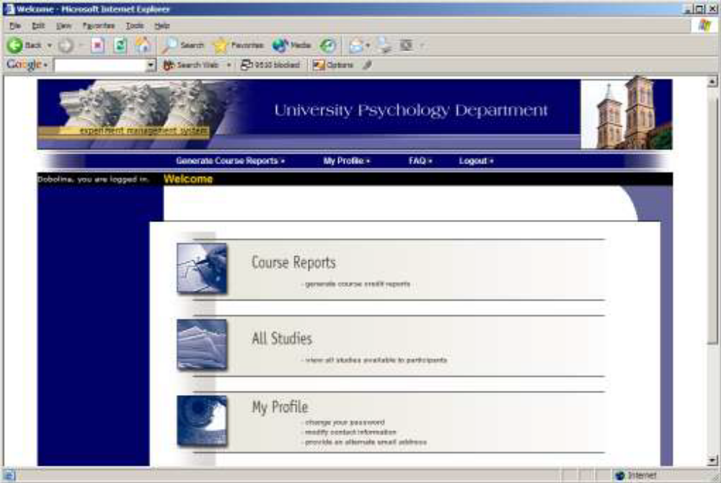
Figure 37 - Main Menu

Course Reports
On the Main Menu that you see after logging in, you will see an option to generate course reports. Once you click on that, you will see a list of all the courses you are listed as an instructor for, and you have the option to generate reports for each of those courses.

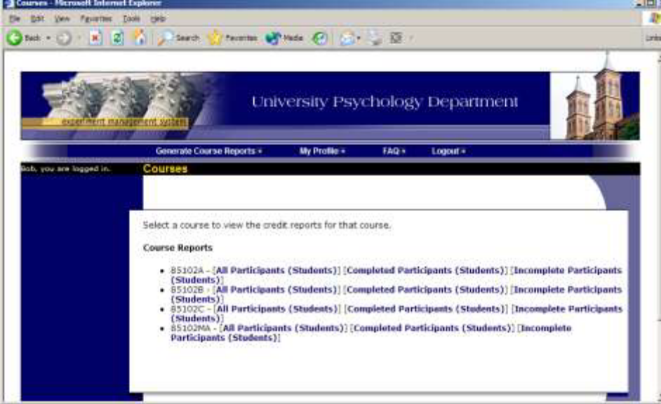
Figure 38 - Course Listing

You have 3 choices for the type of report you would like to generate. All Participants will list all participants in the course. Completed Participants will list only participants who have met or exceeded their credit options (i.e., 5 bonus marks). Incomplete Participants will list only participants who have not met their credit options. Click the link for the desired report.

The report will be listed in alphabetical order by a participant’s last name, and participants who have not completed their credits will be highlighted in bold. For privacy and research ethics reasons, you will never see exactly which studies the students participated in – only a summary of their credit earnings. If for some reason this information is needed, the Administrator can produce such a report for you using the Course Credit History report available to her or him.

If the report is too wide to be printed easily, you can use the Printer-Friendly format. A link to that will appear at the bottom of the report.

If you would prefer to deal with the information in CSV (comma-separated) format (for easy import into a spreadsheet program like Excel), use the CSV link at the bottom of the report to generate such a data file. If you have any problem working with the CSV format file, please contact your IT department for assistance – CSV is a standard data format and they should be quite familiar with it.

To generate a new report, choose the Main Menu link from the left toolbar and proceed from there.

Viewing Studies
In some cases, you may have the ability to view what studies are available in the system (to students). This is useful if you want to discuss information or concepts from those studies in class, as a part of the educational experience. If such an option is available, you will see an All Studies link after you login. If you click this, you will see a list of studies, and you may then click on any study to view more about it. For privacy reasons, you may not see who has signed up for any of the studies.

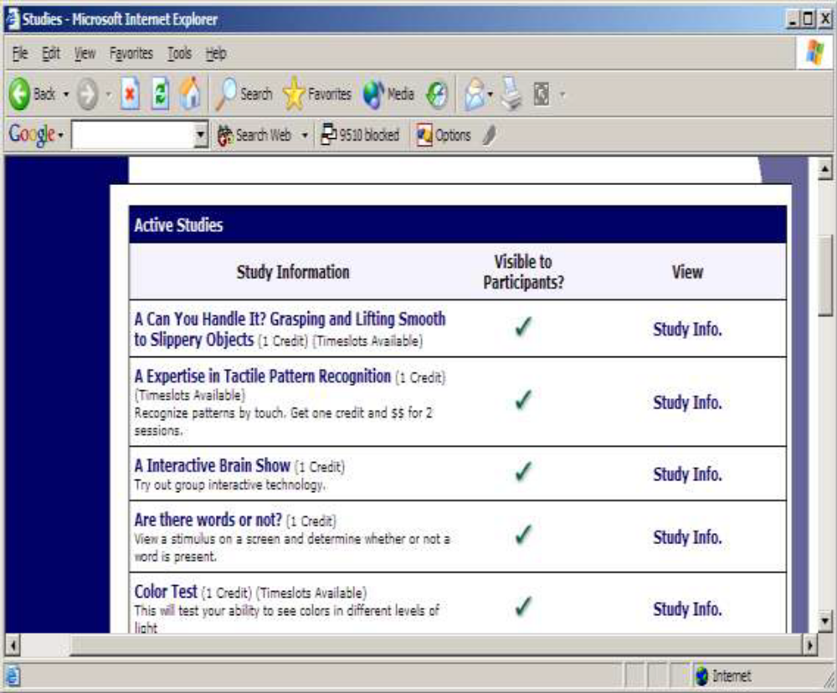
Figure 40 - Viewing Studies

Changing Your Password
To change your password or other information, choose the My Profile choice from the toolbar. Fields marked with (+) are optional and do not need to be filled out. If you change your password, please be sure to select a password that you do not use on any other systems or websites. This is good computing practice, and especially important as in some cases, your password may be sent over email.
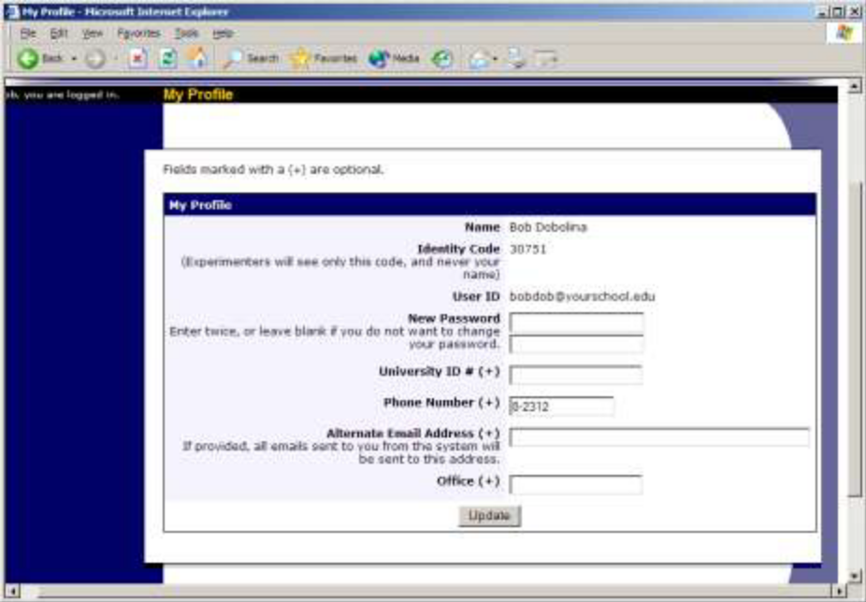
Figure 41 - Updating Your Profile

In situations where the system is configured so you may enter an email address on this page, you will be asked to enter it twice when changing the address, to ensure it is typed correctly.

Logging Out
When you are done using the system, choose Logout from the top toolbar to log out. You are now logged out. It is always a good security measure to close all your browser windows as well, especially if you are using a computer that is shared by others.

