Addition & Subtraction
Word Problems

Choose a word problem card from the box.

Record your problem number on the response sheet.


Solve the problem using base ten materials, hundreds charts, number lines, or any material of your choice.

Show how you solved it using pictures, words or symbols.

Word Problems Response Sheet

Name: ____________________________________

Record the number of your word problem: _________

Show your solution:

1 |   Mike earned $28 last week selling newspapers. This week he earned $15. How much money has he earned in all?
2 |   Katie had 19 apples in her basket. She picked some more apples and now she has 35 apples. How many more did she pick?
3 | 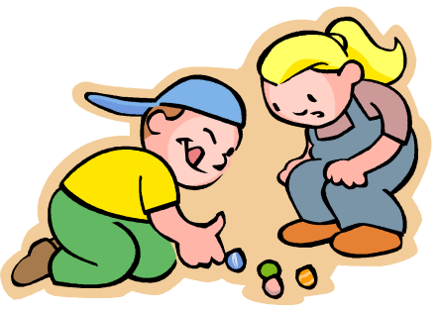  Dylan had some marbles and he won 13 more during recess, now he has 21 marbles. How many did he have when he started?
4 |   Gavin collected 39 shells in his bucket. He gave his brother 13 shells. How many does he have left?
5 |   Annie had some cookies. She gave Alex 14 of them. Now she has 17 cookies left. How many cookies did Annie have to begin with?
6 |   There are 31 boys and 24 girls going on the field trip. How many students in all are going?
7 | 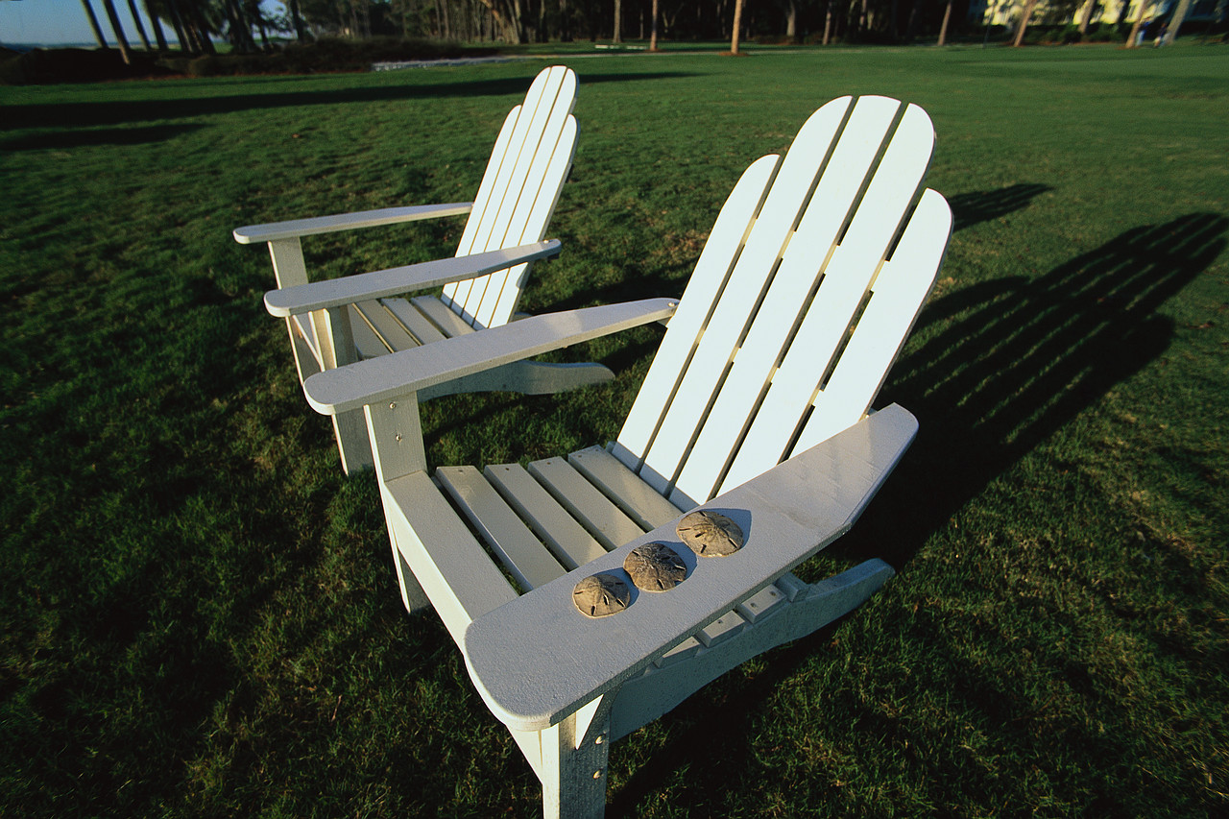  There is going to be a concert in the park this weekend. They sold 38 adult's tickets and 65 children's tickets. How many chairs will they need to seat everyone?
8 |   There were 27 children at the birthday party. Twelve of them were boys. How many were girls?
9 |   Mary sold 78 candy bars for the school fund raiser. Chantella sold 95. How many more did Chantella sell?

