Fossils – Records of Earth’s History

Outcomes:
Students will be expected to:
- Identify and describe rocks that contain records of Earth’s History (300-7).

Materials:
- Aluminum pie plate
- Container for mixing*
- Stick for stirring
- Plaster of Paris
- Sand**
- Water
- Petroleum jelly
- Objects to be fossilized (shells, leaves, parts of tree trunks, bones)*

*Have students bring in beforehand.
**To be brought in by teacher.

Engage:
Have the students do a KWL chart as a class on the board or chart paper. Have them describe what they know and what they want to know about fossils.

Explore:
Students should work in groups of 4 or 5 with each student making their own fossil. Pour a layer of sand about 2.5 cm think in the bottom of an aluminum pie pan. Coat the objects to be fossilized with petroleum jelly and lay them on the sand. Mix equal amounts of plaster of Paris and sand, add enough water so the mixture so moist and just thin enough to pour. Spread the mixture evenly over the sand about 5 cm think. Leave the pan in a warm place to dry. When the mixture hardens (in a day or so), turn the pan over and dump out the hardened material and carefully clean the sand away to observe the fossils.

Explain:
Once this activity is completed as an introduction to fossils, give students the opportunity to find out more about the different ways in which fossils are formed and what formations are most rare and most common.

Extend:
Provide students with a variety of non-fiction materials on fossils, access to the internet, pictures and samples of fossils.

Apply:
Have the students complete the KWL chart – the “Learned” column.

Additional Teacher Info on the following pages.

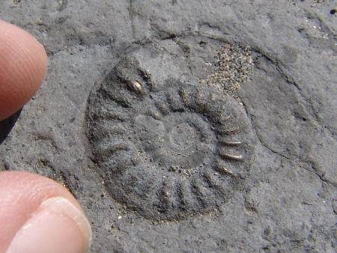
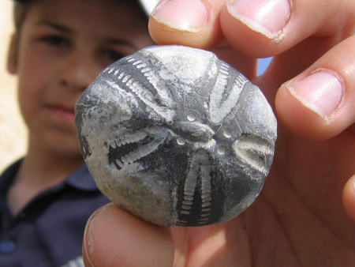
What is a fossil? How do they form?
Left: A small pyritised fossil ammonite (Tropideroceras) from Seatown. Right: A fossilised irregular echinoid (Echinocorys) from Beachy Head.

Fossils are the remains of creatures which existed long ago. Fossils range from thousands of years to many millions of years in age. The earliest fossils of complex life date from around 600 million years ago, however recent reports reveal bacteria may have existed up to 3 billion years earlier. To put this in context, the dinosaurs became extinct just 65 million years ago!

Not all former life was preserved as fossils, in fact the vast majority simply vanished without trace. The most likely materials to survive fossilisation are the hard parts such as shells and objects which in life were constructed from resistant materials, such as Coral. In order for softer materials to survive, the conditions must be extremely favourable.

Fossils come in a variety of sizes, from minute traces to large skeletons. Trace fossils are clues to former life, they result from the activities or presence of creatures and plants. Examples of these traces include footprints, burrows and root tunnels. At the larger end of the scale, fossils also include bones, the largest of which belong to the dinosaurs, which existed between the Triassic and Cretaceous periods.

There are five different ways ways an organism can become fossilised:

Permineralization (Petrification) - This process involves the replacement of the original organic tissues with minerals from the surrounding rock, including silica, calcite or pyrite.

Unaltered preservation - This occurs when the organism is preserved in its original state and protected from the affects of permineralization. Examples of this include insects which become trapped in tree sap, which later turns to amber.

Carbonization (Coalification) - This results from removal of all but the carbon elements. Other elements such as hydrogen, oxygen, and nitrogen are removed.

Authigenic preservation - These fossils are the molds and casts of organisms which have dissolved or rotted away, leaving only a trace of their existence.

Recrystalization - This occurs where crystals form within the original structure, eventually replacing it and resulting in a crystallized copy. The following diagrams illustrate the process of fossilisation, starting with the moment of death. The example used is an ammonite, a shelled creature that lived in the seas around 150 million years ago.

Phase 1 - Death
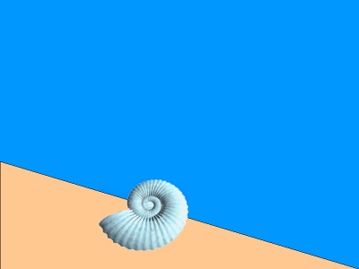

Having died, the ammonite slowly sinks to the sea floor. Scavengers feed on the fleshy body of the creature, and after only several weeks all that remains is the shell.

Phase 2 - Deposition
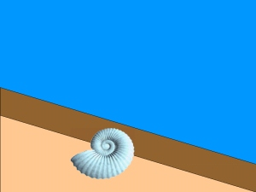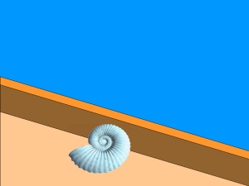

Several months after death the shell gradually becomes covered with silt and sand. These layers continue to build, providing a shield around the shell and protecting it from damage. Time continues to pass and more and more layers are deposited. After a few hundred years the shell is several feet beneath the surface.
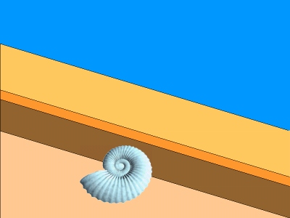

Time continues to pass, 1,000 years, 10,000 years and more...

Phase 3 - Permineralisation (for example)
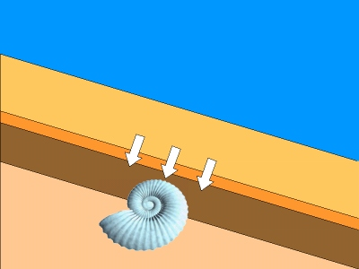

Gradually the chemicals in the shell undergo a series of changes. As the shell slowly decays, water infused with minerals passes through it, replacing the chemicals in the shell with rock-like minerals (Calcite, Iron or Silica). This process is scientifically known as permineralisation.
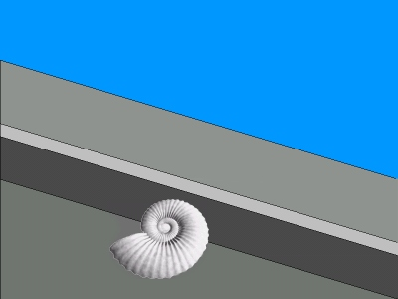

Over millions of years the original shell is completely replaced by the minerals and what remains is a rock-like copy of the original shell. The fossil has the same shape as the original object, but is actually rock. This process also results in loss of original colour.

Phase 4 - Erosion
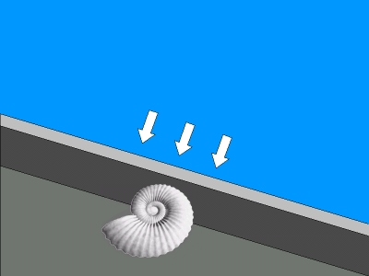

Over millions of years the movement of the earth plates results in the seabed being forced above the surface. The result is a new landscape, within which the ammonite fossil remains buried. Once above the surface the rock is subject to erosion. In certain areas of the world such as Lyme Regis in Dorset, the rock is once again subject to the affects of the sea. In these areas the rock is pounded by the sea, forming towering cliffs. Other factors such as wind, rain, ice and the sun help contribute to the rate of erosion.

Phase 5 - Exposure
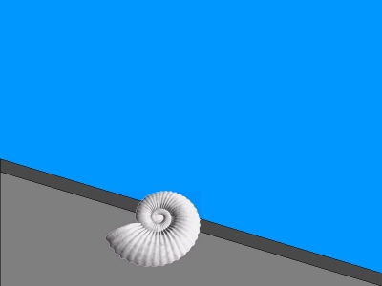

Having laid beneath the surface for 150 millions years the fossil is finally exposed. This final stage may have resulted from a cliff collapse or the efforts of a palaeontologist.
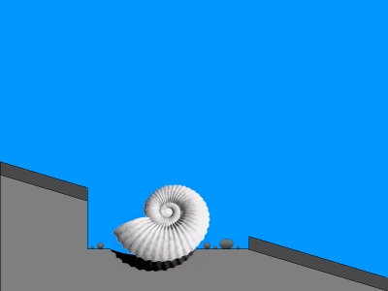

The fossil can then be removed from the ground, cleaned and examined.

Example fossils
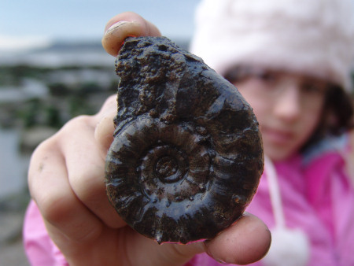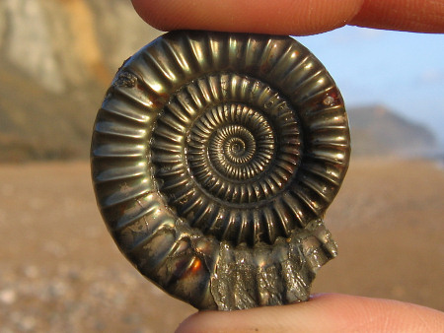
Left: Pyritised ammonite (Eoderoceras) from Charmouth. Right: A pyritised ammonite (Echioceras) from Charmouth.
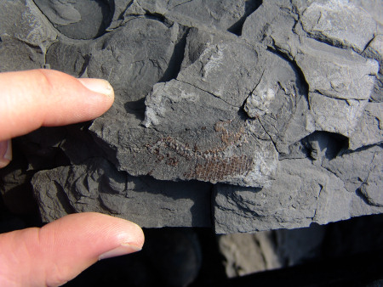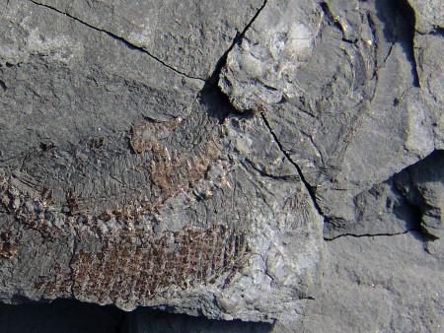
Left: A small fish skeleton with scales (Pholidophorus) from Lyme Regis. Right: Close-up.

