Geology: Weathering and Erosion

Outcomes:
Students will be expected to:
- Describe ways in which soil is formed from rocks and demonstrate and describe the effects of wind, water, and ice on the landscape (301-4, 301-5).
- Demonstrate and record a variety of methods of weathering and erosion, including demonstrate and record a variety of methods of weathering and erosion, including human impact on the landscape (301-6, 108-6, 105-1)
- Describe natural phenomena that cause sudden and significant changes to the landscape (301-7).

Materials:
- Water
- Plastic wrap
- Modeling clay
- Blocks of wood
- Straws
- Small chunks of brick
- Wooden stir sticks
- Sand, mud*
- Trays, aluminum pie plates and watering can

*Brought in by the teacher.

Engage:
Prior to this series of activities that could be done in small groups as rotation stations or a series of stations that groups complete on their own time, the teacher should give some background information if other learning experiences have not already been explored on soil, weathering and/or erosion.

Ask students to write on a small piece of paper, an index card, or in their science journals one piece of information they may recall about how soil is formed. This can be used in a KWL type assessment.

Explore:

Activity 1: Cracking Up
First, roll some modeling clay into a ball. Several balls of different diameters could be formed and teaded to compare the sizes of cracks. Wrap each ball in plastic wrap, label with the group name, and freeze overnight. Next day, unwrap the plastic wrap, the clay will have cracked to represent frozen earth.
- What happens to out landscape when ice weathers it?
- What effect can this have on living things?
- Is it useful?
- Is it harmful? In what ways?
- How has ice changed the Earth over time?

Activity 2: Making a Mountain
Make long, flat rectangles out of modeling clay. Layer three or four on top of each other. Bookend the clay with a block of wood and slowly push the two ends together. A mountain forms when the Earth’s plates push together.

Activity 3: Making a Valley
Fill a pan/tray with sand and raise one end with an item from the classroom (book, block, etc.). Pour a gentle stream of water into the tray in the middle. As the water runs down, a valley will form in the sand. If you have a deep tray or pan, you may be able to simulate how a river (water flowing from mountain tops or ice from glaciers) can erode the Earth from mountains as it runs through steep valleys.

Explain:
Note: When we look at the ground around us, the most common thing we see is soil, yet it is easy to forget that the Earth is made up of rock that is mostly solid. The Earth’s crust is made up of plates of rock that change the landscape of the Earth over time from weathering and erosion. Erosion happens when ice, wind, and water (rivers, oceans) change the Earth’s shape through movement. Weathering happens when ice, wind, and water crack and split the Earth’s surface, wearing down and breaking up the rocks. Bedrock (large, solid, bottom later of soil) is weathered and eroded to make smaller rocks, and then eventually sand and the small bits of rock found in top layers of soil over thousands of years.

Extend:
Activity 4: Changing Coastlines
Using a large pan, use mud to build a coastline. Add packed sand along the coastline (in front of the mud) to build the coastline further. Elevate the side a few inches. Place wooden stir sticks throughout the sand, marking each with a line to show its depth in the sand. Use a watering can to simulate rain. Hold the watering can in different places.
- How does the nature of erosion change? How do the stir sticks show erosion? In what ways can moving water be the most damaging form of erosion to living things? Can you think of instances of erosion in the news?

Rebuild the coastline using same or a lighter consistency of sand. Now blow through using a straw to simulate wind.
- How do you the stir sticks show erosion? How does wind cause erosion and weathering?

Apply:
Activity 5: A Field Experience
Find a place outside to make a mountain, coastline or valley or mark an existing one in the schoolyard. Mark wooded stir sticks and observe over a few days, noting what natural forces fo to change the landscape. Record in a science journal. These activities can happen over a course of several science periods/days.
Weathering & Erosion
Weathering is the process that produces change in the surface of rocks exposed to the atmosphere and/or hydrosphere.
Physical weathering is breaking rock by force.
ex: hitting, scratching, cracking
Frost action (AKA ice wedging)-
- Water seeps into small cracks in rocks.
- When the water freezes it expands creating great pressure.
- The crack widens and allows water to seep deeper into the rock.
(Robert Frost’s Mending Wall makes a reference to a frost heave.)
Plant action
- Tiny root hairs seek out small cracks and pits in rock.
- Once the root hairs find a place they grow and expand.
- The expansion causes great pressure and cracks the rock. 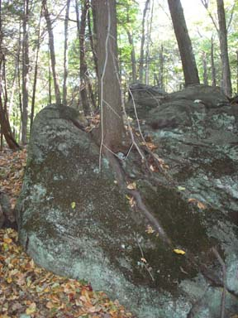 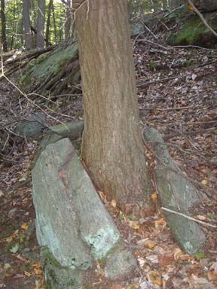

In the pictures above tree roots can be seen growing directly on rocks. In the lower picture, the rock has been broken in two by the force. (Harriman State Park 2005)
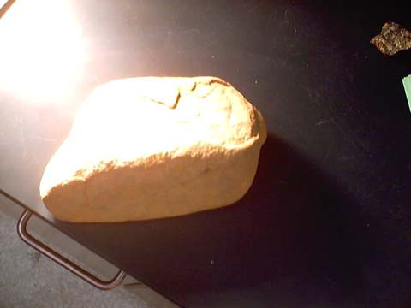
Exfoliation
In the rock to the left, layers have peeled from the outside caused by exfoliation.
- Rocks formed deep in the Earth are made under high pressure.
- When the pressure is released the rocks expand & crack.
- May also be caused by alternate heating and cooling of rocks by weather conditions.

Abrasion- rubbing by other rocks.
Chemical weathering is where the rock material is changed into another substance by reacting with a chemical.
Oxidation
- Oxygen in the atmosphere chemically reacts with minerals.
- ex.: rusting of a nail

Water (hydrolysis)
- Minerals are dissolved in water.
- ex.: Halite, calcite
Acid
- Carbonic acid:
  - C02 dissolves in rain water forming a weak acid (seltzer).
- Acid Rain: Sulfur Dioxide in the atmosphere dissolves in rain water forming a strong acid (sulfuric acid).
Rates of weathering will be influenced by...
Surface area exposed - weathering occurs on the surface. More surface exposed, the faster the weathering will occur.

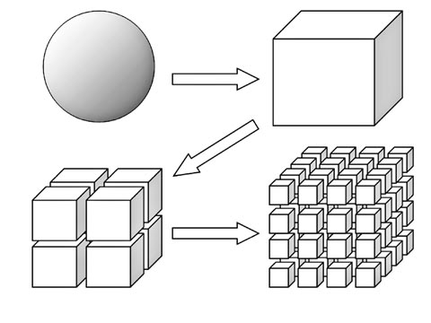

Mineral composition- some minerals are more resistant than others.
ex.:Quartz is resistant to chemical and physical weathering.
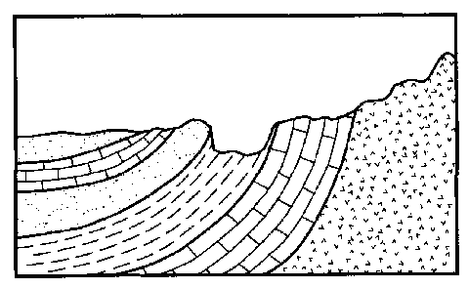
In the diagram above the different layers of the rock are weathered at different rates depending on the minerals within the rock. The layers sticking up most are the most resistant.
Climatic Conditions:
- Cold and/or dry climates favor physical weathering.
- Warm and wet climates favor chemical weathering.
- Frost action works best in areas where the temperature fluctuates wildly.
Soil - The product of weathering
Soil is made from rocks, minerals (mainly sand and clay), and organic material (regolith and organic matter)
Soil forms layers of different characteristics called horizons.
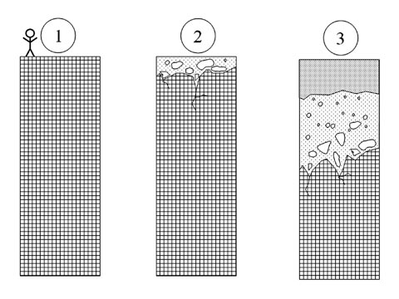
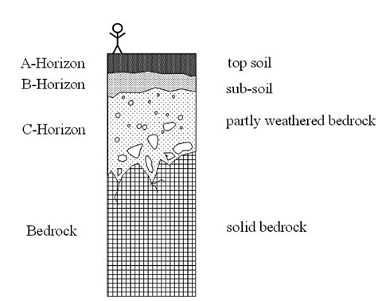
Residual soil is located above the rock that it is formed from (parent rock).
Transported soil has been moved from another location.
Most soil on the Earth's surface is transported.
Horizon | Layer | Description
A | Top Soil | Small sediments and organic material
B | Sub Soil | Lighter in color, no organic material
C | Partly-weathered Bedrock | Larger rocks
Bedrock | Bedrock | Solid Rock

Erosion- the process of moving sediment from one location to another.
The most important FORCE of erosion is GRAVITY. The most important AGENT of erosion is WATER.
The amount of erosion by a stream depends on the velocity and volume of water flow.
Velocity is influenced by the slope & volume of a stream.
As the velocity increases the size of the particles transported will get bigger. (See chart in Handy Dandy Earth Science Reference Tables)
Volume (amount of water flowing) is influenced by rainfall.
The shape of a stream will determine where erosion will occur.The fastest water goes to the outside of the curve. The outside curve gets eroded away.
In a straight run of water, the fastest water runs above center of the stream.
The rate of erosion increases where the velocity increases. (Direct Relationship)
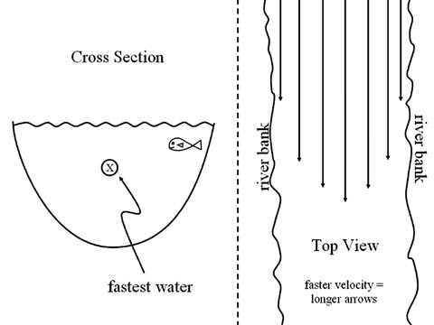
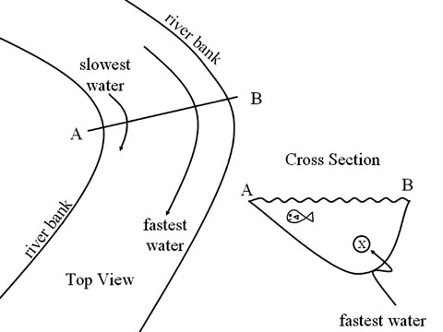
Deposition- the process of dropping material out of transportation.
Kinetic and Potential Energy
- Kinetic Energy is the energy of motion.
- The faster an object moves, the higher its kinetic energy.
- Wherever the KE is high (fast water), there is a lot of erosion.
- Wherever the KE is low (slow water), there is a lot of deposition.
- Potential Energy is the potential to move.
- The high an object is, the higher its potential energy.
The characteristics of deposited particles give information about the erosion and deposition environments.
Water
- sediments get rounded and polished. Sorting occurs.
- particles can be fairly large.
- deposition occurs where the water slows down.
  - ex.: where the river widens or where it dumps into a large body of water.
- As water slows gradually, smaller and smaller particles drop out causing horizontal sorting.
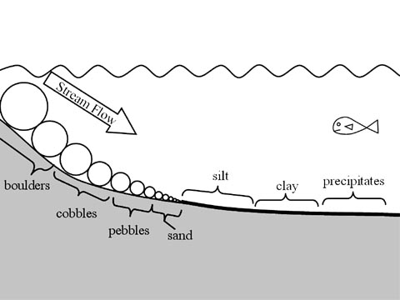
Horizontal Sorting

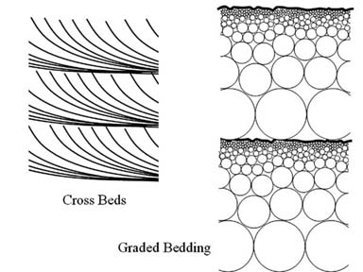
Crossbeds are formed when several horizontal sorting events happen on top of each other such as in a river delta as the stream meanders back and forth.
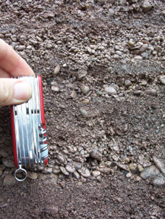
Graded bedding in a glacial esker.
-Medina NY July 2004
Graded Bedding comes from repeated vertical sorting events such as annual spring thaws.
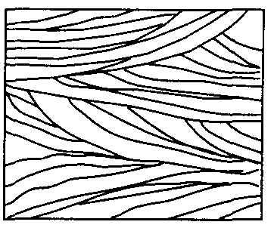
Crossbeds caused by the wandering mouth of a stream.
Crossbeds in a glacial esker.
-Medina NY July 2004
Vertical Sorting- caused by larger, rounder, denser sediments settling first.
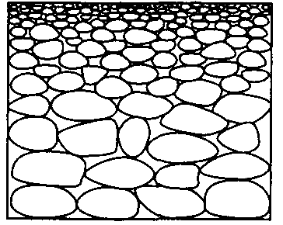
Wind
- sediments are rounded and have a frosty appearance (tiny pits from impacts of flying sand) sorting occurs.
- particles are small
Ice (glaciers)
- Sediments are sharp-edged
- May have scratches or a polished side where they came in contact with the ground
- Deposits are unsorted and can be very large.
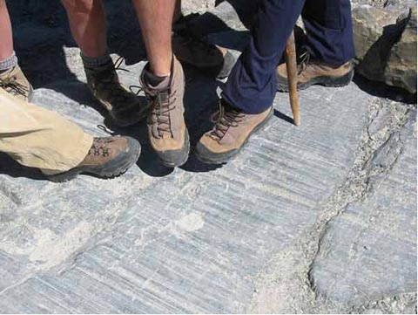
Parallel scratches in bedrock caused by the passage of a glacier.
Gravity by itself can transport sediments.
- Sharp-edged
- unsorted
- no limit in size
- often causes “mass wasting” such as landslides and downhill creep
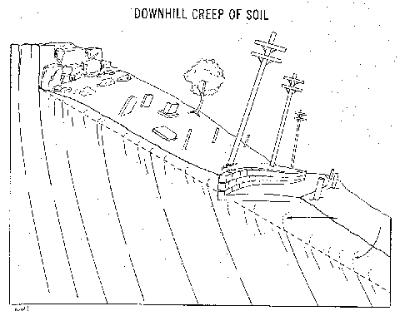
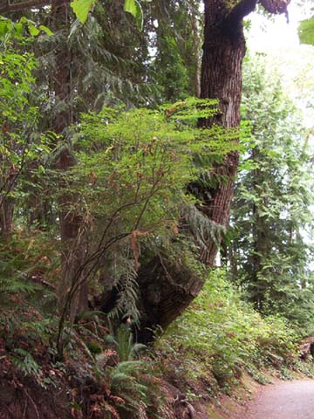
A living tree trunk bent by downhill creep.
-Medina Seattle August 2004

Erosional/Depositional Systems
Glaciers- There are two types of glaciers: Alpine (or valley) and Continental (Ice Caps).
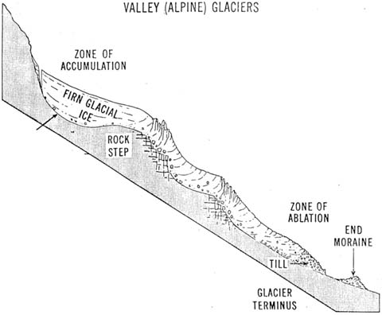
A side view of an alpine glacier.
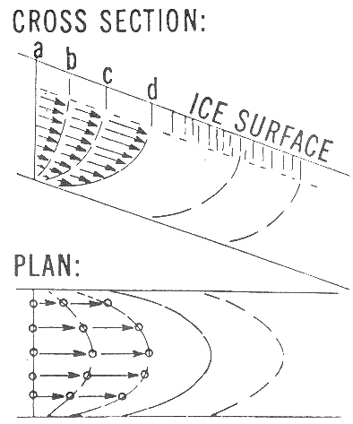
The slow motion flow of a glacier is similar to that of a river- fastest in the middle and slowest along the banks.
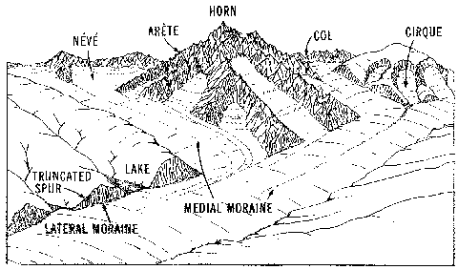
An alpine glaciated area showing many of the typical features.
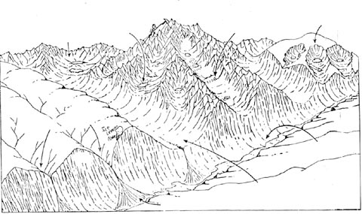
The same area after the glacial ice has melted away.
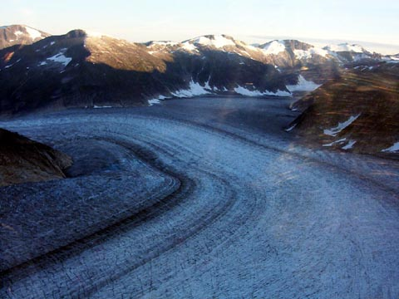
An alpine glacier in Alaska. Note the racing stripes of the medial moraines.
-Medina Aug 2004
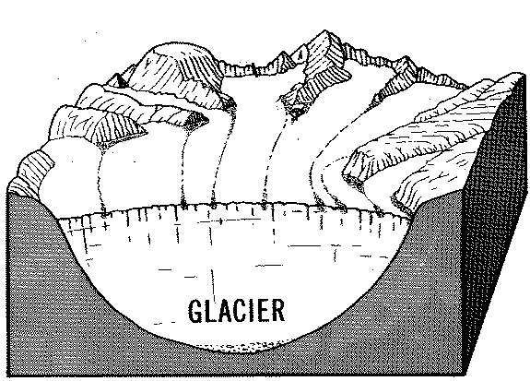
A diagramatic view showing how medial moraines form.
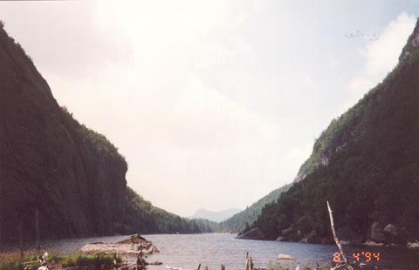
This picture taken on the way to Mt. Marcy (See Reference Tables) shows classic U-shaped valleys of a glaciated region.
-Medina 1994
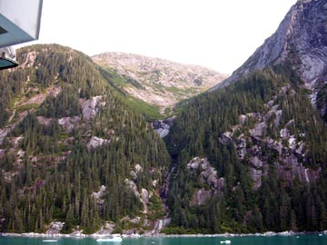
Another U-Shaped Valley in Alaska.
-Medina August 2004
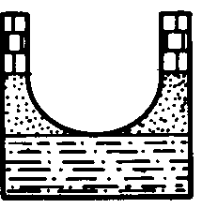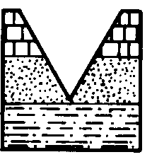
The U-shaped Valley on the left was made by a glacier while the V-shaped valley on the right was made by running water.
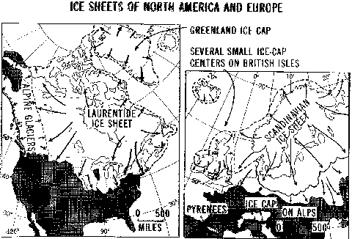
Continental Glaciers as they were at the peak of the Last Ice Age.
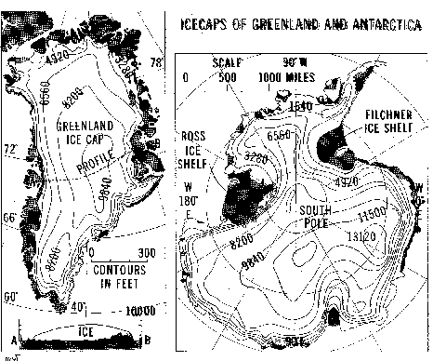
The the current continental glaciers on the planet. Note that the cross section at the bottom left shows that the weight of the glacier has pushed the center of Greenland below sea level!
Continental Glaciers
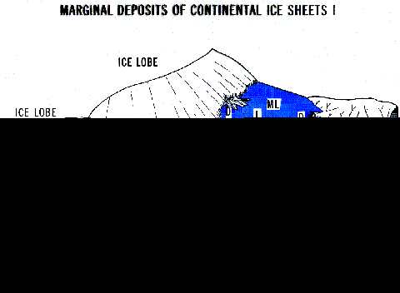
Diagram showing an active ice sheet and many of the features found at its edge.
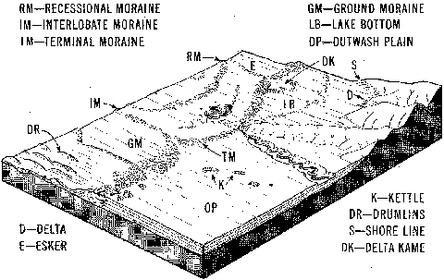
The same are after the glacire retreated.
Streams
In a straight section of a stream, the fastest water is in the middle above center.
On a curve, the fastest water gets thrown to the outside and that's where erosion will happen. The slowest water huggs the inside of the stream and that is where deposition takes place.
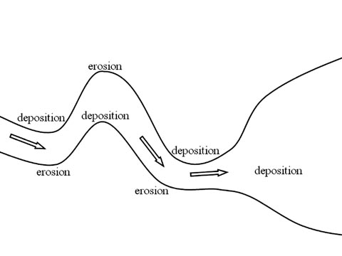
The meander widens from erosion on the outside and deposition on the inside.
The two sides of the meander erode into each other.
Water slows in the outside loop causing deposition . The loop gets cut off into an “Oxbow Lake” while the stream returns to a straighter course.
A Youthful Stream
- Narrow V-shaped
- Downcutting
- Swift water
- Steep gradient
- Erosion is dominant
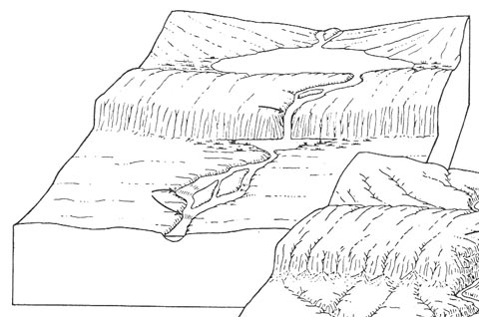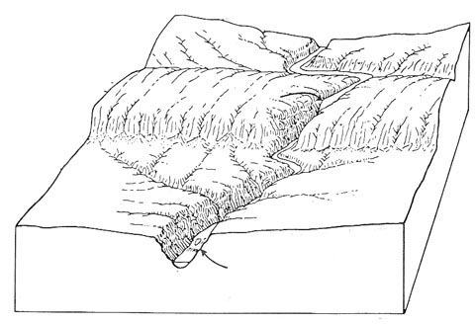
Valley continues to deepen.
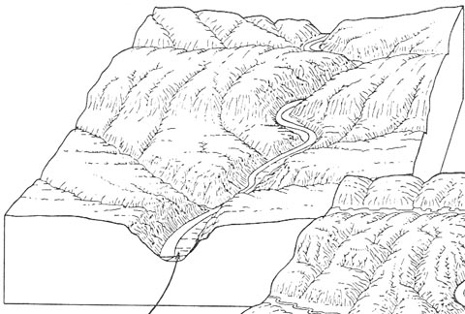
Mature Stream
- Lateral Erosion begins
- Meanders develop
- Floodplains develop
- Gradient lowers
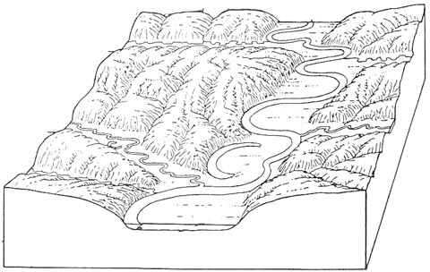
Old Age
- Wide meanders and oxbow lakes
- Wide floodplain
- Low velocity
- Low gradient
- Dynamic equilibrium between erosion and deposition
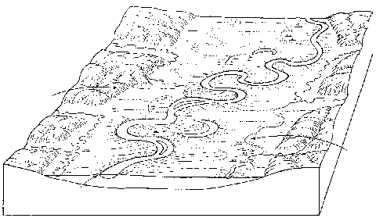
Waves
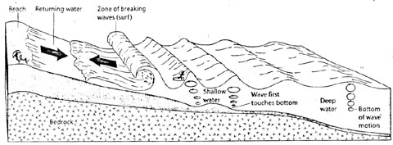
Wave action as seen under the waves

