St Francis Xavier University Human Nutrition Baccalaureate Program

Response to Recommendations and Requirements from
the Dietitians of Canada 2010 Accreditation Site Visit

Submitted May 25, 2013

to Marlene Wyatt,
Director of Professional Affairs
Dietitians of Canada

by Doris Gillis, PhD, PDt,
Chair and DC Program Coordinator
on behalf of
The Department of Human Nutrition
St Francis Xavier University

Introduction

The Summary of the Accreditation Review (November 15th & 16th, 2010) of the St Francis Xavier University (StFX) Human Nutrition (HNU) academic program by Dietitians of Canada (DC) outlined a number of concerns that needed to be addressed in order to achieve full accreditation. This document describes the changes that have been made in response to the Accreditation Surveyors’ recommendations and requirements, and provides evidence of these changes in the appendices. It builds on the response of February Feb 11, 2011. The Department of Human Nutrition has been working with the University Administration including the Dean of Science, Dr Robert van den Hoogen and the Academic Vice-President and Provost, Dr Mary McGillivray to address the identified deficiencies. Other Department heads and faculty have been consulted on issues related to service courses. Curriculum changes have been approved through the necessary processes and organizational structures including the University Senate.

An iterative process of curriculum review has been facilitated by the Department of Human Nutrition’s Curriculum Working Group (CWG), which was first established in 2008. The CWG has been instrumental in assessing the curriculum and proposing curriculum changes to members of the Department of Human Nutrition for their input, discussion and agreement on all accreditation recommendations and requirements. The CWG plays a central role in facilitating ongoing assessment of course content throughout the curriculum in order to meet national standards for dietetic education and practice within the broader human nutrition program. At the May 6th and 8th 2013 curriculum review workshops, threading of core knowledge relevant to the Jan 2013 version of the Integrated Competencies for Dietetic Education and Practice (ICDEP) was also examined in preparation for the upcoming 2013-14 Academic Review of the Department of Human Nutrition.

Recommendations

- STATS 201 (Elementary Statistics) be moved to 2nd year.

This recommendation was approved at the December 17, 2010, Human Nutrition Department Meeting. STATS 201 was moved to second year from the first year course sequence and HNU 235 Communications was moved from second to first year, a change that also addressed students’ request for more Human Nutrition (HNU) courses in their first year. Shifting HNU 235 from second to first year was transitioned over two years with some students taking HNU 235 in first year while others took an open elective.

2) The 2nd year requirement for a 3 credit BSAD elective be removed.

This recommendation was approved at the January 21, 2010, Department of Human Nutrition Meeting, subsequently approved by the Committee on Studies and became effective in the 2011-2012 academic year. The curriculum was reviewed to ensure that competencies previously met in the Accounting, Marketing & Human Resources electives were covered within HNU required and elective courses. (See course outlines for HNU 356 in Appendix A and HNU 456 in Appendix B). This change in elective requirements has alleviated some of the course scheduling difficulties faced by transfer HNU students.

- The lab component of HNU365 (Community Nutrition) be eliminated and lab components of HNU351 (Nutritional Assessment) and HNU352 (Nutrition in Chronic Disease Prevention and Management) be reviewed.

Lab components from HNU 365, 351 and 352 have been restructured with labs for 365 and 352 eliminated, thereby contributing to improved efficiency of faculty resources and increased flexibility in timetabling.

The Department approved elimination of the lab component for HNU 365 on March 2, 2012. In the 2012-13 academic year, relevant content from the lab was covered in HNU 365 lectures and through mandatory participation in Service Learning. Students’ poster presentations of Service Learning projects were featured at the Community Nutrition Fair which was held for the first time off campus at People’s Place— Antigonish Public Library. This setting attracted community members as well as StFX faculty and students. Participant feedback on the venue as well as student feedback on the value of Service Learning for HNU 365 was very positive. (See the course outline for HNU 365 and the Service Learning Community Nutrition Project in Appendix C).

In 2011-12, the HNU 351 lab was redesigned and the HNU 352 lab was eliminated. In 2012-13, HNU 351 and HNU 352 were offered concurrently in the first term to better synchronize content (See course outlines for HNU 351 in Appendix D and HNU 352 in Appendix E). The instructors for HNU 351 and HNU 352 worked closely to incorporate material from the HNU 352 lab throughout lectures in these two courses. For example, HNU 351 introduces the nutrition care process, population surveillance systems, and assessment methods. HNU 352 positions the role of the dietitian in the health care system, nutrition interventions and dietary counselling techniques. Assessment skills are applied to weight management, cardiovascular disease and diabetes throughout HNU 352. Applications of the nutrition care process (including PES statements and documentation methods) are introduced in HNU 351 and through case studies and assignments in HNU 352 and HNU 353 Nutritional Management of Human Disease. Interviewing and counselling skills are taught and practiced in HNU 352 and in workshops developed specifically for dietetic interns. Laboratory content from HNU 352 has also been incorporated into the lecture of other courses required for students pursuing dietetics. For example, dietary modification is now covered in HNU 356 Introduction to Food Service and Quantity Food Production lecture and lab. (See course outline in Appendix A). In the fall term of 2013, the assessment of genetic polymorphisms will be introduced in HNU 351 with further applications covered as part of the nutrition care process in HNU 352 (Apo E and dietary fat responses), and in HNU 353 (folate metabolism [MTHFR] and alcohol exposure related to cancer risk). (See course outline for HNU 353 in Appendix F).

- HNU366 (Maternal and Child Nutrition) and HNU425 (Nutrition in Aging) be
combined.

Course evaluations from HNU students continue to emphasize the value of these two HNU electives. Combining HNU 366 Maternal and Child Nutrition and HNU 425 Nutrition in Aging would limit HNU elective options and dilute coverage of important knowledge with significant relevance to practice. Preparing graduates to meet the needs of an aging population in keeping with the health priorities of the region is a focus of the IDI program which includes a scholarship for interns interested in dietetics and healthy aging. Nutrition during maternal and child development is a priority as childhood obesity and chronic disease prevention are key concerns in this province and health district where chronic disease rates are among the highest in the country. Material on human development within HNU 366 is also required for students pursuing a career in education. To meet the increasing need for teachers with food and nutrition background, the Faculty of Education recently introduced the Family Studies Skills option (See section 6.2.1 in the 2013-14 Academic Calendar at http://sites.stfx.ca/registrars_office/sites/sites.stfx.ca.registrars_office/files/Academic_Calendar2013_2014.pdf). This education option is increasingly attractive to HNU students as an alternative to pursuing the highly competitive and limited dietetic internship opportunities.

Therefore, in light of these priorities and with increased flexibility in scheduling due to the elimination of a 3 credit business (BSAD) elective and lab components of HNU 365 and HNU 352, we do not see the value of combining content of these courses into one course.

5) HNU200 (Nutrition for a Healthy Lifestyle) be eliminated or reduced to 1 semester.

The recommendation to reduce HNU 200 from a 6 credit to a 3 credit course was approved at the December 17, 2010 Department of Human Nutrition meeting and subsequently reviewed by the Committee on Studies and approved by Senate. This revision was effective in the 2011-2012 academic year with the new course renumbered as HNU 215. The course is currently being developed as an on-line course offered through StFX’s Continuing and Distance Education for future delivery by distance in addition to the classroom. (See course outline for HNU 215 in Appendix G).

6) Integration of concepts in 2nd year physiology and human nutrition courses be pursued.

The instructors for biology BIOL 251/252 (Anatomy and Physiology I & II) and HNU 261 Introduction to Nutrition and HNU 262 Principles of Nutrition in Human Metabolism have discussed ways to better integrate concepts across these courses. HNU 261 has seen a reorganization of content so that the micronutrients are now covered using as a functional approach. For example, material on nutrients involved in bone health is presented as a cluster reflecting their physiological role in bone health as opposed to covering vitamins and minerals as separate content categories. This integrated approach aligns with students’ concurrent learning of bone anatomy and physiology in BIOL 251. (See course outline for HNU 261 in Appendix H).

HNU 262 has developed significantly over the past two years. This course applies many anatomical/physiological concepts from genetics and the endocrine, bone, and renal systems, etc. (See course outline for HNU 262 in Appendix I.) These concepts are introduced in HNU 262 after it is covered in BIOL 251/252 to assist students in applying this knowledge to nutritional science. HNU 262 students are also now introduced to the field of nutritional genomics and built upon this knowledge in subsequent courses (HNU 351, 352, 353).

7) The University provide HNU faculty with training needed to use Moodle course
management software.

The HNU faculty and staff attended a Moodle workshop on December 16, 2010 and several faculty members adopted Moodle in their winter 2011 courses. In the 2011-12 academic year, six instructors used Moodle as a course management tool. Since fall 2012, StFX has provided technical support for Moodle with most faculty members now using this system to manage their courses. In May 2013, the StFX Technology Support Group conducted a needs assessment which included interviewing each faculty and staff member in the Department. (A report of this assessment will be made available if required). Anyone needing further training/support in using Moodle will be able to access this during the summer of 2013.

8) The recommendation is that HNU 461 be reviewed to ensure that it reflects
examination of energy metabolism and infectious or inherited diseases building on
HNU 262, HNU 352, and HNU 353, or that HNU 461 be made a required course for
students pursuing the IDI, post-graduation internship or DC accredited graduate
programs.

The Accreditation Committee noted that a recommendation cited in the report on page 6 related to HNU 461 was not listed in the summary of recommendations. It was verified with the surveyors that this should have been added. Therefore, the Accreditation Committee requested that this recommendation be considered.

In 2012, revisions were made to HNU 353 and HNU 461 to address concerns. All common metabolic diseases are covered in the required HNU courses of HNU 262, 352 and 353. Metabolic syndrome, diabetes mellitus, cardiovascular disease, and weight management are covered in HNU 262 and subsequently in greater depth in HNU 352. HNU 353 covers diseases of the Upper & Lower GI tract, hepatobiliary, renal, and respiratory systems, as well as cancer, HIV/AIDS and metabolic stress. (See course outlines for HNU 262 in Appendix I, HNU 352 in Appendix E, and HNU 353 in Appendix F.

HNU 461 Nutrition in Metabolic Disease was modified in 2012-13, as described in the
2013-14 Academic Calendar:

This course examines the etiology and pathophysiology of nutrition-related metabolic diseases, with a focus on the evidence leading to clinical practice guidelines for these disorders. Topics will include rheumatic disorders, skeletal/muscular disease and selected inherited metabolic diseases in macronutrient metabolism. Prerequisite: HNU 353. Three credits.

HNU 461 focuses on the rationale behind the development of relevant clinical
practice guidelines and is intended to enable fourth year students to enhance their knowledge
of advanced nutrient metabolism and disease pathophysiology, while strengthening their skills
in critical review of literature and research methods, and their understanding of the
relationship between research and practice. (See proposed 2013-14 course outline for HNU
461 in Appendix J).

Discussions were held at the May 2013 curriculum workshop regarding “making
HNU461 a required course for those students who wish to pursue the IDI, post-
graduation internship or DC-accredited graduate programs”. Although students
pursuing dietetics will be encouraged to take this course, more consideration needs to
be given to making HNU 461 a requirement for all students pursuing dietetics. This issue will
be further examined over the next year within the context of the new Integrated Competencies
for Dietetic Education and Practice and part of the Academic Review of the Human Nutrition
Department scheduled for 2013-14.

Requirements

- The University recognize the DC Program Coordinator’s responsibilities through financial compensation or workload release; we recommend 0.2 FTE.

The HNU Department agrees and consulted with University administration with respect to financial compensation or workload release for the DC Program Coordinator. In addressing this issue, the Academic Vice-President and Provost, Dr Mary McGillivray and the Dean of Science, Dr Robert van den Hoogen have stated, “The Academic Administration at the University fully recognizes the additional responsibilities and workload associated with the duties of the DC Program Coordinator. The work being done by the individual is respected and highly valued; we also recognize that it is essential to the ongoing success of the Dietetics program at StFX, and we support it to the best of our capacity in what are challenging times for Universities across the country. However, as we are sure Dietitians of Canada recognizes, the terms and conditions of employment may not be set by an outside party: terms and conditions of employment are subject to the Collective Agreement between the University and the St. F.X. Association of University Teachers (the recognized bargaining agent for most of the faculty and support staff on campus).” (email correspondence May 21, 2013).

- HNU program students be provided with individual, on-going academic advising from staff who understand the numerous program options and who are knowledgeable concerning strategies to improve their readiness to apply for the competitive StFX IDI, post-graduate DC internship, and DC accredited graduate programs. The IDI Coordinator should be appointed as the DC Program Coordinator and the DC Program Coordinator role should be recognized as a 0.2 FTE.

Consultations were held within the HNU Department, as well as with the University Administration, to determine an appropriate model for improving academic and career path advising for HNU students, and assignment of the DC Program Coordinator role.

The HNU Department recognized the need for an improved system of individual ongoing academic and career advising within the Department for all HNU students. Faculty members were open to designing a system to engage students with designated faculty in one-on-one academic and career path advising. Classroom sessions across all years were held in March 2012 and 2013. For the fall of 2012, all students were divided into four groups and assigned to one of four faculty advisors. A system was set up for faculty advisors to email students to inform them of group advising sessions and provide contact information for individual meetings with their designated advisors. The Chair continues to be available for all HNU students requiring academic and /or career advising. Students interested in pursuing a career in dietetics or the Cooperative Education Program are referred to the IDI Coordinator for more specific academic and career advising related to the StFX Integrated Dietetic Internship (IDI), post-graduation internship with masters, or DC-accredited graduate programs. In advising students, faculty use a standard form that lays out the course sequence across the four years and lists current offerings of HNU electives. (See advising guide in Appendix K). On-line registration for first year students was initiated in the summer of 2012. In preparation for this, the Chair conducted two webinars directed to first year students. Webinars for new students are also scheduled in the summer of 2013. As part of their 2012 fall orientation, first year and transfer students met their faculty advisors as assigned and were given a tour of the Department facilities. We will continue to emphasize the personalized approach to advising for HNU students. The Chair continues to work closely with the academic advisors in the Deans’ Offices.

Information and advice on career options for HNU graduates, including but not limited to dietetics, food science, education, food service/business, and nutritional science, is provided through seminars within visiting speakers, posted on bulletin boards, and on the Department website which has been redesigned (http://sites.stfx.ca/human_nutrition/). While significant improvement has been made, the Department continues to look for ways to engage faculty and students in academic and career advising, and sees this as a priority as student numbers increase.

With respect to the recommendation to appoint the IDI Coordinator as the DC Program Coordinator with the DC Program Coordinator role [should be] recognized as a 0.2 FTE, this change does not align with the staffing arrangement considered to meet the needs of our program within the context of our institution. To enhance integration of the academic and experiential components of our program, the Master’s qualified IDI coordinator teaches dietetic relevant courses (a 3 credit course in the fall and a 3 credit course in the winter) as well as coordinates the Integrated Dietetic Internship. This arrangement results in a full time position during the academic year. We do not understand the rationale for this requirement as it not consistent with the most recent proposed PDEP accreditation standard requiring the DC Program Coordinator to have both PhD and professional dietitian qualifications. With respect to recognition of the DC Program Coordinator role as a 0.2FTE, please refer to the response Requirement 1 above.

- CHEM255 (Introductory Biochemistry) be substantively revised or replaced by a course that provides students with the required knowledge.

The syllabus for CHEM255 was revised to include coverage of material important for HNU students and was implemented in January, 2011 and further revised in January 2012. An in-depth study on protein biochemistry has been extended to include an overview of lipid and carbohydrate biochemistry, as well as the energy metabolic pathways. Discussions have been held with the course CHEM 255 instructor and the HNU chair with ongoing monitoring and continued dialogue. (See correspondence from Dr D. Morgan, instructor of CHEM 255, to Dr Robert van den Hoogen, Dean of Science, in Appendix L.) In the winter of 2013, the CHEM 255 instructor and HNU Chair agreed to hire a HNU student to provide tutorials sessions to HNU students to supplement the instructor’s weekly tutorials. These additional sessions were evaluated by students (April 2013) with feedback indicating that the tutorials were considered worthwhile and should be offered again next year with some suggestions for improvement.

- BIOL315 (Introductory Microbiology) be substantively revised, or, replaced by a suitable course that provides students with required knowledge. Current students who have completed BIOL315 should be provided with opportunities to acquire the requisite knowledge base prior to graduation. Current students yet to take BIOL315 should be encouraged to enrol in appropriate external course(s) until a suitable course is developed at St. Francis Xavier.

A new course was developed to meet the needs of HNU students. BIOL 215 Microbiology for Human Nutrition, builds on BIOL 115 Microbes in Human Biology (offered to Nursing students) with the addition of a lab including bench techniques plus tutorials covering specific issues relevant to human nutrition, such as infectious disease control and food safety. The course description in the 2012-13 and 2013-14 Academic Calendars follows:

An introduction to microorganisms from a human health perspective, that focuses on immunological concepts, viruses, bacteria and fungi. Laboratories cover basic microbiological techniques and tutorials covering applications from a health perspective to communicable disease control, infection control, food and water quality, and food hygiene. Restricted to Human Nutrition students. Prerequisites: BIOL 111 and CHEM 100. Three credits and lab/tutorial.

The Committee on Studies approved the proposed BIOL 215 Microbiology for Human Nutrition in March, 2012. The course was approved at the April 3rd 2012 meeting of Senate and was offered in the winter term 2013. (See course outline for BIOL 215 and lab assignment outline in Appendix M).

- The curriculum be revised to include adequate examination of the social and cultural factors that influence food choice.

In the fall 2011, the instructor for HNU 185 A Foundation for the Nutrition Professional incorporated material recognizing social and cultural factors that influence food choice.

In 2012-13, HNU 185 was replaced by HNU 161 Food and Nutrition for Heath in Society, a course designed to focus on the integration of social and cultural influences on food choice as a foundation of human nutrition practice. (See item 6 below.) This new introductory course applied a bio-cultural framework and thus covered various social and cultural influences in food choice. (See course outline for HNU 161 and Food and Culture Assignment in Appendix N). Faculty identified opportunities to build on this foundation in higher level HNU courses in ways that move to levels of application and analysis of material pertinent to social and cultural factors that influence food choice. For example, HNU 235 Communications, offered in the second term of first year, builds on material introduced in HNU 161, providing opportunities for students to apply and expand understanding of cultural aspects of foods through presentations related to foods and practices associated with various ethnic and cultural groups. (See HNU 235 course outline and lab activity/assignment in Appendix O).

At the May 2013 curriculum workshop, faculty examined the extent to which social and cultural factors impacting food choice were threaded throughout the curriculum. This exercise demonstrated that socio-cultural aspects of food and food choice were introduced in HNU 161 and threaded through HNU 235, 145, 146, 352, 353, 356, 365, 405, and 475 as well as electives HNU 366, 425, and 456.

- HNU185 (A Foundation for the Nutrition Professional) be revised or replaced.

HNU185 has been replaced by HNU 161 Food and Nutrition for Health in Society, which was reviewed by the Committee on Studies and then approved Senate in November 1, 2011. The course is described as follows:

Designed as a foundation course, this course examines the evolving role of food and nutrition in society from historical and contemporary perspectives. Students will be introduced to local, national and global influences on societal food consumption trends and factors influencing individual food choice and behavior. The impact of socio-economic factors and culture, such as customs and worldviews, on food selection and dietary practices will be explored in depth. An introduction to the history and philosophy of the nutrition profession and emerging issues in human nutrition will be integrated throughout the course. Three credits

HNU 161: Food and Nutrition for Health and Society was offered in the first term of 2012 with 56 students enrolled. This course includes mandatory participation in Service Learning. (See course outline for HNU 161 in Appendix N).

- Suitably qualified clerical support be provided to the Chair and IDI Coordinator.

We fully agree that an additional, full-time, administrative assistant is needed to support the Chair and the IDI Coordinator. Discussions have been held with University administration to negotiate a full-time clerical position for the Department. Performance evaluations of administrative assistants were completed in summer 2012, resulting in more designated support to the HNU Chair, IDI Coordinator and HNU faculty and staff. One FT administrative assistant retired in May 2013. In addressing this staffing issue, the Academic Vice-President and Provost, Dr Mary McGillivray and the Dean of Science, Dr Robert van den Hoogen state, “The University is managing through a restructuring that will see greater administrative support to the Department of Human Nutrition. The administrative support will be clearly identified with respect to the duties required for programs in Human Nutrition, and there will be closely monitored quality assurance processes in place” (email correspondence May 21, 2013).

- Access to the PEN database be provided to HNU students, faculty, and IDI interns.

The Department of Human Nutrition faculty met with the librarian designated to Human Nutrition on November 19, 2010, to discuss the departmental library resources and access to PEN for HNU students, IDI interns and faculty. Reallocation of existing library resources to obtain PEN access was not considered feasible at that time. Given the imperative of having access to PEN within this professional program, the cost of access to PEN for selected instructors and IDI interns was covered from the departmental budget. More recent discussions with the University Librarian and others has resulted in agreement to purchase two PEN site licenses from designated library allocations for the Department of Human Nutrition and for the School of Nursing (supported by the Director of the School of Nursing given that nursing students are required to take two 3 credit human nutrition courses). As noted by the University Librarian, “We will go ahead and purchase two PEN licenses as outlined below, for this year and review for future needs”. (email correspondence May 22, 2013).

- Computers identified by TSG be replaced.

Computers identified as out-of-date by the StFX Technical Support Group (TSG) have been replaced. Since November 2010, all faculty members have been provided with MacBook Pro computers. The lab instructor was supplied with a new desk top computer in the fall of 2012. Assessment of technology resources and needs was completed by TSG in May 2013 in preparation for the 2013-14 Academic Review of the Department. This report can be made available if requested.

- The University enhance its promotion and recruitment efforts for the HNU program.

The Department Chair has met and will continue to meet with Recruitment Office staff to identify opportunities to strengthen recruitment efforts. The Dean of Science also encouraged the Recruitment Office to enhance its HNU student recruitment efforts. In 2011, the HNU website was redesigned in keeping with the university-wide website template (http://sites.stfx.ca/human_nutrition/) and Dr. J. Jamieson is responsible for keeping it current. Student enrolment has increased since 2010 with fall 2013-14 projections reflecting continuation of this trend.

Conclusion

The Department of Human Nutrition has worked diligently to address the recommendations and requirements of the DC Accreditation Surveyors. As we look towards the future, we are aware of the importance of ongoing assessment of the curriculum within the context of the new Integrated Competencies for Dietetic Education and Practice. We are also cognizant of the potential impact of new accreditation standards on future development of the Human Nutrition program and sustainability of the Department of Human Nutrition at StFX.

List of Appendices

Appendix A- HNU 356: Introduction to Food Service and Quantity Food Production Course Outline
Appendix B- HNU 456: Food Service System Management Course Outline
Appendix C- HNU 365: Community Nutrition Course Outline with Service Learning Assignment
Appendix D- HNU 351: Nutritional Assessment Course Outline
Appendix E- HNU 352: Nutrition in Chronic Disease Prevention & Management Course Outline
Appendix F- HNU 353: Nutritional Management of Human Disease Course Outline
Appendix G- HNU 215: Nutrition for a Healthy Lifestyle Course Outline
Appendix H- HNU 261: Introduction to Nutrition Course Outline
Appendix I- HNU 262: Principles of Nutrition in Human Metabolism Course Outline
Appendix J- HNU 461: Nutrition in Metabolic Disease Course Outline
Appendix K- Human Nutrition Program of Study 2013-14 Advising Guide
Appendix L- CHEM 255 Biochemistry Correspondence
Appendix M- BIOL 215: Microbiology for Human Nutrition Course Outline with Lab/Tutorial Assignments
Appendix N- HNU 161: Food and Nutrition for Health in Society Course Outline and
Food and Culture Assignment

Appendix O- HNU 235: Communications Course Outline with Food and Culture Lab Assignment

Appendix A
Human Nutrition 356
Introduction to Foodservice & Quantity Food Production
St. Francis Xavier University
Fall 2012
Course Instructor: Dina Spigelski, MSc
Office: 343 J. Bruce Brown Hall
Phone: (902) 867-3224
Email: (preferred) dspigelski@stfx.ca
Office hours: Mon 2–4 pm, Wed 1–3 pm, Fri 9:15–11:15 am (or by appointment)
Course Information
Class times: Mon 10:15, Wed 9:15, Fri 8:15 | Lab time: Thurs 2:15
Class location: BB 236 | Lab location: BB 255
Course Prerequisites: HNU 261/262
Required Text:
Payne-Palacio & Theis. Foodservice Management: Principles and Practices, 12th edition. Upper Saddle River: Pearson Education, Inc., 2012.
Additional readings may be placed on reserve in library or Moodle

Reference Periodicals Available in Library:
Foodservice & Hospitality; Food Management; Restaurants & Institutions; Journal of Foodservice Systems

Recommended Websites (not meant to be exhaustive):
Canadian Restaurant & Foodservices Association: (http://www.crfa.ca)
Food Management: (http://www.food-management.com/)
Whole Foods Market: (http://www.wholefoodsmarket.com/)
Foodservice & Hospitality (Canada’s Hospitality Business Magazine): (http://www.foodserviceworld.com/)
Food Safety Training & Certification in Canada:
(http://www.traincan.com/index-news.asp)
Food Industry & Consumer Trends:
(http://www-t.wrbm.com/nl/jsp/m.jsp?c=53da959182d5a1ad73)
Culinary Calculations [e resource]: Simplified Math for Culinary Professionals:
(http://site.ebrary.com/lib/stfx/docDetail.action?docID=10296032)

Newsletter:
https://www.kostuchmedia.com/component/rsform/form/5-newsblast-subscription.html

Course Description:
In this course, principles, policies, and practices applied to successful management of quantity food service systems are examined. Topics include food safety, menu management, quantity recipe standardization and costing, procurement, production and service of quality food, marketing, staff scheduling, equipment and furnishings.
Course Outcomes:
Upon completion of this course, students will:
- Understand history of food service and different types of food service systems in place today
- Identify the various trends and influences in the food service industry
- Describe/understand sanitation and food safety principles and the importance of these practices in food service
- Use critical thinking in making decisions related to procurement, production and service of quality food
- Understand the foundations and processes of menu planning, recipe development and recipe standardization for quantity food production
- Apply principles and methods of cost control, cost and evaluation of the value of ingredients, recipes and menus
- Apply principles of ordering food and non-food items in quantity
- Develop marketing skills for promoting food products, concepts and services
- Apply principles of financial management to small foodservice businesses

Lab Outline by Week:

Week | Date | Topics and Activities
1 | Sept 6 | No lab
2 | Sept 13 | Menu audits (application of principles of menu planning)
3 | Sept 20 | Possible site visit
4 | Sept 27 | Recipe quantification & recipe costing
5 | Oct 4 | Possible site visit
6 | Oct 11 | Menu pricing and menu engineering
7 | Oct 18 | Possible site visit
8 | Oct 25 | Food Safety Certification, part 1
9 | Nov 1 | Food Safety Certification, part 2
10 | Nov 8 | Preparation for Food Market
11 | Nov 15 | Food Market
12 | Nov 22 | Food Market debrief and lab wrap-up
13 | Nov 29 | Possible review day
This schedule is tentative and may change as site visits are confirmed. Please check lab website often to make sure you have the most up-to-date version. Lab assignments are due the following week in lab.

Class Outline by Week:
(note: class notes will be posted in Moodle before class or as soon as is possible; you are responsible for all chapters below even if not covered in detail in class)

Week* | Chapter | Topics and Activities *
1 | 1 | -Course outline and introductions  -History of foodservice Industry
2 | 2  5 | -Foodservice systems  -Sept 12: Food Safety Presentation (see Moodle for details)  -The menu
3 | 18 | -Menu planning assignment  -Marketing
4 | 8 | -Production
5 | 7 | -Receiving, storage & inventory
6 | 6 | -Purchasing
7 | 9 | -Service  -Menu Planning assignment due Oct 19
8 | 17 | -Financial management
9 | 3 | -Food safety
10 | 11 | -Equipment and Furnishings
11 | 4 | -Facility sanitation & worker safety
12 | 10 | -Facilities planning & design
13 |  | -Review for Final Exam
* subject to change depending on how quickly course material is covered in class

Course Evaluation:

Activity | Date | %
Class: Attendance & Participation |  | 5%
Daily Informer | See list posted in Moodle | 5%
Lab: Participation, Assignments & Site Visits | See online lab manual for details | 10%
Food Market Group Project | Food Market Event to be held Nov 15;  See online lab manual for further details | 25%
Menu Planning Assignment | Oct 19 | 20%
Final Exam | TBA | 35%

Failure to meet all assignment deadlines will result in loss of 10 marks for each day past the due date (including weekends).
Daily Informer
At the beginning of each class, a daily informer will educate the class on a current topic (no earlier than August 2012) regarding the foodservice industry. Accepted topics include food safety, new foodservice systems, food service trends, marketing of new products/programs, management issues, issues impacting foodservice profits/loss, profit/loss estimates/trends, or foodservice management and human resource issues (including work flow, productivity, worker recruitment/retention, strikes).

Source material must be from 1) local (Chronicle-Herald) or national (Globe & Mail) newspapers, 2) Canadian news magazines, 3) foodservice publications and assigned foodservice websites (see list of recommended periodicals and websites). Ideas must be sent to instructor for approval prior to class.

The daily informer will submit a written record (no handwritten work please) to include: 1) title of foodservice item/topic/issue, 2) reference source, 3) brief summary (point form or maximum of 10 lines). Instructor will choose presentation dates randomly: the list will be posted on Moodle the first week of classes.

Lab
The lab includes site visits and lab assignments. Site visits will be scheduled and dates confirmed as received throughout the term. It is the student’s responsibility to attend all lab sessions and site visits. Please bring a calculator to all lab sessions. Included as part of the lab is a Food Safety Training Program (Level 1) offered through the NS Department of Agriculture & Fisheries. This course is recognized as a safe food handling certification program and is taught by a Food Safety Specialist. Successful completion of the training program is required to pass this course.

Food Market Group Project
See online lab manual for details.

Menu Planning Assignment
Detailed instructions & supporting materials incl. evaluation criteria will be distributed in class during the menu planning lecture and lab.
Objectives:
- To identify and utilize menu planning criteria
- To apply a menu pattern to a particular situation, target group and setting
- To develop an understanding of the importance of many customer, operational and external factors during the menu planning process
- To gain experience adapting menus for modified diets
- To gain experience in planning a menu for a special event
- To apply nutritional standards when developing a menu
Final Exam
The final exam will be held as per the university exam schedule. The exam format will consist of multiple choice, true and false, short answer and multiple part questions. Additional exam information will be provided closer to the date.

Classroom Environment:
In order to create an environment conducive to learning during class time please 1) refrain from chatting to your neighbour and 2) set electronic devices to mute/vibrate mode. Your cooperation is much appreciated!

Academic Regulations
Class Attendance:
Section 3.7 from the 2010-2011 Academic Calendar states that students are required to attend ALL classes and labs. Students should contact their professor/instructor following an absence of more than one class. If a sudden emergency requires students to miss more than five (5) days, they must inform the dean’s office. Faculty are required to report all unexplained absences of over three (3) hours over at least two classes in any term.

Academic Integrity:
Students are responsible for knowing the StFX academic integrity policy. This is outlined in section 3.8 of the 2010-2011 Academic Calendar. If you have questions about plagiarism, please feel free to ask me, or visit the Writing Centre on campus. http://www.mystfx.ca/resources/writingcentre/

Appendix B
HNU 456: Food Service System Management (3 Credit Course)
Course Syllabus
Winter Term 2013
Instructor: Fran Haley PDt, MHSA, CHE
E-mail: fhaley@stfx.ca
W/drive: people.stfx.ca - /fhaley/
Office: 335B J. Bruce Brown Hall

Course Description
Building on material introduced in HNU 356, this course focuses on managerial decision making relevant to human resource and financial management of food service systems in a range of settings in the public and private sectors. Using a Problem Based Learning (PBL) approach, students working in small groups on problems assigned by the professor will examine current issues in food service practice and learn to apply quality assurance mechanisms in their management.

Prerequisites: HNU 356; BSAD 261

Learning Objectives:
Upon completing of this course, students are expected to be able to:
- Identify, describe and apply principles of food service operations and management to institutional food service operations in diverse settings including acute care hospitals, long term care facilities, colleges/universities, and business and industry.
- Apply systems theory to food service management as demonstrated through case study analysis.
- Demonstrate the ability to critically analyze and solve problems related to food service operations.
- Demonstrate skills in gathering and evaluating information needed for solving problems in food service operations.
- Work cooperatively in teams and small groups.
- Demonstrate the application of effective oral and written communication skills with individuals and groups.

Using a case study approach, students will apply foodservice management theory and resources to address management issues pertinent to large food service organizations. This investigation will include identification of the scope of the foodservice industry, the financial impact of management decisions, leadership and organizational change, human resource management, food product flow and kitchen design, menu, marketing and quality management.

When presented with a problem in foodservice systems management, the student will:
- generate learning issues (questions)
- classify relevant learning issues into learning tasks
- search for, organize, interpret and critically analyze relevant evidence from a variety of sources (text book, journals, etc.)
- share findings and critique with other students
- design an evidence-based solution which demonstrates application of what they learned through their assessment of the problem case
- facilitate learning of the other group members and the class as a whole

Specific topics include; budgeting and financial and cost controls, revenue generation, benchmarking, management information systems, analysis of data to facilitate operational planning and decision making, facility planning and equipment selection, leadership, ethical and professional practice, planning and system change, human resource management, labour relations management and performance appraisal and improvement.

Required Texts:
Lieux,E.McKinney & Luoto, Patricia K. (2008) Exploring Foodservice Systems Management Through Problems. (3rd ed.). Upper Saddle River, NJ: Prentice Hall
Gregoire, Mary B. (2013). Foodservice Organizations: A Managerial and Systems Approach, (8th ed.). Upper Saddle River, NJ: Prentice Hall.

Optional Text:
Payne-Palacio, J. & Theis,M. (2012) Foodservice Management Principles and Practices (12th ed.) Upper Saddle River, NJ: Prentice Hall

Reference Books:
- Jones, Terri. (2008). Culinary Calculations: Simplified Math for Culinary Professionals (2nd ed.).Hoboken, NJ: John Wiley and Sons.
- Lea R. Dopson, David K. Hayes, Jack E. Miller. (2011). Food and Beverage Cost Control (4th ed.). Hoboken, NJ: John Wiley and Sons.
- Manfared Rohatsch, Frits Lamme, Peter Neumann, Frand Wagner. (2007). Professional Kitchens: Planning, Design, Equipment. Freiburg Germany: FCSI Huss-Medien,
- Karen Davison, Barbara Dominik, editors. Audits and More: A Nutrition and Foodservice Audit Manual for Adult Residential Care Facilities with 25 or More Persons in Care. BC Ministry of Health Services.
- Puckett, Ruby. American Society for HealthCare Food Service Administration (2004). Food Service Manual for Health Care Institutions, (4th ed.). NJ: John Wiley and Sons.
- Molt, Mary. (2011). Food for Fifty (13th ed.). Upper Saddle River, NJ: Prentice Hall.
- Barbara A. Almanza, Lendal H. Kotschevar Margaret E. Terrell. (2000) Foodservice Planning: Layout, Design, and Equipment (4th ed.) Upper Saddle River, NJ: Prentice Hall.
- Linda Dietrich, Dietitians of Canada et al. (1999) Success with prepared foods: Guide for Healthcare Foodservice Professionals. Toronto, ON: Dietitians of Canada.
- PMI Food Equipment Group Canada. (2000). Planning for Cook-Chill. Toronto, ON: PMI Food Equipment Group Canada

Reference Periodicals:
  - Foodservice and Hospitality Magazine
  - Food Management
  - Food Service Director Magazine
  - Journal of Foodservice Systems
  - The Journal of Foodservice Management and Education
  - Journal of the Academy of Nutrition and Dietetics (formerly; Journal of the American Dietetic Association)
  - Canadian Journal of Dietetic Practice and Research

Selected Web Pages:
www.crfa.ca
http://www.food-management.com/
http://www.healthcarefoodservice.org/
http://www.traincan.com/index-news.asp
http://www.fsdmag.com/
http://www.agr.gc.ca/index_e.php
http://www.nacufs.org/
http://www.schoolnutrition.org/
http://www.foodserviceworld.com/

Methods of Instruction:
Problem-Based Learning exercises, instructor facilitation, guidance and support, guest speakers, service learning case study, site visits. Students will work in small groups on case study problems assigned by the professor. It is expected that students will work together on the problems to identify what they already know and then identify the learning issues (questions) that need to be explored to understand options and possible solutions to the problems. Students will also research appropriate information from a variety of sources, i.e. current journals, periodicals, books, trade magazines, research reports and relevant web based references. It is the student’s responsibility to review and be familiar with the text chapter subject matter prior to the class. Accounts of practical/actual food service situations that apply important concepts of the subject matter being discussed will be presented. Class discussion and questions will be encouraged and expected.

Group Work and Class Organization:
- Assignment to groups is made by the professor.
- Groups are permanent for the entire semester as would be found in the working world.
- It is essential for everyone in the group to contribute to the group effort.
- In order to ensure everyone’s participation, roles will be assigned that will rotate with each problem. Possible roles may include: Discussion leader, Scribe, Reporter, Accuracy coach, Skeptic and Encourager.
- Each group will develop its own ground rules for behavior.
- Group rules are to be written and provided to each group member and the professor.
- Rules may be modified as necessary with group consensus.
- The group should decide in advance the consequences of not adhering to each of the ground rules.
- Upon completion of each problem, group members will provide informal feedback on the performance of all members.
- Twice during the term you will complete a peer evaluation form about the performance of each member of the group, including yourself.
- Evaluation criteria for both informal and written feedback will include: participation, preparation, knowledge acquisition, reasoning processes, communication and ability to synthesize and apply information. These evaluations will be part of each individual’s grade.

Attendance:
Group learning requires that members of learning groups/ teams be present. If absence is necessary, the student is responsible for contacting each group member in advance of class. All research materials should be provided for each group member before the class, and the absent member must make every effort to be accessible by e-mail or phone to respond to questions from the group.

Evaluation Scheme:
Case studies, write-ups/presentations: (6 @ 10 marks each) 60
Service Learning Case Study 15
Worksheets: 7 @10 marks each 70
Peer and faculty evaluation: 25
Final exam: 30
Total: 200 (/2 adjusted to 100%)

Academic Regulations:
See Sections 3.7 and 3.8 of the 2011-2012 Academic Calendar. Please note the following:

3.7 Class Attendance:
“Students are expected to attend all classes and laboratory periods. Following an absence of more than one class, students should contact each professor or instructor. In the case of sudden emergency requiring an absence of more than five days, students should contact the dean’s office. Faculty are required to report to the dean all unexplained absences in excess of three hours over at least two classes in any term.”

Please inform your instructor if you are unable to attend class because of illness. Be aware of
and attentive to University statements regarding flu outbreaks and recommendations regarding
precautionary practices with respect to transmission to others.

3.8 Academic Integrity:
"All members of St. Francis Xavier University are expected to conduct themselves in an ethical manner in their academic work. It is the policy of the university that academic dishonesty in any form is not acceptable. Academic dishonesty is defined as any act, practice or behavior that gives a student an unearned academic advantage over another or that counteracts or undermines the integrity of academic or scholarly endeavor at St. Francis Xavier University.”

3.8.1 The Code of Academic Conduct
An academic community flourishes when its members are committed to five fundamental values. An academic community of integrity:
a) advances the quest for truth and knowledge by acknowledging intellectual and personal honesty in learning, teaching, research, and service;
b) fosters a climate of mutual trust, encourages the free exchange of ideas, and enables all to reach their highest potential;
c) establishes clear standards, practices, and procedures and expects fairness in interactions among students, faculty, staff, and administrators;
d) recognizes the participatory nature of the learning process and honours and respects a wide range of opinions and ideas; and
e) upholds personal responsibility and accountability and depends upon action in the face of wrong-doing.”

This course is intended to help you become more aware of the values and beliefs which guide the nutrition profession as well as your future actions. Learning will be facilitated through various means including working in groups and sharing your ideas with others. There is a requirement that throughout this learning process, your own words are expressed and your own work, as individuals and teams, is submitted for assessment.

PLAGIARISM IS CONSIDERED A SERIOUS OFFENCE.

“Although academic work often involves research on, or reference to, the ideas, data, and critical commentary of other scholars, academic integrity requires that any use of another person’s work be explicitly acknowledged. Plagiarism is the misrepresentation of another’s work-whether ideas or words, intellectual or creative works, images or data, published or unpublished-as one’s own. Examples of plagiarism include:
i) quoting, paraphrasing, or summarizing text, even small portions of text, without proper acknowledgement;
ii) paraphrasing too closely (e.g., changing only a few words or simply re-arranging the text); and,
iii) downloading from the Web or from a library or any other database all or part of a paper, a journal article, or a book, or downloading any other website material, excluding bibliography makers, and presenting it as one’s own work.”

Ref: St. Francis Xavier University Academic Calendar 2012-2013, Section 3.8.2, p. 13.

Please refer to the University’s Academic Integrity Policies and Procedures, which can be found online at: http://www.sites.stfx.ca/registrars_office/academic_integrity for an outline of Roles, Responsibilities and Disciplinary Procedures regarding an offense against academic integrity.

Appendix C
Human Nutrition 365.20: Community Nutrition
St. Francis Xavier University
Winter 2013
Course Outline
Course Instructor: Dina Spigelski, MSc
Office: JBB 343
Phone: (902) 867-3224
Email: (preferred) dspigelski@stfx.ca
Office hours: Mon 2–4 pm, Wed 1–3 pm, Fri 9–11 am (or by appointment)

Course Information
Class times: Tues 12:15, Thur 11:15, Fri 1:15 | Class location: NH345
Course Prerequisite: HNU262

Required Materials:
Textbook in bookstore
- Boyle MA & Holben DH. Community Nutrition in Action. An Entrepreneurial Approach. Sixth edition. Belmont: Wadsworth, 2013. (fifth edition also acceptable)

Additional readings will be posted in Moodle.

Course Description:
This course is an introduction to the field of community nutrition and its role in health and health care, which assumes student’s familiarity with the theories and principles of normal nutrition. Students will explore the role of the community nutritionist in determining the needs of specific population groups; factors that influence eating behavior; processes available for planning, delivering and evaluating community nutrition services; and necessary tools, skills and techniques for developing effective change strategies.

Course Topics:
Course information (outlines, schedules, etc.) will be posted in Moodle. Check often for updated information. Posting of class notes will be done in advance of class; however this is not a replacement for coming to class, as additional information will be covered.
Course Outcomes:
Upon completion of this course, students will be able to:
- Develop critical thinking skills to assist in analysis and reporting on nutrition-related health problems in a community
- Develop an understanding of the processes and theoretical foundations of community/public health nutrition
- Articulate a definition of health concepts including health promotion, population health, disease prevention, community development and social determinants of health as they relate to nutrition programming
- Understand techniques to assess nutrition needs of a community and translate those needs into community nutrition programming
- Describe the agencies, organizations and individuals providing nutrition services at the national, provincial and local levels and how they work in and with communities
- Understand the role of the nutrition professional as a partner in social change
- Describe the effects of culture and environment on the development of food choice behaviours
- Gain an understanding of the different tools, skills and techniques available for assessing and modifying food choice behaviours

Course Evaluation:

Activity | %
Participation | 5%
Midterm (Tuesday, February 12th) | 15%
Group Project (TBA) | 35%
Presentation (throughout semester) | 10%
Final Exam (TBA) | 35%

Failure to meet all assignment deadlines will result in loss of 10 marks for each day past the due date (including weekends).

Attendance & Participation:
You are expected to attend every class and participate in a meaningful fashion. Please also see class attendance in Academic Regulations on Page 2.

Classroom Environment:
In order to create an environment conducive to learning during class time please 1) refrain from chatting to your neighbour and 2) set electronic devices to mute/vibrate mode and keep in your bag/pocket. Your cooperation is much appreciated!

Academic Regulations

Class Attendance:
The Academic Calendar states that students are required to attend ALL classes and labs. Students should contact their professor/instructor following an absence of more than one class. If a sudden emergency requires students to miss more than five (5) days, they must inform the dean’s office. Faculty are required to report all unexplained absences of over three (3) hours over at least two classes in any term.

Academic Integrity:
Students are responsible for knowing the StFX academic integrity policy (see http://www.sites.stfx.ca/registrars_office/academic_integrity).
"All members of St. Francis Xavier University are expected to conduct themselves in an ethical manner in their academic work. It is the policy of the university that academic dishonesty in any form is not acceptable. Academic dishonesty is defined as any act, practice or behavior that gives a student an unearned academic advantage over another or that counteracts or undermines the integrity of academic or scholarly endeavor at St. Francis Xavier University.”

Plagiarism is considered a serious offence:
“Although academic work often involves research on, or reference to, the ideas, data, and critical commentary of other scholars, academic integrity requires that any use of another person’s work be explicitly acknowledged. Plagiarism is the misrepresentation of another’s work-whether ideas or words, intellectual or creative works, images or data, published or unpublished-as one’s own. Examples of plagiarism include:
- quoting, paraphrasing, or summarizing text, even small portions of text, without proper acknowledgement;
- paraphrasing too closely (e.g., changing only a few words or simply re-arranging the text); and,
- downloading from the Web or from a library or any other database all or part of a paper, a journal article, or a book, or downloading any other website material, excluding bibliography makers, and presenting it as one’s own work.”

The name of a student found to have plagiarized or cheated on any submitted paper will be submitted to the Office of the Registrar according to the University’s Academic Integrity Policy and Procedure.

If you have questions about plagiarism, please feel free to ask me, or visit the Writing Centre on campus. http://www.mystfx.ca/resources/writingcentre/

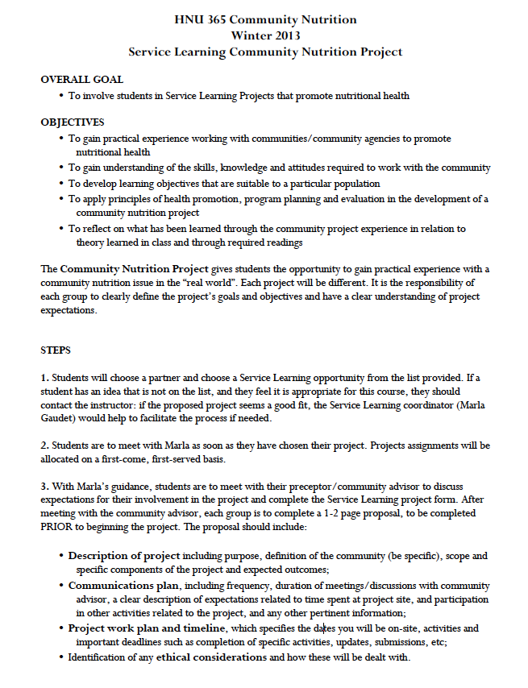
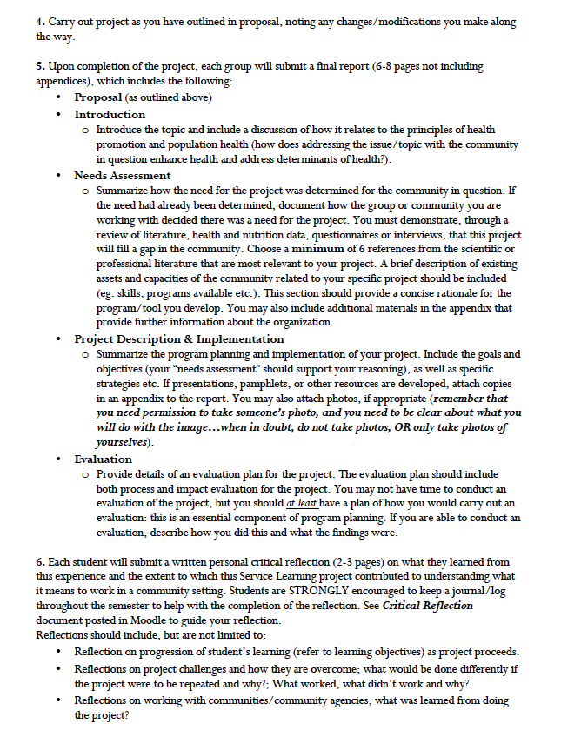
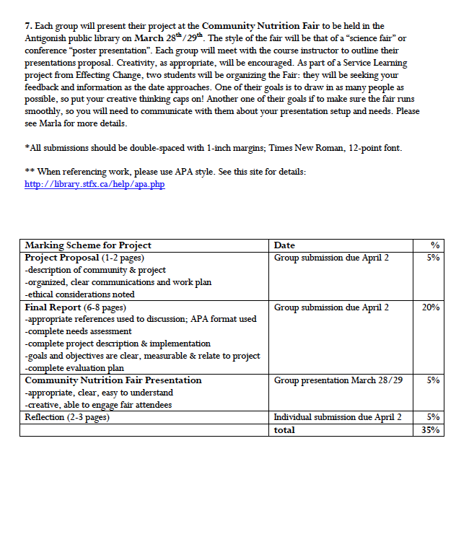

Appendix D:

HNU 351 Nutritional Assessment

Course Outline – Fall 2012

Professor: Jen Jamieson, PhD
Telephone: 867-5568
Email: jjamieso@stfx.ca
Office: JBB 434
Office hours: Tues 2:15-4:15; Thur 2:15-4:15
Course website: http://moodle.stfx.ca
Class times: Mon. 8:15-9:05; Tues. 10:15–11:05; Thurs. 9:15-10:05

Course Content
This course addresses the principles and methods in nutritional assessment of individuals and populations with consideration for variations in health status and stages across the lifespan. It provides the theoretical foundation for nutritional assessment in the nutritional care process and covers methods of nutritional assessment including dietary, anthropometric, biochemical, ecological and clinical evaluations for individuals as well as populations, with a focus on identifying the strengths, weaknesses, and valid use of the various methods. The development and appropriate use of the Dietary Reference Intakes is explored in depth. 3 credits.

Course Objectives

Students will:
1. Describe and understand the role of assessment in the nutrition care process.
2. Evaluate the strengths and limitations of methods of nutritional assessment used with individuals and populations, including dietary, laboratory, anthropometric, clinical methods, and ecological factors.
3. Demonstrate skills in assessing nutritional status including social, and dietary history, as well as anthropometric and biochemical indicators used in clinical dietetic, research and public health practice settings.
4. Describe systems for nutritional screening and assessment in clinical and public health settings.
5. Interpret nutrition assessment and nutrition screening data pertinent to cases in various practice settings and draw conclusions regarding nutritional status.
6. Demonstrate skills in searching, reviewing, interpreting, describing, and critically evaluating the current scientific literature used to develop the Dietary Reference Intakes.
7. Apply an understanding of nutrient metabolism to biochemical assessment of nutritional status and clinical presentation of deficiency or toxicity.
8. Develop confidence in discussing nutrition issues with peers and colleagues.

Method of Instruction

Lectures, in-class discussion, in-class, laboratory and on-line individual and group activities. All cell phones must be turned off and put away during class. Laptops are only to be used to refer to course material in class. You are encouraged to meet with your instructor during office hours to discuss course material and any concerns related to your engagement in learning during the course.

Required Texts/Resources
Nutrition Therapy & Pathophysiology. Marcia Nelms, Kathryn Sucher, & Sara Long. Thomson & Wadsworth. 2011.
A lab manual is required and can be purchased from the Main Office (JBB).

Recommended:
Gibson, R.S. (2005). Principles of Nutritional Assessment. 2nd edition. New York: Oxford University Press. This text is an excellent resource material for those pursuing dietetics careers or graduate school in the human nutrition field but is not a required text for HNU 351.

Reference Texts (on library reserve):
- Gibson, R.S. (2005). Principles of Nutritional Assessment. 2nd edition. New York: Oxford University Press. At least 2 copies of this text will be available on reserve.
- Lee, R.D. & Nieman, D.C. (2007). Nutritional Assessment 4th ed. New York: McGraw Hill.
- Otten, J.J., Hellwig, J.P.& Meyers, L.D. (2006). Dietary Reference Intakes: The Essential Guide to Nutrient Requirements. Washington, D.C.: National Academies Press. [Also available in Reference section]

The Dietary Reference Intake Reports are available in the Reference section of the library and free pdf versions are also available online from the Institute of Medicine.
You will be notified of any additional required and supplementary readings such as web reports and journal articles.

Course topics

MODULE 1: Week 1-2
Overview of nutritional assessment (Chapter 3)
The nutrition care process and the role of nutrition assessment in clinical and public health settings (Chapter 2)
Nutritional screening (Chapter 3)

MODULE 2: Week 2-5
Development and use of the Dietary Reference Intakes
Dietary assessment & nutrient analysis (Chapter 3)

MIDTERM EXAM: modules 1 and 2

MODULE 3: Week 6-7
Anthropometric assessment & body composition analyses (Chapter 3)
Development and use of the WHO Child Growth Standards

MODULE 4: Week 8-11
Laboratory and biochemical assessment: protein status and hematology; role of inflammation in nutritional assessment (Chapters 3, 9, 19)
Clinical examinations in nutritional assessment

MODULE 5: Week 12-13
Assessment of drug-nutrient interactions (Chapter 11)
Assessment of social and economic indicators of nutritional health

FINAL EXAM: modules 3 to 5

Laboratory Component
Students will participate in various 2-3 hour laboratory sessions over the semester. Lab sessions will address the following topics:
Lab 1: Dietary assessment – 3 day food record
Lab 2: Dietary assessment - Nutritional Screening, 24 h recall, & FFQ
Lab 3. Dietary assessment – Repeat 24 h recall
Lab 4: Population (group) dietary assessment
Lab 5: Anthropometric assessment
Lab 6: Biochemical & clinical assessment
Lab 7: Nutrition assessment case study & tutorial
From these lab sessions, four individual lab reports and one group presentation will be required.

Evaluation

Mid-Term Exam 25 % Monday October 15
Lab reports and presentation 40 %
Final Exam 35 % TBA

Academic Regulations:
NOTE: “Students are expected to attend all classes and laboratory periods. Following an absence of more than one class, students should contact each professor or instructor. In the case of sudden emergency requiring an absence of more than five days, students should contact the dean’s office. Faculty are required to report to the dean all unexplained absences in excess of three hours over at least two classes in any term.”
St. Francis Xavier University Academic Calendar 2011-2012, Section 3.7, p. 13.
NOTE: Please read the academic integrity policy outlined in
St. Francis Xavier University Academic Calendar 2011-2012, Section 3.8, p. 13-14 and on-line at http://library.stfx.ca/faculty/academic_integrity.php

Appendix E:
HNU 352 - Nutrition in Chronic Disease Prevention & Management

Course Outline - Fall 2012

Professor: Laura Reid, MEd,PDt.,CDE
Telephone: 867-5039
Office: JBB 247
Office Hours: Tues 2:30-3:30pm; Thurs 1:30-2pm; Friday 10:30-11am
Class Times: Tues 12:15-1:05; Thurs 11:15-12:05pm; Friday 1:15-2:05

Course Description

Nutritional care is the application of the science and the art of nutrition to the care of people. This course provides an overview of the role of nutrition in chronic disease prevention and management, how the nutrition care process relates to chronic disease prevention and management, and related roles for nutrition professionals in our current health system. Nutrition care principles will be applied while examining the epidemiology, pathophysiology, and role of nutrition in the prevention and management of chronic diseases prevalent within the Canadian population. Specifically, weight management, including obesity and disordered eating, metabolic syndrome, diabetes mellitus, and cardiovascular diseases will be addressed. In addition, this course will explore and provide applications of the nutrition care process including medical terminology, charting, nutrition counselling techniques, cultural competency, dietary planning/modifications, nutrition support, and ethics in nutrition practice.

HNU 352 is intended to increase the student's understanding of:

the broad social determinants influencing chronic disease development in Canada with an emphasis on health inequalities

diet and nutritional considerations in the etiology and management of chronic diseases that are major causes of mortality and morbidity among Canadians

nutritional interventions in the prevention and management of disease

the role of the dietitian/nutritionist in promoting healthy eating practices which assist in the management of diet-related conditions and in supporting the nutritional health of individuals

the dietitian/nutritionist as a vital member of an interdisciplinary collaborative health team

nutritional care within the context of the current and evolving health care system

Course Objectives
This course, through its lectures and assignments, will enable students to

Demonstrate an understanding of various factors which contribute to the development and management of chronic disease in Canada.

Develop an understanding of the range of interventions designed to prevent and manage chronic diseases prevalent among Canadians.

Demonstrate an understanding and use of medical terminology necessary for dietetic practice.

Apply nutritional assessment data including medical, social, and dietary history, as well as anthropometric, biochemical, and clinical indicators in the management of selected diet-related chronic diseases.

Discuss the rationale for dietary modifications in the management of selected diseases.

Apply the nutritional care process in meeting the needs of patients and clients in a range of health care settings.

Demonstrate an understanding of a client/patient-centered approach to nutritional prevention and management of chronic disease.

Demonstrate an understanding of evidence-based practice and ability to apply recommendations for dietary prevention and management of selected diseases.

Identify and apply approaches and strategies key to effective nutrition counselling.

Demonstrate an understanding of the role of nutrition support and its appropriate application.

Required Texts/Resources:
About Canada. Health and Illness. Dennis Raphael. Fernwood Publishing 2010.

Nutrition Therapy & Pathophysiology 2nd Edition. Marcia Nelms, Kathryn Sucher, Karen Lacey & Sara Long Roth. Wadsworth, Cengage Learning 2011.

Medical Terminology: A Short Course 6th Edition by Chabner, Davi-Ellen, Saunders Elsevier 2006.

You will be notified of additional required readings such as web reports and journal articles via the course website on Moodle.

Method of Instruction:
Lectures, class discussion and case studies.
Evaluation:
Term Assignments 15% Throughout term¹
Group Case Studies (10% each) 20% Oct 25 & Nov 16
Medical Terminology Quizzes 5% Throughout term via Moodle²
Midterm Quiz 25% Thursday Oct 18
Final Examination 35% TBA

1) Diabetes Meal Planning, Documenting Nutrition Care, Modified Diets. Due within one week of being assigned.
2) Medical terminology quizzes will consist of multiple choice questions based on the content of each assigned chapter. Quizzes will be opened on Monday of the week they are due and will close Friday of that week. The following schedule of quizzes will be followed: September 11th Chapter 1 Basic Word Structure; September 18th Chapter 2 Organization of the Body; September 25th Chapter 3 Suffixes; October 2nd Chapter 4 Prefixes; October 9th Chapter 5 Medical Specialists & Case Reports

Academic Regulations:

NOTE: “Students are expected to attend all classes and laboratory periods. Following an absence of more than one class, students should contact each professor or instructor. In the case of sudden emergency requiring an absence of more than five days, students should contact the dean’s office. Faculty are required to report to the dean all unexplained absences in excess of three hours over at least two classes in any term.”
St. Francis Xavier University Academic Calendar 2012-2013, Section 3.7, p.13

NOTE: Please read the academic integrity policy outlined in
St. Francis Xavier University Academic Calendar 2012-2013, Section 3.8, p. 13 and on-line at http://library.stfx.ca/faculty/academic_integrity.php

Appendix F
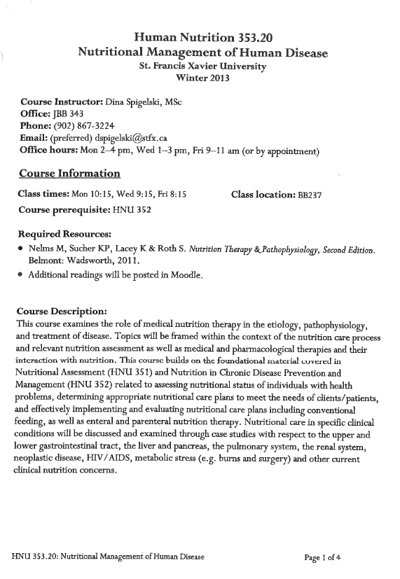
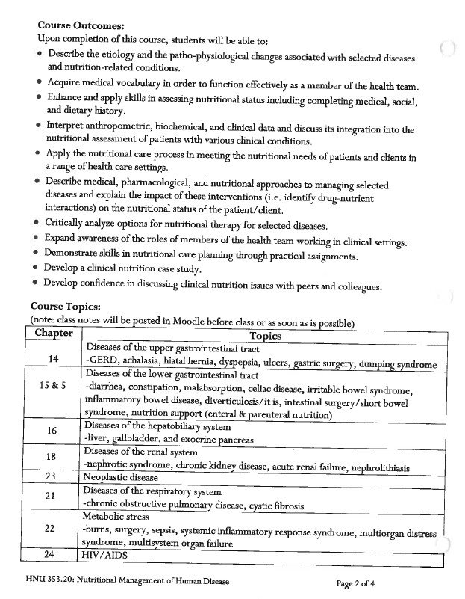
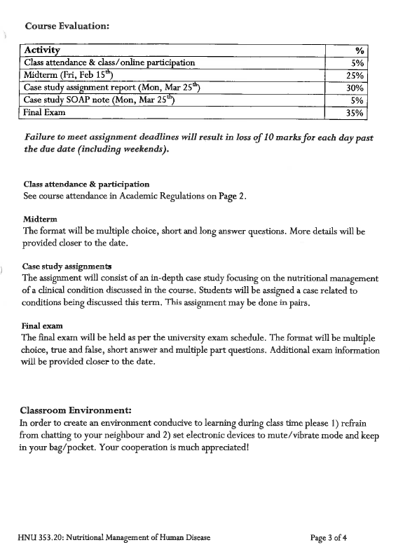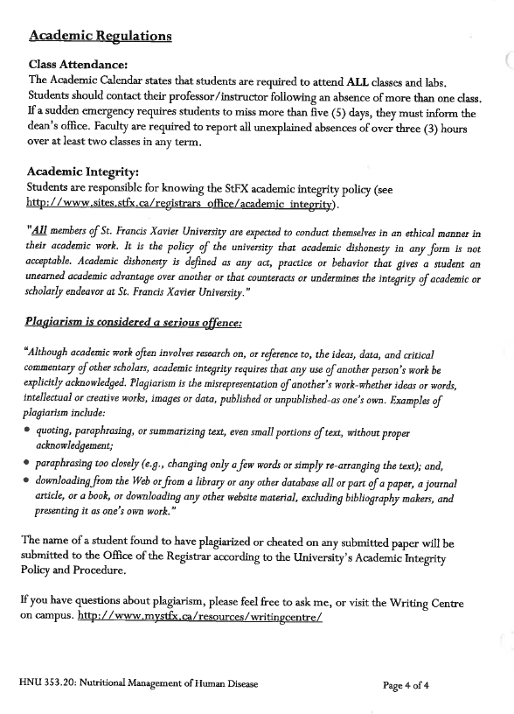

Appendix G

HNU 215.10: Nutrition for a Healthy Lifestyle
Saint Francis Xavier University
Fall 2012
Course Outline+

Course Instructor: Dina Spigelski, MSc
Office: 343 J. Bruce Brown Hall
Phone: (902) 867-3224
Email: (preferred) dspigelski@stfx.ca
Office hours: Mon 2–4 pm, Wed 1–3 pm, Fri 9:15–11:15 am (or by appointment)

Course Information
Class times: Mon 9:15, Wed 8:15, Thurs 10:15
Class location: BB 334

Course Prerequisites: none
Required Text:
McGuire & Beerman. NUTR. Belmont: Wadsworth, Cengage Learning, 2013.
Additional readings may be placed on reserve in the library or on Moodle

Course Description:
Designed for non-science students, this course introduces nutritional science and the role that nutrition, exercise, and other lifestyle behaviours play in the promotion of health. Topics will include the function of food and its components in maintaining and promoting health, healthy weights, disordered eating, nutrition in the prevention of disease, vegetarianism, food safety, and physical activity. Current nutrition issues and controversies will be discussed.
Course Outcomes:
Upon completion of course, students will:
- Understand how our body uses the foods we eat
- Identify and use reliable sources of nutrition information
- Develop critical thinking skills to analyze nutrition information in the public domain
- Learn how to plan a nutritious diet based on Eating Well with Canada’s Food Guide
- Compare personal dietary intake with Canadian guidelines
- Identify sources of key micro- & macro-nutrients and understand their roles in health
- Explain factors that influence body composition, energy balance, and the maintenance of healthy body weights

Course outline by week:

Week/Dates* | Chapter | Topic*
Week 1  Sept 5-6 | 1 | Introduction to health & nutrition
Week 2  Sept 10-13 | 2 | Planning a nutritious diet  Introduction to dietary analysis assignment
Week 3  Sept 17-20 | 2 | Label reading, food guides
Week 4  Sept 24-27 | 3  4 | What happens to the food we eat?  Carbohydrates
Week 5  Oct 1-4 | 5  6 | Protein  Lipids
Week 6  Oct 10-11 | 7 | Vitamins  Dietary analysis assignment part 1 due
Week 7  Oct 15-18 | 8 | Water & minerals  Midterm
Week 8  Oct 22-25 | 9 | Energy balance and body weight
Week 9  Oct 29-Nov 1 | 10 | Life cycle
Week 10  Nov 5-8 | 11  12 | Physical activity  Disordered eating
Week 11  Nov 12-15 | 13 | Alcohol  Dietary analysis assignment part 2 due
Week 12  Nov 19-22 | 14 | Food safety
Week 13  Nov 26-29 | 15 | International perspective: Food Security
*Subject to change depending on how quickly material is covered in class; we may spend more time on certain topics depending on class interest

Course Evaluation:
Activity | Date
Class participation/In-class activities | Throughout semester | 10%
Dietary analysis assignment | Part 1 (10%) Oct 10th  Part 2 (15%) Nov 15th | 25%
Mid-term exam | Oct 18th | 20%
Final Exam | TBA | 45%

Class attendance is required by university (see below).
The midterm and final exam may consist of multiple choice, true/false, fill in the blank, short/medium answer. More detail to be provided as the dates draw near. The final exam will be held as per published university exam schedule (time and location TBA).
Classroom Environment:
In order to create an environment conducive to learning during class time please 1) refrain from chatting to your neighbour and 2) set electronic devices to mute/vibrate mode. Your cooperation is much appreciated!
Academic Regulations
http://www.sites.stfx.ca/registrars_office/sites/sites.stfx.ca.registrars_office/files/Academic%20Calendar2012-2013_0.pdf
Class Attendance:
Section 3.7 from the 2012-2013 Academic Calendar states that students are required to attend ALL classes. Students should contact their professor/instructor following an absence of more than one class. If a sudden emergency requires students to miss more than five (5) days, they must inform the dean’s office. Faculty are required to report all unexplained absences of over three (3) hours over at least two classes in any term.

Academic Integrity:
Section 3.8 of the Academic Calendar states that “All members of St. Francis Xavier University are expected to conduct themselves in an ethical manner in their academic work. It is the policy of the university that academic dishonesty in any form is not acceptable. Academic dishonesty is defined as any act, practice or behavior that gives a student an unearned academic advantage over another or that counteracts or undermines the integrity of academic or scholarly endeavor at St. Francis Xavier University”.

Plagiarism is considered a SERIOUS offence:
“Although academic work often involves research on, or reference to, the ideas, data, and critical commentary of other scholars, academic integrity requires that any use of another person’s work be explicitly acknowledged. Plagiarism is the misrepresentation of another’s work-whether ideas or words, intellectual or creative works, images or data, published or unpublished-as one’s own.

The name of a student found to have plagiarized/cheated on a paper will be submitted to the Office of the Registrar according to the University’s Academic Integrity Policy & Procedure (http://www.sites.stfx.ca/registrars_office/academic_integrity).

Appendix H

HNU 261: Introduction to Nutrition
Course Syllabus
September 2012

Professor: Dr. Laurie A. Wadsworth
Department of Human Nutrition
Office: JBB 246
Phone: 867-2190
E-mail: lwadswor@stfx.ca
Web Page: http://moodle.stfx.ca/logon/index.php

Course content
This course will introduce the study of nutrients found in foods and how the body handles them including ingestion, digestion, absorption, transport, metabolism, interactions, storage and excretion. Also included will be the study of the environment and of human behaviour as it relates to food choice. In this course, students will develop an understanding of the fundamentals of the science of nutrition with an emphasis on energy nutrients, vitamins and minerals required by humans. The functions of these nutrients, their food sources and how the body handles them will be discussed. Students will learn how to apply tools for dietary guidance to meet the Dietary Reference Intakes.

Course Goal
This course aims to provide a solid foundation in basic nutrition for students who require an understanding of human nutrition as background to their professional practice. Because nutritional care can be viewed as both a science and an art, health care providers need to know not only how the body uses nutrients but also why people eat the foods they do. Students are expected to apply critical thinking skills when analyzing challenging nutrition issues related to promoting and maintaining the health of individuals and populations.

Intended Learning Outcomes
After successfully completing this course you will be able to:
- Recognize nutrition as a specific discipline and understand its relationship to other sciences
- Describe Canada’s Food Guide, its relationship to the Dietary Reference Intakes (DRIs) and how to use it for planning nutritious diets
- Describe the chemical composition, biological function, dietary sources and risks of over- and under-consumption of carbohydrates, lipids, proteins, vitamins, and minerals
- Explain how food moves from the mouth to the cells by the processes of digestion, absorption, transportation and metabolism
- Complete calculations needed to determine energy provided by the carbohydrate, protein and fat components of foods
- Describe the role of nutrition in the prevention of disease and the promotion and maintenance of health
- Become aware of current nutrition issues in the popular media.
- Develop skills necessary to critically analyze the complex food and nutrition issues facing contemporary society

Method of Instruction
Lectures, assignments, as well as class and on-line discussions and activities will provide opportunities for students to develop knowledge and skills in normal nutrition.

Prerequisites
CHEM 100 or 150, BIOL 111 or 105.

Required Texts/Resources:
Whitney, E, Rolfes, S. R., Hammond, G., & Piche, L.A. (2013). Understanding Nutrition. First Canadian ed. Toronto, ON: Nelson Education Ltd.

Evaluation
Classroom & on-line activities 15% Throughout term
Midterm 1 15% Friday October 19
Paper Assignments (3) 15% Throughout term
Midterm 2 15% Thursday November 15
Final Exam 40% TBA

Assignments
Classroom & Online Activities (15% of final grade)
These activities will involve class and small group discussions during class time and small online quizzes conducted on the course Moodle page. They will assist with the practice and application of major concepts from the course.

Paper Assignments
These will be short tasks that will be assigned in class with due dates within one week. Assignments will explore aspects of the course material and are designed to assist with understanding major concepts. There will be three or four of these throughout the term.
Any references to the work of others used to complete these assignments should use the citation and reference list format system of APA (version 6). Please use the tables provided in this syllabus for guidance (see p. 7-9). A complete manual is housed in the Student Resource room (JBB 243) for use in the room only.

NOTE: Late assignments will be penalized 10 marks per day including weekends and holidays.
Midterm Exams (2 x 15% of final grade)
There will be two midterm exams during the term. These will be held in class on October 19, 2012 and November 15, 2012. These will consist of multiple choice questions with a few short answer questions.
Final Exam (40% of final grade)
This will be held as per exam schedule. The exam will consist of multiple choice questions with a few short answer questions.

Academic Regulations
See Sections 3.7 and 3.8 of 2011-2012 Academic Calendar
Class Attendance
NOTE: “Students are expected to attend all classes and laboratory periods. Following an absence of more than one class, students should contact each professor or instructor. In the case of a sudden emergency requiring an absence of more than five days, students should contact the dean’s office. Faculty are required to report to the dean all unexplained absences in excess of three hours over at least two classes in any term.”
St. Francis Xavier University Academic Calendar 2012-2013, Section 3.7, p. 13.
Academic Integrity
One focus of this course is to enable you to become more aware of the values and beliefs which guide the nutrition profession as well as your future actions. Although you will have many opportunities to work in groups and to share your thoughts and ideas with others, the learning process is best facilitated when your own words, and your own work is submitted. PLAGIARISM IS A FORM OF CHEATING AND IS CONSIDERED A SERIOUS OFFENCE. (adapted from Riley, B. (2007). IDS 305 Course Outline)
NOTE: Academic Integrity Policy:
“All members of St. Francis Xavier University are expected to conduct themselves in an ethical manner in their academic work. It is the policy of the university that academic dishonesty in any form is not acceptable. Academic dishonesty is defined as any act, practice or behaviour that gives a student an uneared academic advantage of another or that counteracts or undermines the integrity of academic or scholarly endeavor at St. Francis Xavier University.” St. Francis Xavier University Academic Calendar 2012-2013, Section 3.8, p. 13.
“Plagiarism is the misrepresentation of another’s work-whether ideas or words, intellectual or creative works, images or data, published or unpublished-as one’s own. Examples of plagiarism include:
i) quoting, paraphrasing, or summarizing text, even small portions of text, without proper acknowledgement;
ii) paraphrasing too closely (e.g., changing only a few words or simply re-arranging the text); and,
iii) downloading from the Web or from a library or any other database all or part of a paper, a journal article, or a book, or downloading any other website material, excluding bibliography makers, and presenting it as one’s own work.”
St. Francis Xavier University Academic Calendar 2012-2013, Section 3.8.2, p. 13.
Any submitted work found to have been plagiarized will be dealt with according to the University’s Academic Integrity Policy and Procedure, which can be found online at: http://www.stfx.ca/services/registrar/academic-integrity-document.pdf The library website also provides further details at http://library.stfx.ca/faculty/academic_integrity.php
Equitable Learning Environment
Learning is best facilitated in a respectful, safe and equitable learning environment free from discrimination and harassment. I invite you to work with me to create a classroom space – both real and virtual – that fosters and promotes values of human dignity, equity, non-discrimination and respect for diversity. These values and practices are in accord with the St. FX Discrimination and Harassment Policy which can be found at http://www.mystfx.ca/campus/stu-serv/equity/ .
Please feel free to discuss with me any questions or concerns you have about equity in our classroom. If I cannot adequately address your concerns, I encourage you to talk to the Chair of the Human Nutrition Department or the Human Rights and Equity Advisor, Marie Brunelle (mbrunell@stfx.ca).

Tentative Course Content
Course topics may move based on the needs of the class.
Topics | Chapter in Text
Introduction to human nutrition  Classification of nutrients  Why we eat  Dietary Reference Intakes  Connecting diet and health  Nutrition and dietary assessment | 1. An Overview of Nutrition
Defining healthy eating  Food guidance systems  Planning a healthy eating pattern  Label reading | 2. Planning a Healthy Diet
How the body uses food | 3. Digestion, Absorption, & Transport
Carbohydrates: Digestion, absorption, food sources  Health Effects of sugars and fibres  Alternative sweeteners  Low carb diets | 4. The Carbohydrates: Sugars, Starches & Fibres
Lipids: Digestion, absorption, food sources  Health Effects and Recommended Intakes | 5. The Lipids: Triglycerides, Phospholipids, and Sterols
Proteins: Digestion, absorption, food sources  Health Effects and Recommended Intakes | 6. Protein: Amino Acids
B-vitamins  Minerals for energy metabolism | 10. Nutrients for Energy Metabolism
Nutrients in fluid balance | Water and the Electrolytes
Nutrients as antioxidants  Phytochemicals | The Antioxidant Nutrients  Highlight 14, p. 460
Nutrients key to bone health | Nutrients for Bone Health
Roles of minerals in blood health  Trace minerals | Nutrients for Blood Health

Appendix I

HNU 262 Principles of Nutrition in Human Metabolism

Course Outline – Winter 2013

Professor: Jen Jamieson, PhD
Telephone: 867-5568
Email: jjamieso@stfx.ca
Office: JBB 434
Office hours: Mon 2:15-4:15; Tues 11:15-12:15; Wed 1:45-2:45 or by appointment
Course website: http://moodle.stfx.ca
Class times: Mon 11:15-12:05; Tues 1:15–2:05; Thurs 12:15-1:0

Course Content

In this course, students will apply the fundamentals of the science of nutrition with an emphasis on the nutrients, their functions, metabolism and their dietary sources (as covered in HNU 261) while drawing on foundational knowledge in anatomy, physiology, and chemistry. Nutritional concerns pertaining to the stages across the life course will be discussed within the framework of nutrition in the promotion of health and the prevention of chronic diseases. Topics will include energy metabolism, energy balance, weight control, and the emerging role of nutrigenomics in the field of nutrition. Upon completion of HNU 261 and 262, students will be eligible to take upper level HNU electives. 3 credits.

Course Objectives

Students will:
1. Become aware of the emerging role of nutrigenetics and nutrigenomics in the field of nutrition.
2. Explain how dietary macronutrients (i.e., carbohydrates, lipids, protein) are used for cellular energy production.
3. Evaluate the internal (metabolic disturbances, genetics) and external (food price/availability/advertising, physical inactivity) factors that influence body composition, energy balance, and maintenance of healthy body weights.
4. Discuss factors that influence nutritional health across the life course from preconception, through pregnancy, infancy, childhood, adolescence, adulthood and the senior years.
5. Strengthen skills in accessing, understanding, critically evaluating and applying academic literature relevant to current human nutrition issues.
6. Evaluate critically and discuss the credibility and value of nutrition messages directed to Canadian consumers.
7. Describe and demonstrate the appropriate use of Dietary Reference Intakes and Canada’s Food Guide in assessing dietary adequacy and promoting healthy eating practices for various life stages.

Method of Instruction
Lectures, in-class and online discussion, individual and group activities and assignments will provide opportunities for students to develop nutrition-related knowledge and skills.

Class Environment
Laptop use in class is not encouraged as this can be disruptive to other students. Laptops may only be used in the first three rows of the classroom and must only be used to refer to course material in class. Lecture notes will be available in pdf form but will not contain sufficient material to study on their own. Students are strongly encouraged to take notes during class to complement the textbook and powerpoint material. Please note that PDF slides may still be printed with multiple sheets per page to save on printing costs. All cell phones must be turned off and put away during class. You are encouraged to meet with your instructor during office hours or by appointment to discuss course material and any concerns related to your engagement in learning during the course.

Prerequisites
HNU 261; BIOL 251, 252, completed or concurrent; CHEM 225, 255, completed or concurrent.
Required Texts/Resources
Understanding Nutrition First Canadian Edition. Whitney, Rolfes, et al. Nelson. 2013.

Reference Text (on library reserve):
Nutrition Therapy & Pathophysiology. Chapter 10: Nutritional Genomics. Nelms, Sucher, et al. Thomson & Wadsworth. 2011.
You will be notified of any additional required and supplementary readings such as web reports and journal articles through the course moodle page.

Course topics

MODULE 1: Nutritional Genomics………………………………….Chapter 10 (on reserve)

MODULE 2: Energy
Energy metabolism…………………………………………………….Chapter 7
Energy balance and body composition……………………………….Chapter 8
Weight management: overweight, obesity and underweight…………Chapter 9

MIDTERM EXAM: modules 1 and 2…………………………………February 14

MODULE 3: Lifecycle Nutrition
Life cycle nutrition: Pregnancy and lactation……………………..........Chapter 16
Life cycle nutrition: Infancy, childhood, and adolescence…………….Chapter 17
Life cycle nutrition: Adulthood and the later years…………………....Chapter 18

Evaluation

Online participation (3 moodle posts) 6 %
Mid-term exam 30% Thursday Feb 14
Food record assignment 24 %
Final exam 40 % To be announced

Academic Regulations:
NOTE: “Students are expected to attend all classes and laboratory periods. Following an absence of more than one class, students should contact each professor or instructor. In the case of sudden emergency requiring an absence of more than five days, students should contact the dean’s office. Faculty are required to report to the dean all unexplained absences in excess of three hours over at least two classes in any term.”
St. Francis Xavier University Academic Calendar 2012-2013, Section 3.7, p. 13.

NOTE: Please read the academic integrity policy outlined in
St. Francis Xavier University Academic Calendar 2012-2013, Section 3.8, p. 13-14 and online at http://library.stfx.ca/faculty/academic_integrity.php

Appendix J

Human Nutrition 461

Nutrition in Metabolic Disease

Proposed Course Outline: Winter 2014
Professor: | Dr. Jen Jamieson | Office: | JBB 434
Telephone: | 867-5568 | E-mail: | jjamieso@stfx.ca
Course Room: | TBA | Webpage: | moodle.stfx.ca

Course Description
This course examines the etiology and patho-physiology of nutrition-related metabolic diseases, with a focus on the evidence leading to clinical practice guidelines for these disorders. Topics will include rheumatic disorders, skeletal/muscular disease and selected inherited metabolic diseases in macronutrient and micronutrient metabolism. Prerequisite: HNU 353. Three credits.
Course Outcomes
Upon completion of this course, students will be able to:
- Describe the etiology and patho-physiology of selected nutrition-related metabolic diseases.
- Describe the clinical practice recommendations for select metabolic diseases.
- Enhance and apply skills in critically evaluating scientific literature and research design
- Demonstrate skills in evaluating the quality of evidence used to form clinical practice guidelines.
- Identify knowledge gaps in clinical practice guidelines relevant to nutrition.
- Develop an appreciation for the relationship between research and practice.
- Enhance skills in self-directed learning, leadership and teamwork.

Course Resources on Library Reserve
Hoffmann GF, Zschocke J, Nyhan WL (Eds). 2010. Inherited Metabolic Diseases. Springer-Verlag, Berlin Heidelberg.
Ross AC, Caballero B, Cousins RJ, Tucker KL, Ziegler TR. 2014. Modern Nutrition in Health and Disease, 11th Edition. Lippincott Williams & Wilkins, Baltimore MD
Saudubray JM, Berghe GVD, Walter JH (Eds). 2012. Inborn Metabolic Diseases, 5th Edition.. Springer-Verlag, Berlin Heidelberg.

Evaluation
Midterm exam 25 %
Group Project
Proposal 5% Worksheets 10 %
Paper 15 %
Presentation 10 %
Peer and faculty evaluation 10 %
Final exam 25 %

Major project: Students will work in small groups to critically evaluate the quality of evidence used to form nutrition-related clinical practice recommendations for a selected metabolic disease. It is expected that students will work together on the problems to identify what they already know and then identify the learning issues (questions) that need to be explored to understand the scientific evidence and implications for practice. Problem-based worksheets will be used throughout the term, with group members participating in various roles (discussion leader, scribe, reporter, accuracy coach, skeptic and encourager). Groups will prepare a final paper and presentation on their topic for the end of term. Class discussion and questions will be encouraged and expected.

Appendix K

Advising Guide

Human Nutrition Program of Study 2013-14
Normal Course Sequence for B.Sc. in HNU Major
Fall Term Winter Term
Year 1
_BIOL 111: Introductory Cell Biology _HNU 145: Introduction to Foods
_CHEM 100: General Chemistry ………………………………………………………………………………..
_HNU 161: Food & Nutrition for Health in Society _HNU 235: Communications
_6 credits humanities electives………………………………………………………………………………….
_6 credits social sciences electives…………………………………………………………………………….

Year 2
_BIOL 251: Human Anatomy & Physiology I _BIOL 252: Human Anatomy & Physiology II
_CHEM 225 Organic Chemistry _CHEM 255: Introductory Biochemistry
_HNU 146: Introduction to Food Science _BIOL 215: Microbiology In Human Nutrition
_HNU 261: Introduction to Nutrition _HNU 262: Principles of Nutrition in Human Metabolism
_STAT 201 Elementary Statistics _BSAD 261: Organizational Behaviour

Year 3
_HNU 351: Nutritional Assessment _HNU 365: Community Nutrition
_HNU 352: Nutrition in Chronic Disease
Prevention & Management _HNU 353: Nutritional Management of Human Disease
_HNU 385: Research Methods _HNU elective
_HNU elective _Open elective
_6 credits humanities or social sciences electives for pair……………
Note: Before applying to the IDI program, students must have completed the required courses including HNU 356 as a HNU elective.

Year 4
_HNU 405: Food Availability _ HNU 475: Effecting Change
_HNU elective _ HNU elective
_HNU elective _ HNU elective
_Open elective _Open elective
_Open elective _Open elective
Note: HNU 456 (HNU elective), required for all graduate internship applicants and IDI interns, is normally taken in 4th year.

The normal sequence for the B.Sc. in HNU with Advanced Major is identical to B.Sc. in HNU Major with the addition of HNU 491: Advanced Major and Honours Seminar in year 4. The B.Sc. in HNU with Honours requires HNU 491, HNU 493 (a 3-credit thesis course ) and 12 of the 21 HNU elective credits at the 400 level.

Year 4 (Honours)
_HNU 405: Food Availability _HNU 475: Effecting Change
_HNU 493/491 _HNU elective
_HNU elective _HNU elective
_Open elective _Open elective
_Open elective _Open elective

List of Current HNU Electives

HNU 356 Introduction to Food Service & Quantity Food Production
HNU 363 Sport Nutrition
HNU 366 Maternal and Child Nutrition
HNU 425 Nutrition in Aging
HNU 445 Advanced Food Study
HNU 456 Food Service System Management
HNU 461 Nutrition in Metabolic Disease
HNU 467 Advanced Nutrition
HNU 471 Entrepreneurial Practices for Nutrition Professionals
HNU 486 Qualitative Research Methods
HNU 499 Directed Study (only in exceptional circumstances)

Note:
The normal sequence for meeting requirements for application to Dietitians of Canada (DC) approved internship programs (either the StFX Integrated Dietetic Internship (IDI) program or a Graduate internship program) is identical to B.Sc. in HNU Major, with the addition of HNU 356 in year 3 and HNU 456 in year 4.

Your faculty advisor is: _______________________________

Appendix L
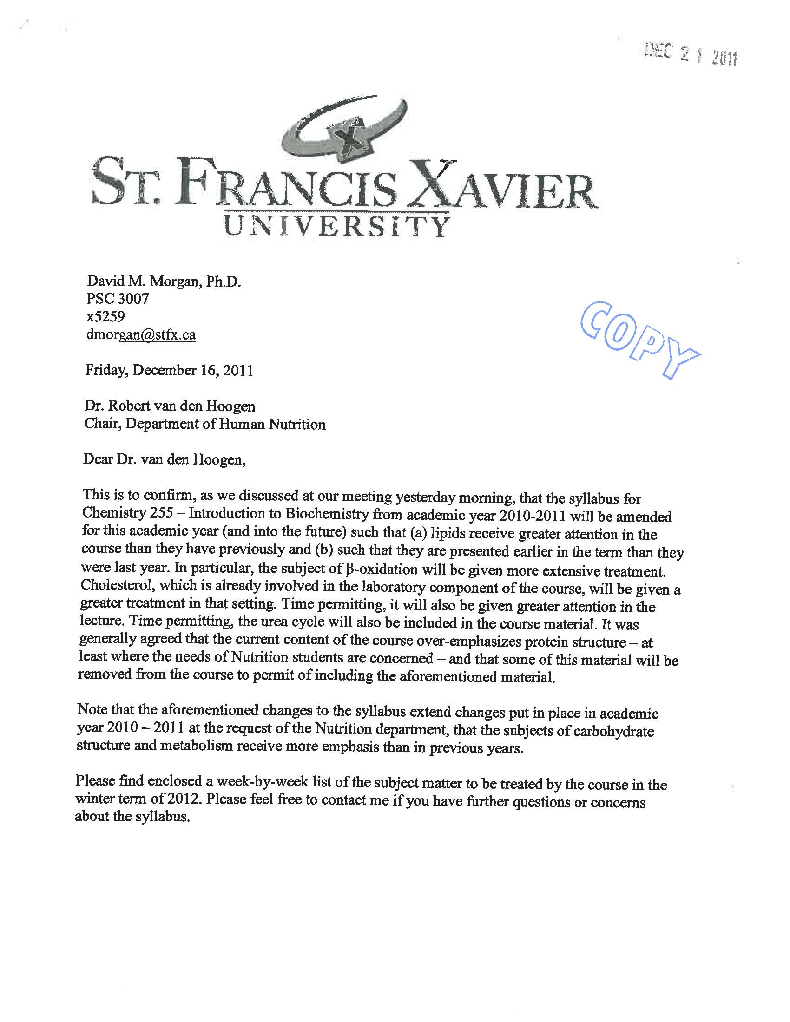
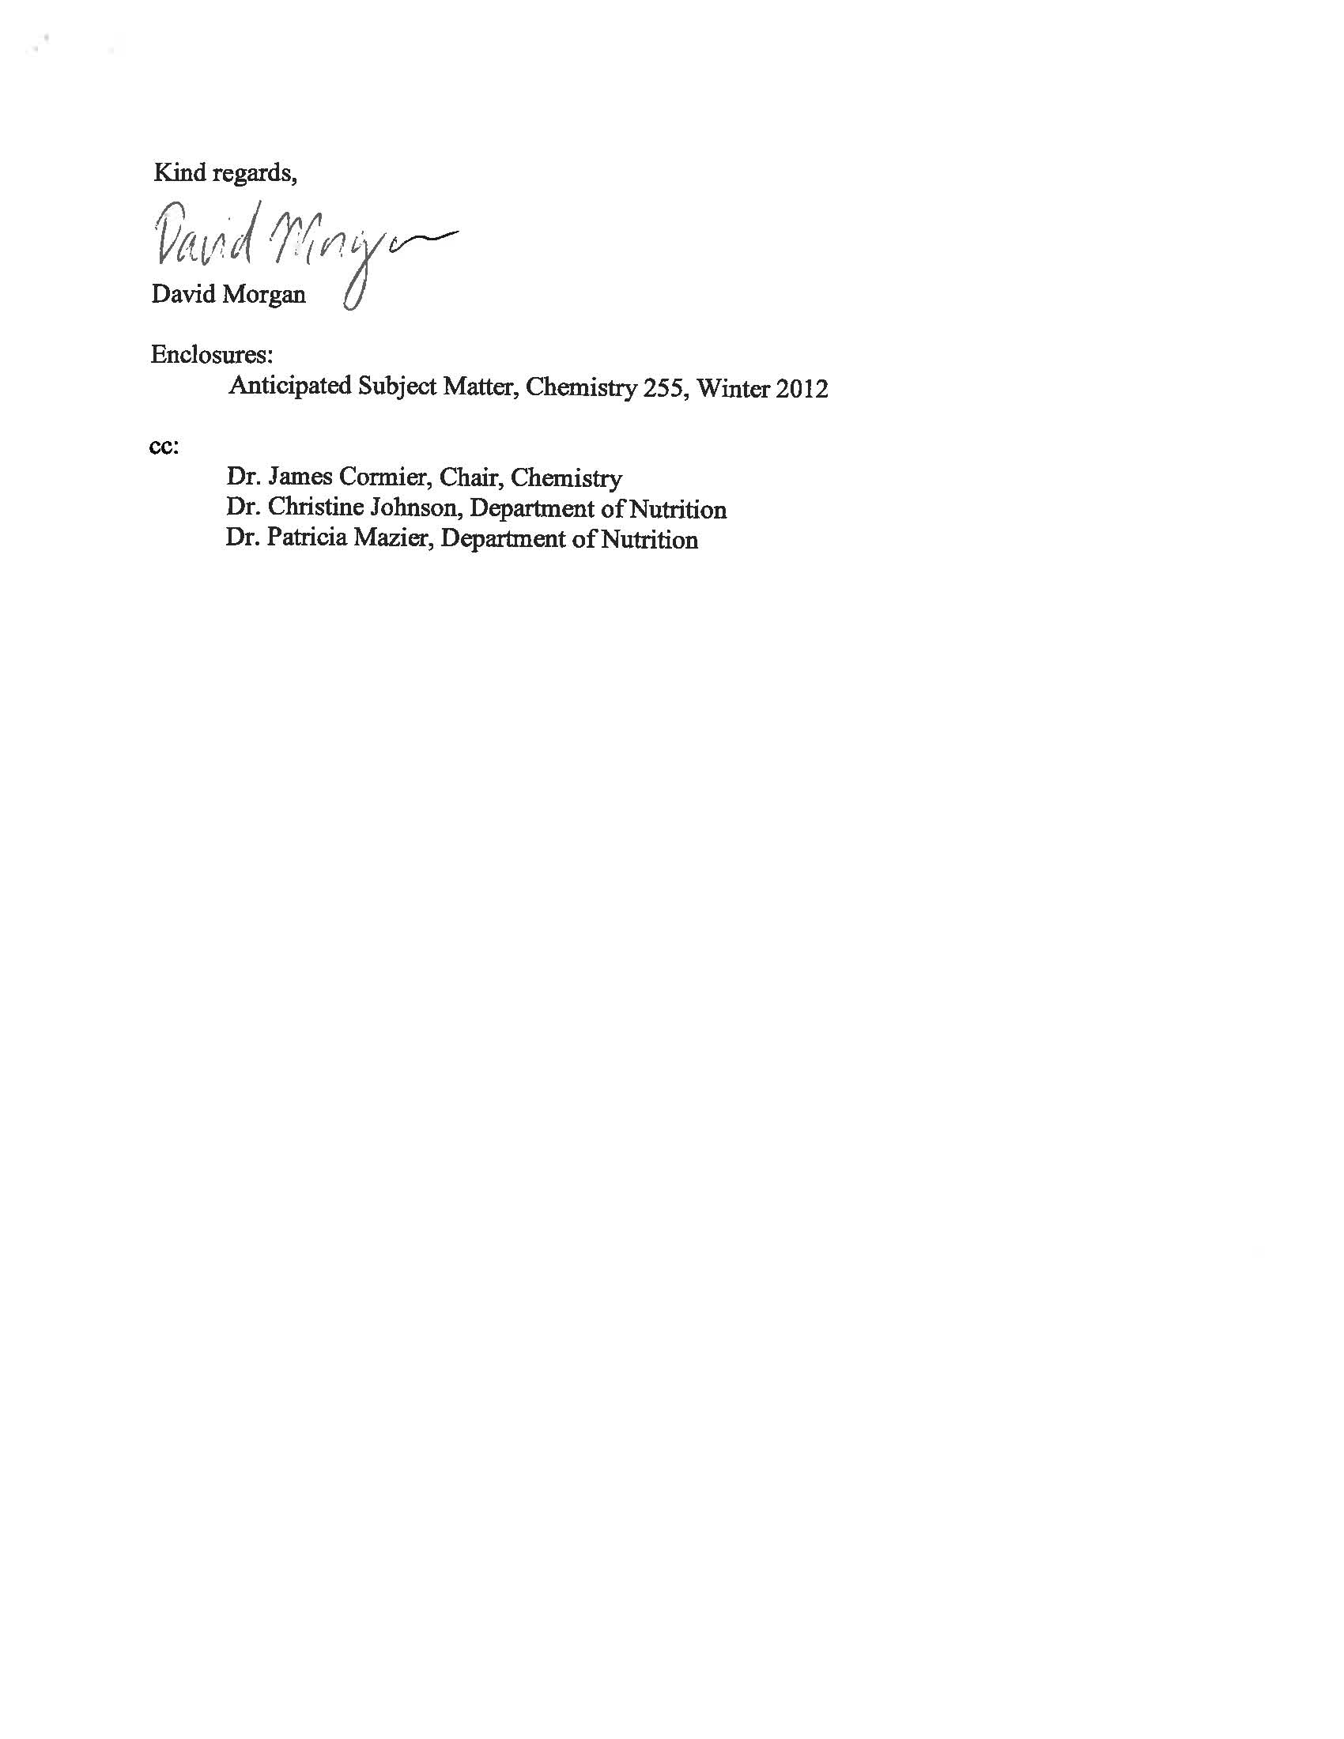

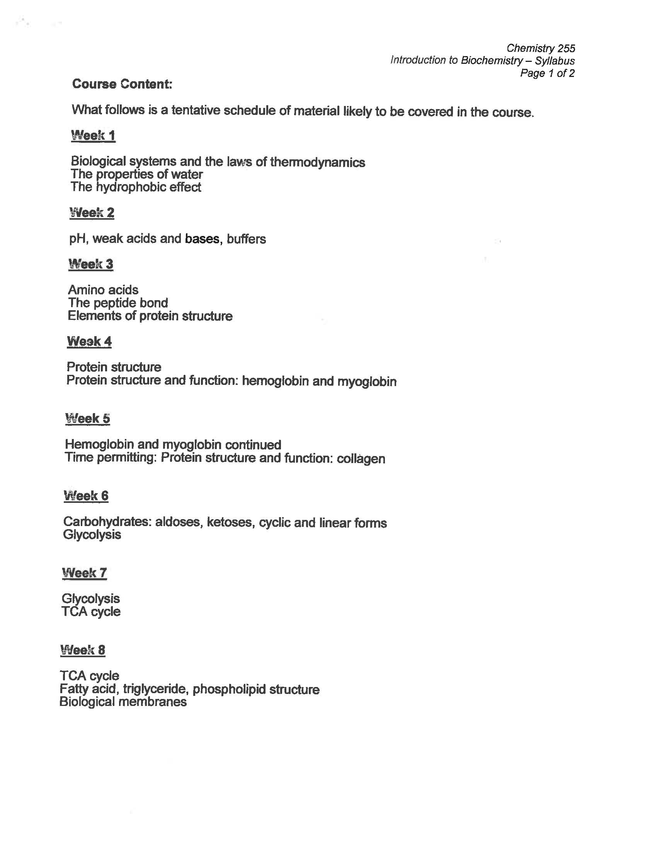

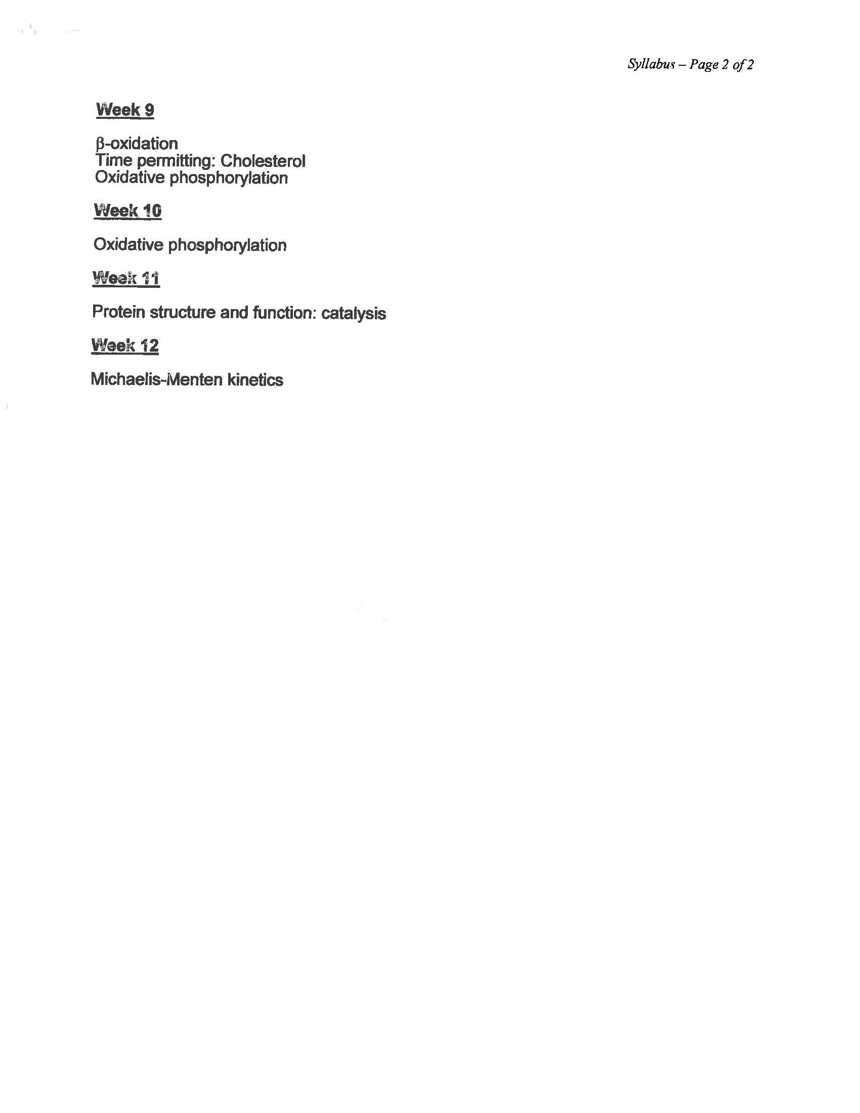

Appendix M

Biology 215 : Microbiology for Human Nutrition

January 2013
Course Text:
Bauman, Robert W. (2011). Microbiology: with diseases by taxonomy,
(3rd edition). San Francisco: Pearson/Benjamin Cummings.

Course Syllabus:
1) Basic immunological concepts: body defense systems (phagocytosis,
antibody/antigens, T cells, B cells, immunological memory, vaccines, food
allergies).
2) Bacterial structure and function (including microscopy and staining, microbial
identification techniques).
3) Enzymes & energy (enzyme inhibition & denaturation, respiration and
fermentation, fermented food products).
4) Microbial nutrition and growth (topics covered include: temperature, pH,
oxygen concentrations, salinity and its influence on food storage and
spoilage).
5) Microbial genetics (gene transfer systems and the emergence and transfer
of antibiotic resistance).
6) Biotechnology and recombinant DNA technology (implication of recombinant
DNA technology on the production of food supplements and on the
identification of microbial contamination).
7) Control of microbial growth (chemical and physical agents used to control
microbial numbers; its implications of food hygiene, food storage and food
preservation).
8) Antibiotics and chemotherapy (mode of action of antibiotics, emergence of
and issues related to minimizing of antibiotic resistance organisms).
9) Viruses (viral structure, mode of infection, HIV, food-related viral
infections & transmissions).
10) Epidemiology (principles of epidemiology & relevance to food-related
infections)

Laboratory Exercises:
1. Basic microbiological techniques
2. Colony & cell morphology (microscopy/simple stain – yeast & bacteria)
3. Differential stains (Gram stain / demonstration of capsules & flagella) &
Biochemical analysis (demonstration)
4. Environmental effects on growth (temperature / sucrose / pH –
demonstration / nutritional factors)
5. Enumeration of microbial cells (yeast – life & dead / direct count / viable
plate counts – demonstration)
6. Inhibition of microbial growth (antibiotics – demonstration / UV exposure /
discs impregnated with household chemicals)

Tutorials/Seminars:
Four tutorial/seminar topics will be focused to food-related issues:
Food allergies
Case studies on Eschericia coli 015:H7 infection outbreaks
Food irradiation
Food storage & spoilage
Class will be divided into 4 groups – each group will present a seminar on one of
the 4 topics. The group will also submit one paper (2-3 thousand words) of the
seminar topic. The group mark will be based on the seminar presentation and
the paper.

Evaluation:
1) Midterm - 25%
(Multiple Choice & Short Answer Questions)
2) One paper - 15%
3) Seminar – 10%
3) Lab – 10%
3) Essay Exam - 10%
4) Final Exam – 30%
(Multiple Choice & Short Answer Questions)

Essay Topic- 15%
Write an essay (between 1100 and 1300 words):
“The use of biocompetitiive agents to control aflatoxin production in food crops”
The essay will be marked on content and presentation. Avoid use of first person or personal
accounts in science papers. Avoid using quotes. Quotes should not be used to replace
explaining the material in your own words. Include a bibliography (at least one of which
should be print-based reference, which means, not a website). The essay must be typed
(use size 12 print, Comic Sans preferred), double-spaced and formatted in APA style.
Leave a one-inch margin all around. Make sure you proofread for errors and grammar. Make
sure you keep a copy (digital and paper) of the essay in case the submitted copy is lost or
mislaid. See website for hints.
Your essay should include the following:
a) What are aflatoxins (brief introduction);
b) Detail one example of a biocompetitive agent used (or tested) to control
aflatoxin production in a food crop (this should be the body of your essay);
c) Concluding section (brief).

Due date: Submit Essay (Wed, Mar 13 2013, 8.15 am). (Late submissions: 10%
penalty/day).

Biol 215: Microbilogy for Human Nutrition
(January-April 2013)

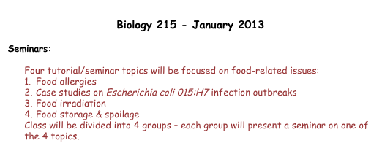
Group presentations
A1 (Food Allergies)
B1 (Food Allergies)

A2 (Escherichia coli infection outbreaks)
B2 (Escherichia coli infection outbreaks)

A3 (Food Irradiation)
B3 (Food Irradiation)

A4 (Food Storage & Spoilage)
B4 (Food Storage & Spoilage)

Biology 215 Laboratory Outline 2013

Laboratory Instructor : Leslie Buckland-Nicks
Office: Room # 331 JBBH
Phone: 867-3957; email lbucklan@stfx.ca

Office Hours: Please contact me by email for an appointment. I will also be available
every second Friday before lab (9 Am to 10 Am) or after lab (4:15 to 5:15) in the
laboratory or my office.

Laboratory Demonstrator: Katelyn MacNeil

Laboratory Evaluation
The laboratory component of Biology 215 is worth 15% of your total mark.
Pre-lab Quizzes (5) 2% each 10%
Hand-ins (2) 5%
Total Lab Value 15%

Pre-lab Quizzes
The 10 minute quizzes are given at the start of labs 2 to 6. They will be based on the
material covered in last week's lab (including demonstration material) and the
material that you have read for the current week's lab. There will be no makeup
quizzes if you miss a lab or are late. Look up the Laboratory section of the Biology
215 Moodle site for the current laboratory. There will be key words and topics listed
to help you focus on the most important sections of the laboratory!

Hand-ins
During the final lab, Laboratory 6, you will be required to hand in two of the
exercises completed during the term. One will be from Laboratory 4, Microbial
Physiology, the other will be from any of the other labs. It is important, therefore,
to complete all exercises throughout the course, and answer all assigned
questions as you must be prepared to hand in any two of these during the final
lab.

Note that there is no laboratory exam for this course

Appendix N
HNU 161: Food and Nutrition for Health in Society
Course Outline
2012 Fall Term

Professor: Doris Gillis, PhD, PDt. Office: JBB 207
Telephone: 867-5401 E-mail: dgillis@stfx.ca
Prof home page: http://sites.stfx.ca/human_nutrition/Doris_Gillis
Office Hours: Mon 10:15 am-12:05 pm; Wed 9:15 am-12:05 pm;
Thurs 11:15 am-12:05 pm

Class Times: Mon. 2:15 pm-3:30p m; Wed. 2:15 pm-3:30 pm
Class Room: J Bruce Brown 237
Course Website: https://moodle.stfx.ca/login/index.php

Course Description
Designed as a foundation course, this course examines the evolving role of food and nutrition in society from historical and contemporary perspectives. Students will be introduced to local, national and global influences on societal food consumption trends and factors influencing individual food choice and behaviour. The impact of socio-economic factors and culture, such as customs and worldviews, on food selection and dietary practices will be explored in depth. An introduction to the history and philosophy of the nutrition profession and emerging issues in human nutrition will be integrated throughout the course.

Course Learning Objectives
Students will be able to
- Describe how the human diet has evolved and compare it to contemporary dietary patterns.
- Discuss the interaction of people with their environment to obtain food in industrialized and non-industrialized societies, including food production, distribution and consumption.
- Explain basic principles of human nutrition and planning for a healthy diet.
- Explain the interactive and complex set of factors influencing food availability and consumption and relevance to the nutritional status of individuals and population groups.
- Describe the complex array of socio-cultural factors, which influence food choice behaviour among various population groups in Canada and internationally.
- Examine contemporary nutrition issues in Canadian society which demonstrate the complex set of factors and conditions linking food and health.
- Demonstrate an understanding of key concepts and issues in global and domestic food security.
- Develop an understanding of how behavioural and societal change relates to food and nutrition practice.
- Develop an awareness of the field of human nutrition, potential career paths, and the relevance of the human nutrition program to career options.
- Become aware of how the varied community contexts in which people engage with food for health and wellness.
- Develop skills in critically analyzing the academic literature and public media and reflecting on current practices and personal experiences relevant to food and nutrition.

Required Text
Bryant, C.A., DeWalt, K.M., Courtney, A., Schwartz, J. (2004). The Cultural Feast: An introduction to food and society. 2nd ed. Brooks Cole.

Reference Texts (available in the library)
Kittler, Sucher & Nelms. (2010). Food and culture. 6th ed. Wadsworth Cengage. (Library reserve desk)
Rolfes, Pinna, Whitney (2012). Understanding normal and clinical nutrition. 9th ed. Wadsworth Cengage. (Library reserve desk)
Katz, S (ed) (2003). Encyclopedia of Food and Culture. Library Reference Section: GT2850 E53 2003.

Evaluation
Midterm Quiz 15 % Oct 17
Assignment on culture and food 15 % Nov 12
Service Learning critical reflection report 15 % Nov 21
In-class & on-line assignments and discussion 15 %
Final Exam 40% TBA
Late assignments will be penalized by 10% per day past the due date.

Method of Instruction
Lectures, invited speakers, in-class discussion, in-class and on-line individual and group activities. All cell phones must be turned off during class. Laptops are only to be used in class to refer to class material. You are encouraged to meet with your instructor during office hours to discuss course material and any concerns related to your engagement in learning during the course.

Academic Regulations
NOTE: “Students are expected to attend all classes and laboratory periods. Following an absence of more than one class, students should contact each professor or instructor. In the case of sudden emergency requiring an absence of more than five days, students should contact the dean’s office. Faculty are required to report to the dean all unexplained absences in excess of three hours over at least two classes in any term.”
St. Francis Xavier University Academic Calendar 2012-2013, Section 3.7, p. 13
NOTE: Please read the Academic Integrity Policy outlined in St. Francis Xavier University Academic Calendar 2012-2013, Section 3.8, p. 13-14 and online at http://library.stfx.ca/faculty/academic_integrity.php
Creating an Equitable Learning Environment
Everyone learns more effectively in a respectful, safe and equitable learning environment, free from discrimination and harassment. I invite you to work with me to create a classroom space—both real and virtual—that fosters and promotes values of human dignity, equity, non-discrimination and respect for diversity. These values and practices are in accord with the StFX Discrimination and Harassment Policy which can be found at http://www.mystfx.ca/campus/stu-serv/equity/.
Please feel free to talk to me about your questions or concerns about equity in our classroom or in the StFX community in general. If I cannot answer your questions or address your concerns, I encourage you to talk to the Human Rights and Equity Advisor, Marie Brunelle at mbrunell@stfx.ca.

Topic Outline
Week | Date | Topic | Text Readings
1 | Sept 5-7 | Introduction to HNU 161  Course expectations and objectives  Overview of topics to be covered  Mission of Human Nutrition Program at StFX  Service Learning
 |  | Part 1: Evolution and historical roots of human dietary practices
2 | Sept 10-14 | Biocultural framework for the study of nutrition  Key concepts: nutritional status, diet, cuisine,  Relevance of physical, sociocultural and economic environments. | Chp 1
3 | Sept 17-21 | Historical perspective on food and people  Evolution of the human diet and comparisons with today. | Chp 2, 3
4 | Sept 24-28 | Scientific basics of human nutrition  Fundamental principles of human nutrition.  Key concepts, strategies and resources used in planning for a healthy eating in Canada. | Rolfes et al. (2012).
 |  | Part 2: Food & culture
5 | Oct 1-5 | Eating is a cultural affair  The complex array of socio-cultural factors influencing food choice behaviour. | Chp 4
6 | Oct 9-12  (Thanksgiving) Mon) | Food technologies  Interaction of people with their environment to obtain food in industrialized and non-industrialized societies, including food production, distribution and consumption.  Food getting: foraging, horticultural, pastoral & agricultural | Chp5 & 6
7 | Oct 15-19  (Midterm quiz Oct 17) | Food & social organization  Food and relationships with family and friends  Food and economic and political alliances  Food and social status | Chp 7
8 | Oct 22-26 | Worldviews, religion, & health beliefs  Symbolic meaning of food  Worldview  Religion  Ethnicity  Health beliefs | Chp8
9 | Oct 29-Nov2 | World cuisines and food practices  Examples of cuisines from various countries | Kittler et al. (2010).
10 | Nov 5-9 | Contemporary issues surrounding food and nutrition in Canadian society, e.g.  Shifting demographics (e.g. age, multicultural)  Obesogenic environments  Chronic disease prevalence  Social inequities and health disparities  Food insecurity
 |  | Part 3: Global nutrition challenges
11 | Nov 12-16 | Key concepts, issues and strategies in global nutrition  Factors influencing food production  Food systems and sustainability  Food insecurity, hunger & malnutrition  Global nutrition and HIV/AIDS | Chp 9 &10
 |  | Part 4. Fields of professional practice
12 | Nov 19-23 | Developing professional perspectives  Relevance of a biocultural framework to food and nutrition practice.  Evolution of nutrition profession in Canada  Ethics & professional practice guidelines  Relevance of the human nutrition program to career opportunities
13 | Nov 26-30 | Summary and review

HNU 161: Food and Nutrition for Health in Society

Culture and Food Assignment

Fall 2012

The objective of the assignment is to increase your understanding and appreciation of how culture influences food choice and human dietary behaviour. It is also intended to help you develop your skills in seeking and referencing relevant literature to support your writing.

Research and write a short paper discussing the similarities and differences in cultural aspects of food and dietary practices of two cultural/ethnic groups. One group should reflect your own cultural heritage. The second group should be a population group that you would like to learn more about. The second one must be distinctly different from your own. You can describe how people engage with food in their home land and also refer to how cuisines and dietary practices of immigrants to Canada are retained, lost or altered.

Your paper comparing and contrasting cultural aspects of food and dietary practices of these two groups should be informed by the literature. The following library resources may be useful in getting started.

Katz, S (ed) (2003). Encyclopedia of Food and Culture. (Library Reference Section: GT2850 E53 2003.
Kittler, Sucher & Nelms. (2010). Food and culture. 6th ed. Wadsworth Cengage. (Library Reserve Desk)

You must also draw from at least three other sources from the academic literature (such as journal articles) to support your discussion. List and cite references using APA 6th Edition Publication Manual of the American Psychological Association. See: http://www.apastyle.org/apa-style-help.aspx For more helpful tips, see: http://owl.english.purdue.edu/owl/resource/560/02/

Your paper should be three to four pages, typed and formatted with 1.5 line- spaced, one inch margins and size 12 font. You may also include photos in your submission up to a total of 5 pages. References can be listed on a separate page at the end. Please include a cover page with your name, your student ID number, the course number and name, the date submitted and title of the assignment. Be prepared to discuss insights from your paper in class when we discuss cultural aspects of food.

This assignment is worth 15 % of our final grade and is due in class on Nov 12.
Appendix O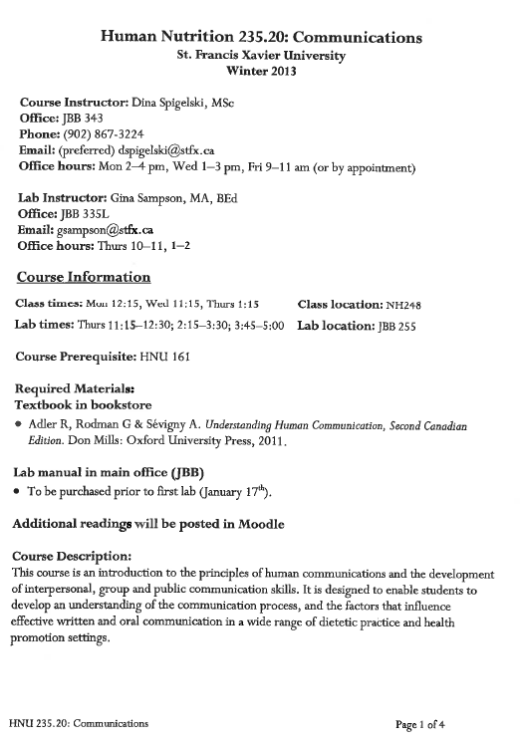

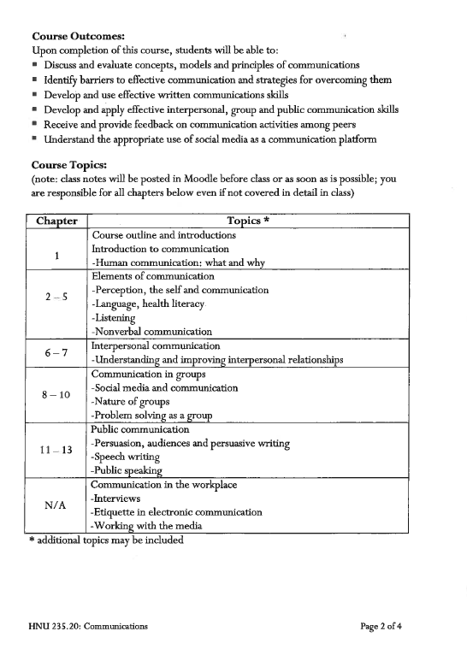

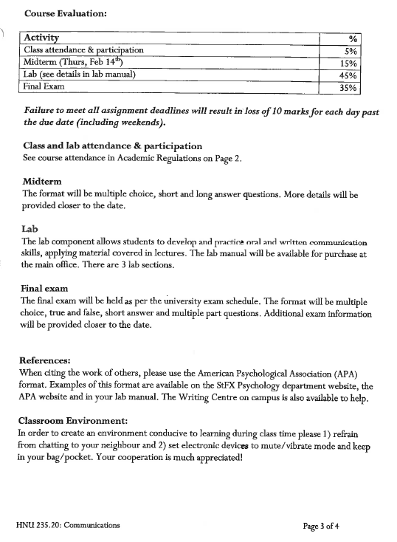

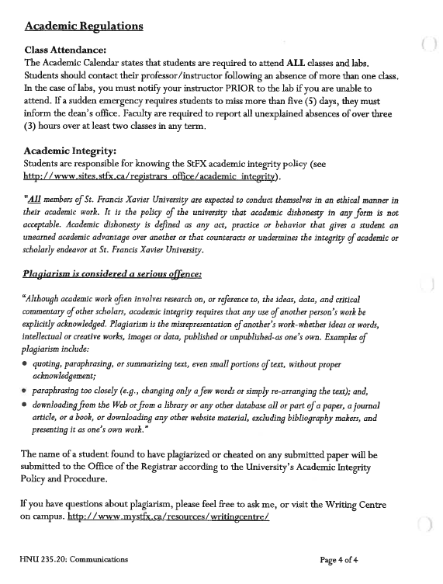
HNU 235 Communications

Food and Culture: Oral Presentation and Interactive Group Activity Lab

In groups of four (Students in Lab Section 1, work in groups of 3) you will be asked to make a 20–25 minute presentation to the class on a topic related to food and culture. This presentation is to include two sections: (1) a formal presentation using visual aids (PowerPoint, Prezi, etc.) and (2) an interactive component.

Possible Topics: (Submit a Topic Planning & Approval Form (Lab Manual, page 8) by MARCH 14)
- Historical food of a specific region (e.g. food in Antigonish 100 years ago)
- Modern food of a specific region (e.g. Okanawan eating patterns)
- Food of a specific group (e.g. First Nations community, Ukranians in Western Canada)
- Food associated with a specific celebration (e.g. Chinese New Year)
- Food cultural rituals (e.g. tea ceremony)
- A topic of your choosing

Oral presentation: follow the guidelines in the lab manual, pages 50-52

Group Activity: Create an activity which will involve all the members of the class and will allow them test their knowledge of the topic you’ve presented.
- This activity may be competitive, but it does not have to be.
- Some examples: a quiz-show style game (like Jeopardy); a board game; a cooperative group activity (like a Survivor puzzle challenge)
- The activity may be completed in pairs or in larger groups, but it needs to have an interactive component. (In other words, it can’t be an activity that class members complete entirely individually).
- At the end of the activity, you should bring the whole class back together for a period of reflection to review the group’s learning and wrap up the presentation.

Submissions:
On the day the lab is presented:
- Cover page with title, names, IDs and date
- Statement of audience, goals, objective (see Lab Manual)
- Paper copy of oral presentation slides and/or audio-visual material. (Please print PowerPoint 6 slides per page)
- Copy of other handouts or resources used
- Reference list in APA style
One week after the lab is presented:
- Each member of the group must submit a Peer Assessment Form (Lab Manual, p. 56-57)
- Self-Feedback form (Lab Manual, page 52) completed after viewing video of your presentation.
HNU 235 Food and Culture Presentation and Activity Lab
Sign up sheet
LAB Section 1
DATE | TOPIC | TEAM
MARCH 28 | Tea and Culture
MARCH 28 | Day of the Dead
APRIL 4 | Greek Food and Culture
APRIL 4 | Dietary Laws of various Religions

LAB Section 2
DATE | TOPIC | TEAM
MARCH 28 | Easter food
MARCH 28 | Guatemalan Cuisine
APRIL 4 | Traditional Newfoundland Diet
APRIL 4 | Hanukkah
APRIL 11 | Cuisine of Ghana
APRIL 11 | Sunday dinners in three different cultures

LAB Section 3
DATE | TOPIC | TEAM
MARCH 28 | Newfoundland Cuisine
MARCH 28 | Greek Cuisine
APRIL 4 | Alcohol and Food in Czech Culture
APRIL 4 | Easter Traditions around the world
APRIL 11 | Italian Cuisine
APRIL 11 | Chinese New Year

