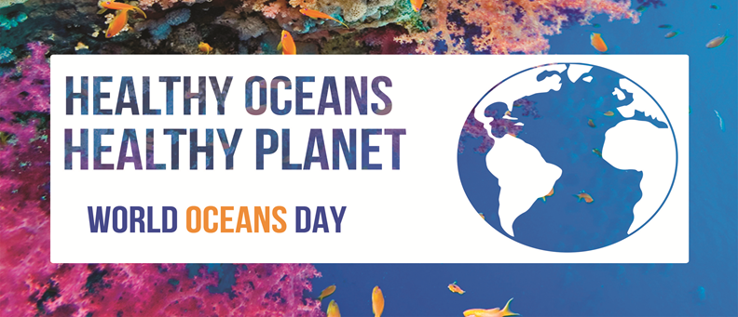

2016

Explore live marine organisms
(sea anemones, sea urchins, sea stars, and much more)

Saturday, June 11
11:00am-1:00pm, StFX Biology Dept.
J. Bruce Brown Building, 2320 Notre Dame Ave.
All are welcome!

For more information visit
www.antigonishkidscorner.ca or
http://sites.stfx.ca/biology/Biology_News

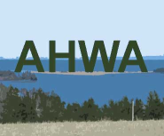
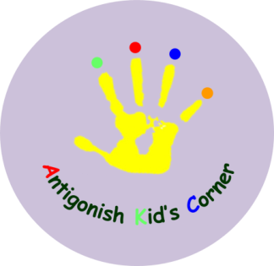
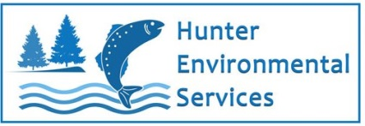
Sustainable Antigonish
Biology

