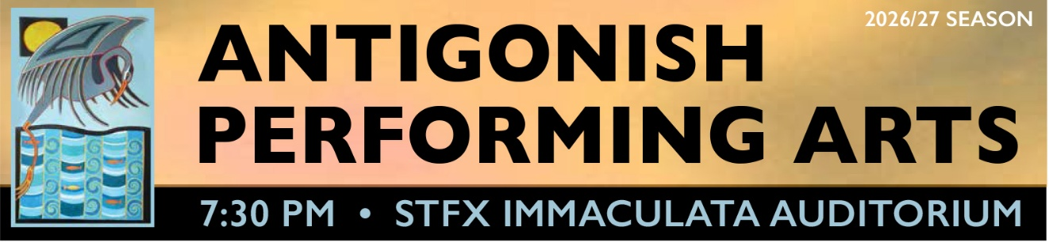

Subscription prices:
Adult $225
Senior $175
Under 30 $50.

For Office: Subscription Ticket No.______

Season tickets can be purchased at the door, by e-transfer to
performingarts004@gmail.com or by mail to:
Antigonish Performing Arts, Dept. of Physics, StFX, Box 5000, Antigonish, Nova Scotia B2G 2W5
If ordered by mail, your ticket will be available at the door at the first concert you attend.
NAME: ___________________ ADDRESS:_________________________________
TOWN: ________________ POSTAL CODE: _________ Campus Box # _________
TELEPHONE: __________ E-MAIL (if you want reminder emails): ________________
For season subscription ticket, please check one category
- ADULT ___ ($225)
- SENIOR ___ ($175)
- UNDER 30 ___ ($50)
==============================
Single tickets available at the door: $30 Adult, $25 Senior, Under 30 $15

