Field of A. MacLean (Eigg Mountain Settlement History)

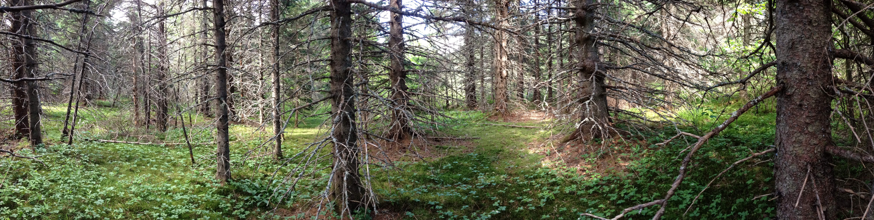
Figure 1 – Former field, July 3, 2016.

