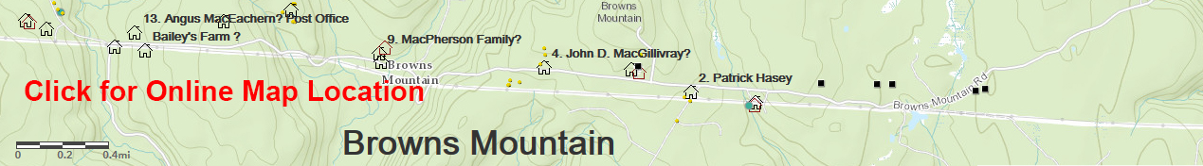
Hugh MacDonald (Eigg Mountain Settlement History)

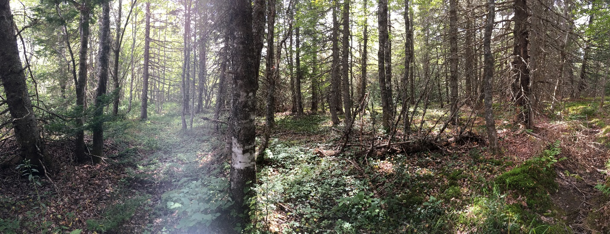
Figure 1 – Fields behind the house

This is a foundation that Charlie and I stumbled upon almost by accident. Charlie saw it from the truck as we drove north on the Hoochi Trail, and we were both so surprised to find it that we questioned whether it was in fact a house foundation. The evidence, including the well-cultivated (former) field close to the house, and the discovery of rock beneath the berm, weighed in favour of it.

The cellar measures 21 by 15 feet with the long side facing the road and very close to it.

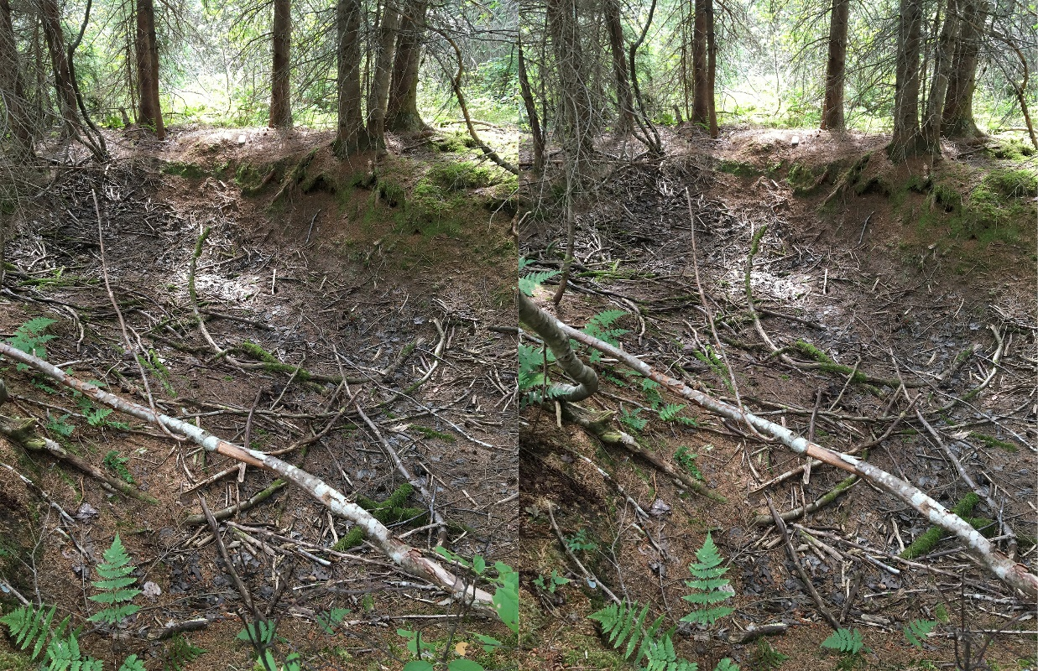
Figure 2 – Cellar looking southwest

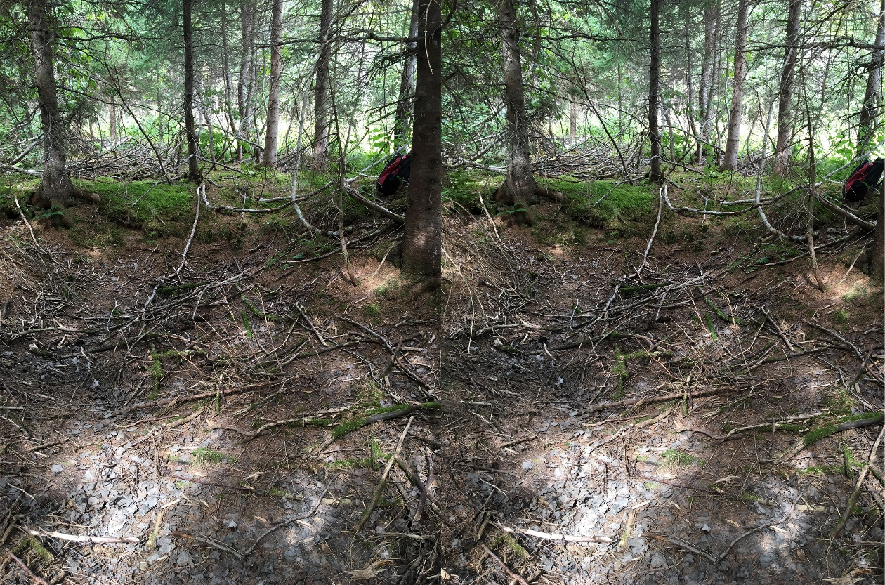
Figure 3 – Cellar, looking northeast toward the road

