Deed Bk, 19, p. 600, 1869 (PDF) Martin MacDonald to Ronald (of John) MacDonald, Brown’s Mountain (Eigg Mountain Settlement History)

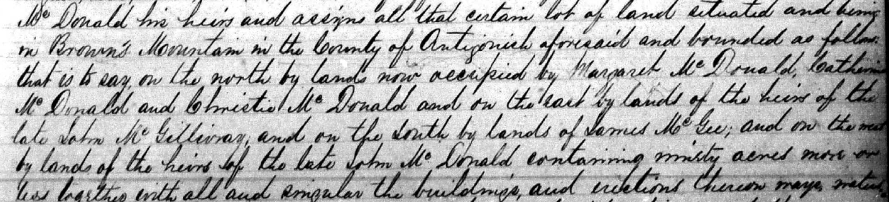
Bounded on the:
-North: Margaret, Catherine and Christie MacDonald
-East: lands of the heirs of the late John MacGillivray
-South: James McGee
-West: Heirs of the late John MacDonald

This looks like Escheat 39-17

