Deed Bk, 19, p. 600, 1869 (PDF) Martin MacDonald to Ronald (of John) MacDonald, Brown’s Mountain (Eigg Mountain Settlement History)

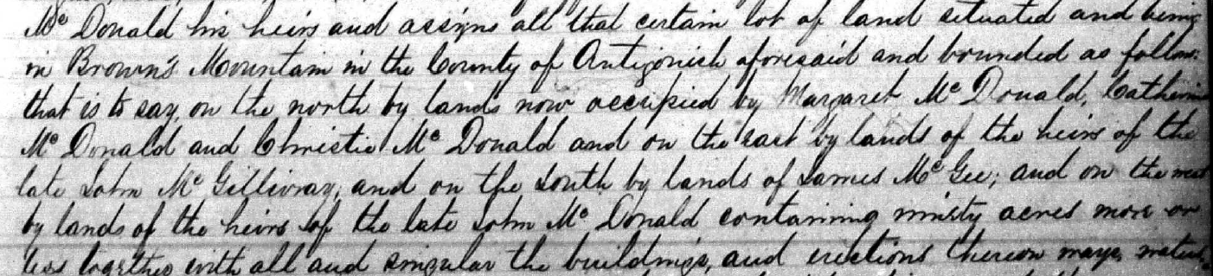

This looks like Escheat 39-17

