Deed Book 20, Page 538, 1871, Donald MacDonald to Colin MacDonald, Brown’s Mountain (Eigg Mountain Settlement History)

-for $140
-100 acres
-bounded as follows (Lot 511):
-toward the east by William Quinn
-toward the north by John MacDonald and James MacDonald
-towards the west by Allan MacDonald and Colin MacDonald
-towards the south by Angus MacEachern

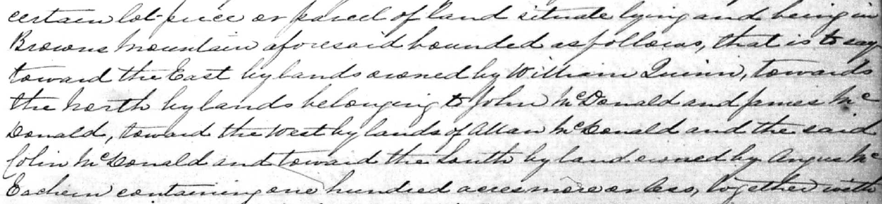

This land description seems in direct contradiction to the first parcel in 1871 deed D_20_560. They both list Colin and Allan to the west on the same date. I am assuming that this parcel was split – that seems to resolve most of the contradictions.

