Deed Book 20, Page 560, 1871, Ronald MacDonald to Angus MacEachern, Brown’s Mountain (Eigg Mountain Settlement History)

-$368
-First Parcel (see Lot 601):
-in the 12th range, bounded in the north by lands of Colin MacDonald,
-towards the east by lands of Ronald MacDonald
-towards the south by the southern boundary of the 12th range
-towards the west by lands of Colin and Allan MacDonald
-80 acres more or less
-Second parcel (not yet identified):
-11th range
-towards the south by the southern boundary of the 11th range
-towards the north by the southern boundary of the 12th range
-towards the east by lands of Ronald and Dugald MacDonald (*not placed)
-and towards the …?

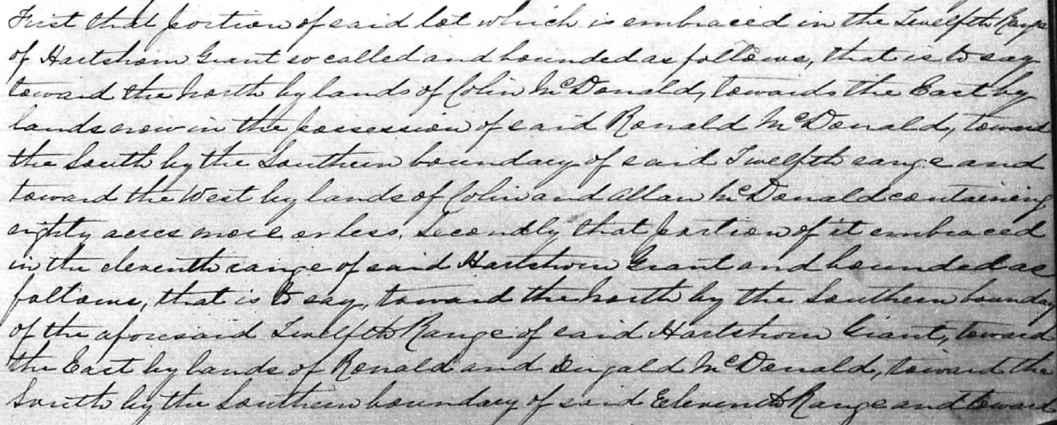
See PDF

