Escheat 126, (Eigg Mountain Settlement History)

-file not yet obtained.
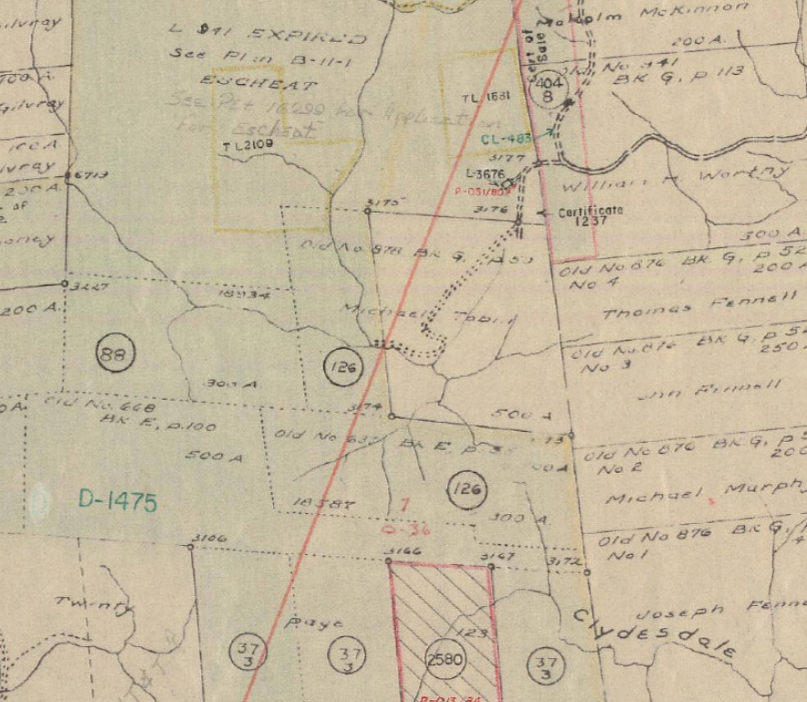
Figure 1 – 126 South of Tobin

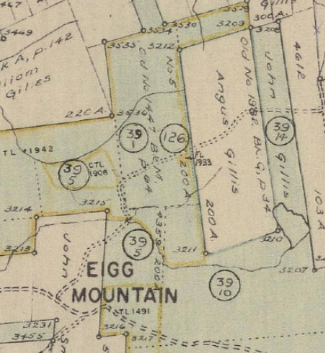
Figure 2 – 126 on Lewis Road

