Escheat 146, 1946 Tax sale of Alex D. MacDonald’s land (Eigg Mountain Settlement History)

-see PDF

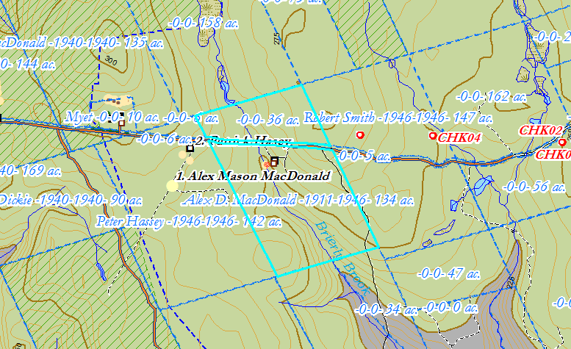

County does “sell, unto the said DEPARTMENT OF LANDS AND FORESTS its successors and assigns all that certain \ parcel or tract of land in the said municipality of Antigonish, described as follows:
Situated at Brown's mountain and bounded on the North by lands of Hartshorne Grant; on the west by lands of Peter Hassey; on the south by lands of Hartshorne Grant; on the east by lands of Robert Smith, containing 100 acres more or less
The same appearing to be the property of Alex D. MacDonald by deed dated and registered at Antigonish in book 40 at page 442.”

