Escheat 37, 1939 County of Antigonish and the Crown (Eigg Mountain Settlement History)

The depicted plus…
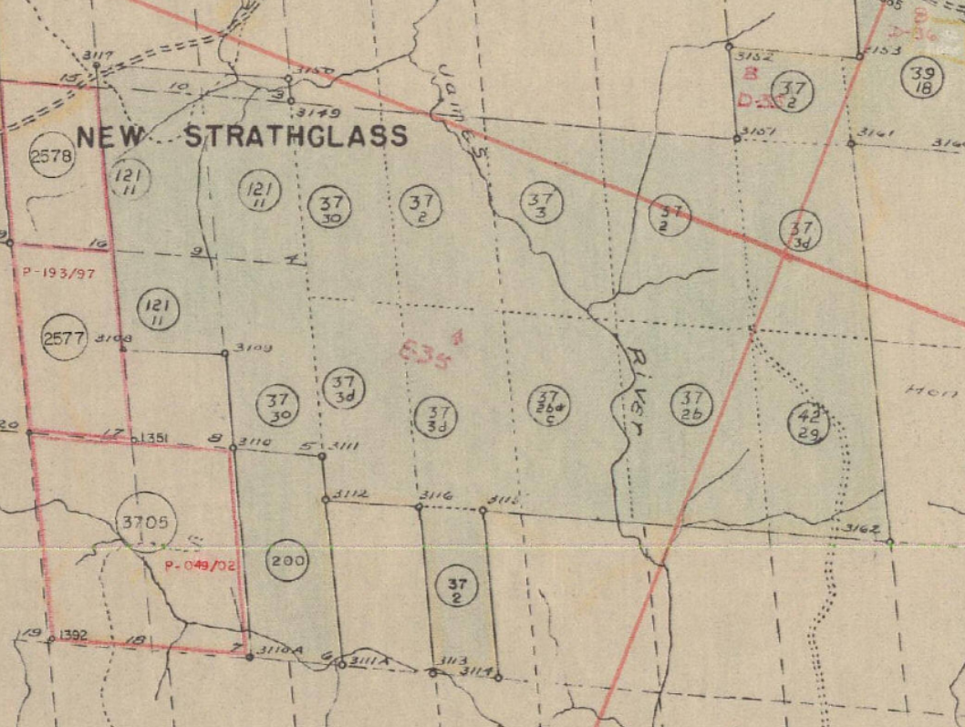
-see PDF

