Escheat 39, 1940 County and the Crown, (Eigg Mountain Settlement History)

-see PDF
-Partially done

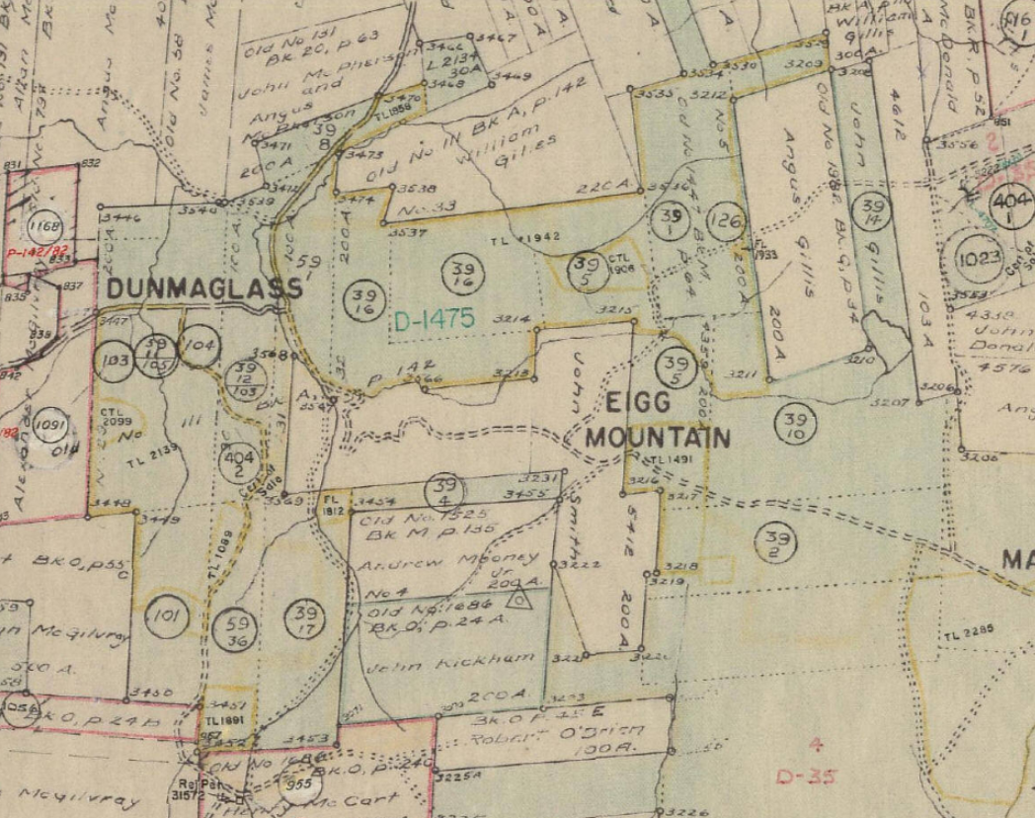
Figure 1 – Escheat 39 on Eigg Mountain

Lot 39-1 “Property at Maple Ridge formerly Owned by Lewis MacDonald, bounded on the North by lands of Alex McAdam, on the East by lands of William MacDonald, on the South by lands of Angus A. Fraser, on the west by lands of Dan A. Fraser; containing 100 acres more or less.

Lot 39-2 “Property at Maple Ridge formerly owned by Angus Fraser, bounded on the North by lands of Ronald MacDonald, on the South by lands of Pat Delaney; on the East by lands of Rod MacIsaac, on the West by lands of Angus M. Fraser; containing 200 acres more or less.

Lot 39-3 “Property at Maple Ridge formerly owned by William and Allan McMillan, bounded on the North by lands of Archie MacLellan, on the South by lands of John A. and Hugh Smith, on the East by the MacGillivray Lot. on the West by Crown Lands; containing 200 acres.more or less.

Lot 39- 4 “Property at Maple Ridge formerly owned by Alex. Fraser, bounded on the North by lands of James Sullivan and Angus MacDougall, on the south by lands of Heirs Dan Fraser, on the East by lands of Angus Smith, on the west by lands of Colin J. MacDonald and George MacDonald; containing 50 acres more or less.

Lot 39-5 “Property at Maple Ridge formerly owned by Dan Fraser, bounded on the North by lands of Ronald MacDonald; on the South by lands of Rod McIsaac, on the East by lands of Lewis MacDonald, on the West by lands of Ronald MacDonald; containing 100 acres more or less.

Lot 39-6 “Property at Map1e Ridge formerly owned by Archie McLellan, bounded on the North by lands of Ronald Smith, on the South by lands of Allan McMillan; op the East by lands of Angus McQuarrie, on the West by lands of Robert Power; containing 100 acres more or less.

Lot 39-14 “Property at Rear Arisaig, formerly owned by John A. Gillis, bounded on the North by lands of Angus Smith, on the South by lands of John McIsaac, on the East by lands of Alexander Gillis, on the West by lands of Colin MacDonald; containing 100 acres more or less.

Lot 39-15 “Property at Rear Arisaig, formerly owned by William Gillis, bounded on the North by lands of the rear or southern line of shore division of lots; on the South by lands granted to Angus MacDonald, on the East by the lands in possession of Lauchlin Gillis; containing 100 acres more or less.

Lot 39-16 “Property at McAra’s Brook, formerly owned by James MacEachern, bounded on the North by lands of Angus and John MacPherson, on the south by lands of Angus Smith, Dan McGillivray and Angus MacDougall; on the East by lands of Dan Fraser, on the West by lands of up Angus MacEachern and Colin J. MacDonald; containing 500 acres more or less.

Lot 39-17 “Property at Brown's Mountain, formerly owned by George McDonald, bounded on the North by lands of heirs of Joseph and Donald MacGillivray, on the south by lands of James and Rod McGee. On the East by Crown Lands and Miners’ Settlement Board, on the west by lands of Heirs of Joseph MacDonald; containing 100 acres more or less.”
This looks like Deed Bk 19, pg 600, 1869

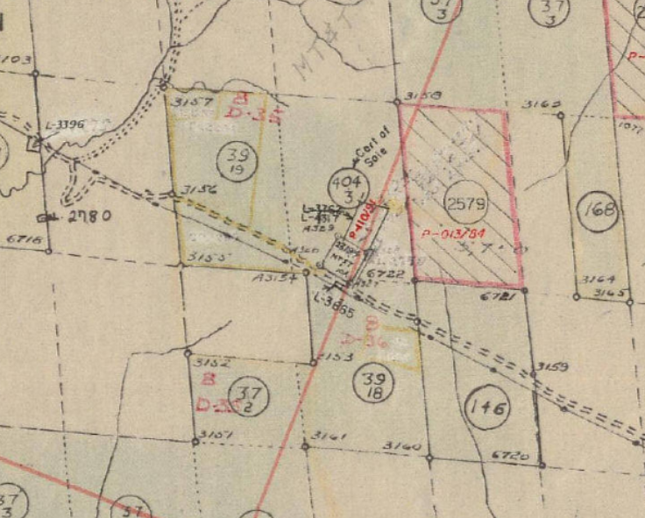
Figure 2 – 39-18 and 39-19 on Brown’s Mountain

