Escheat 404, (Eigg Mountain Settlement History)

-no file yet.

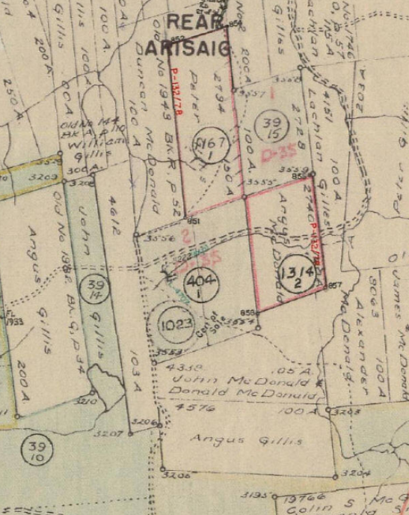
Figure 1 – 404-1 east of Rory’s Lake
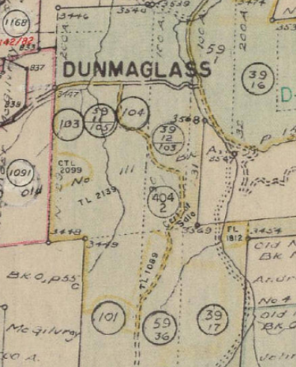
Figure 2 – 404-2 Dunmaglass

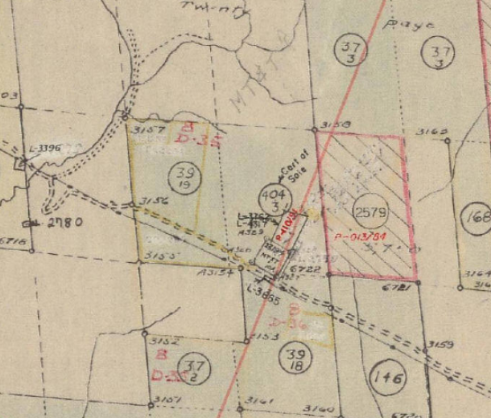
Figure 3 – 404-3 East of Cutie’s

