Hardwood over Field (Eigg Mountain Settlement History)

This is the lower field of “the hermit” and is an example of a former field growing over in hardwood. The view (Figure 1) is looking east across the field from its western boundary (defined by rock piles like the one below (Figure 2)). The hardwood is second growth. The large stumps are from old softwood trees that originally grew up on the field which was probably abandoned in the early 20th century. This portion of the field is overgrown in the 1945 aerial photo.

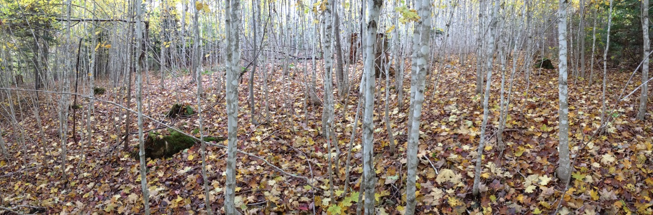
Figure 1 – Panorama of Young Hardwood Stand

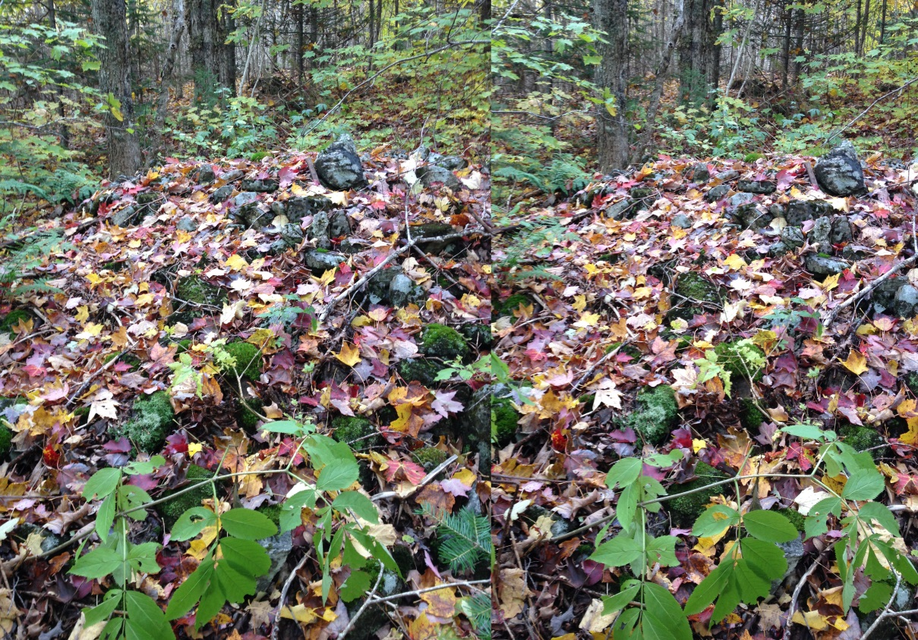
Figure 2 – Rock Pile. The stereo image (viewed cross-eyed) gives a good impression of the scale of the rock pile.

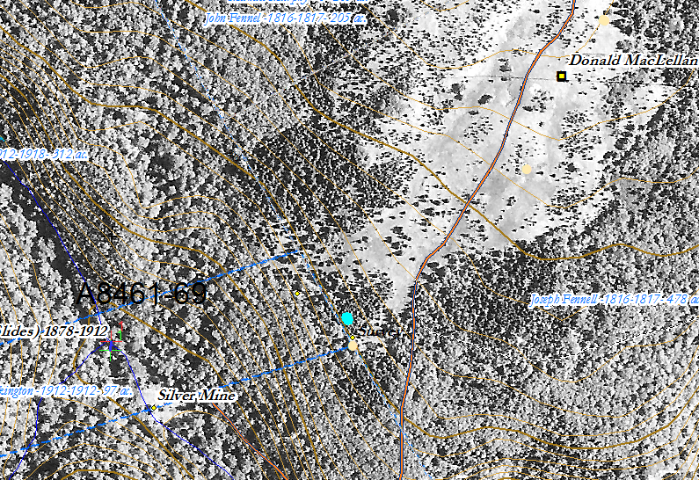
Figure 3 – Location of photographs (Figures 1 and 2) on the 1945 aerial photograph georeferenced to the ArcGIS basemap, 2018.

October 24, 2015

