Land Tenure (Eigg Mountain Settlement History)

A deed of 1835 (see Deed Book 8 pg. 110) indicates that this lot was “formerly possessed by one Michael Fitzgerald.” The information comes from Michael Baggley who sold the adjacent lot which he apparently occupied. Baggley does not mention another tenant, so apparently the land was unoccupied by 1835.

Later, the land is attributed to Donald MacGillivray in an escheat file 59-37.

The land does not, from the aerial photos, look like it was ever farmed.

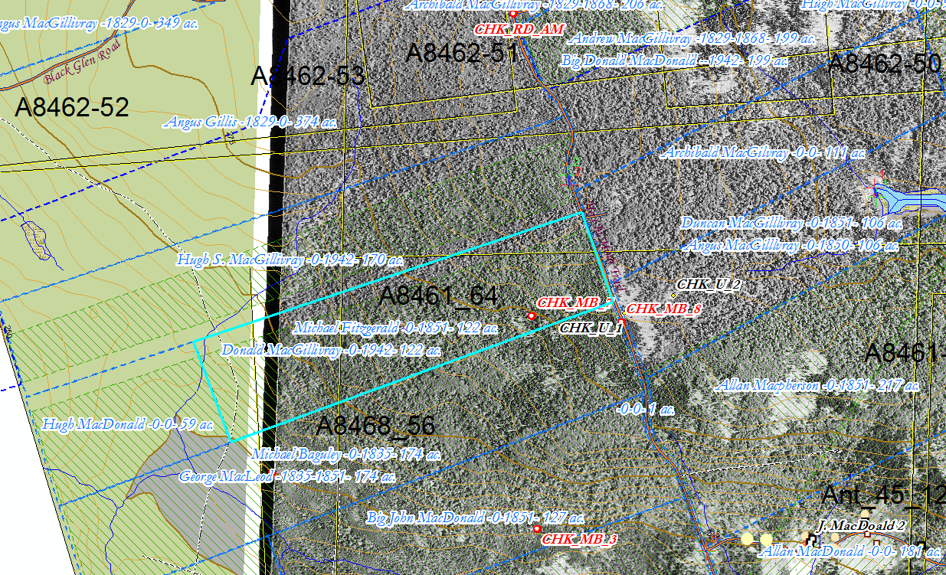
Figure 1 – Fitzgerald Lot

