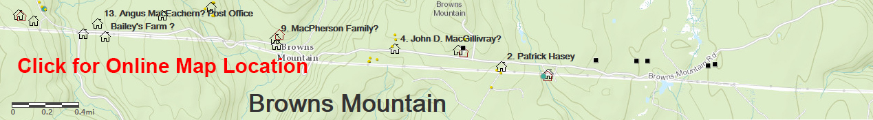 J. MacDonald (Small Cellar) (Eigg Mountain Settlement History)

This is at a site marked J. MacDonald on the Geological Survey map. What remains is a small foundation 28 ft X 25 ft. oriented southwest (310º along the upper 28 ft wall) down a slope towards a stream. Below this house is another, larger one apparently part of the same farmyard area.

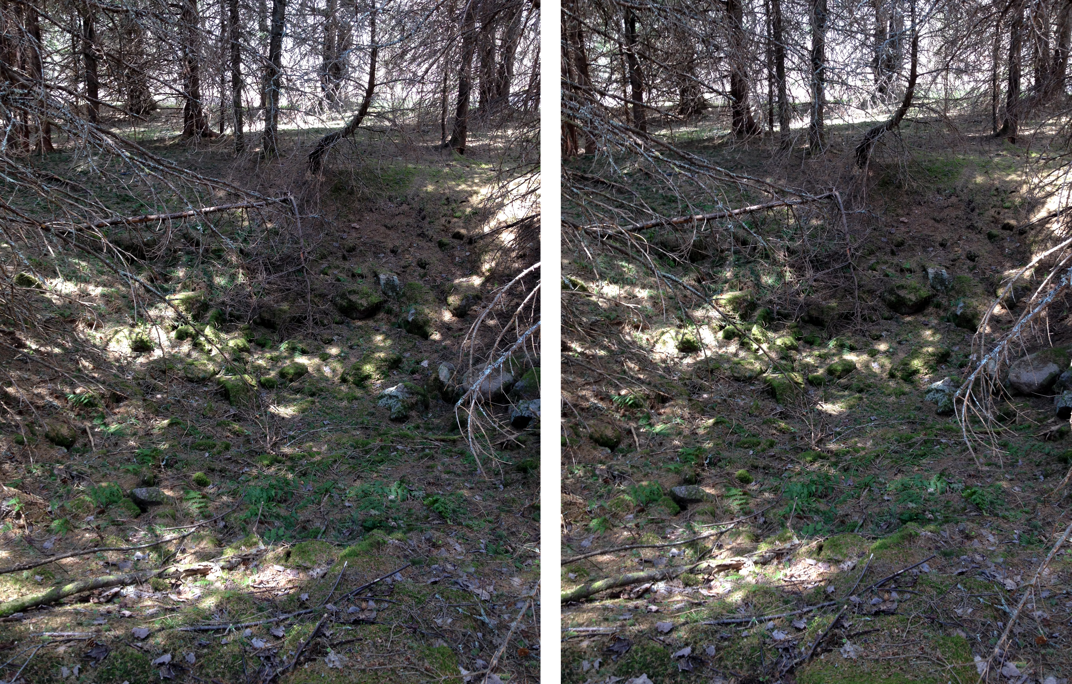
View from within the cellar.

6 June 2015

