MacGillivary (Eigg Mountain Settlement History)

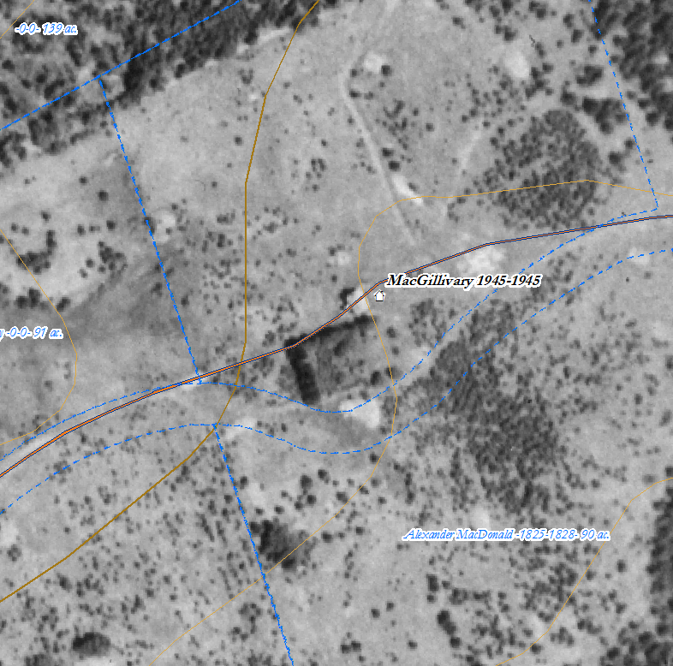
Figure 1 – MacGillivray House site

Charlie remembers rhubarb still growing at this site. You can see the garden and perhaps the orchard to the south of the site in the aerial photo (Figure 1).

The cellar is in the south half of the foundation which measures about 25 by 30 ft.
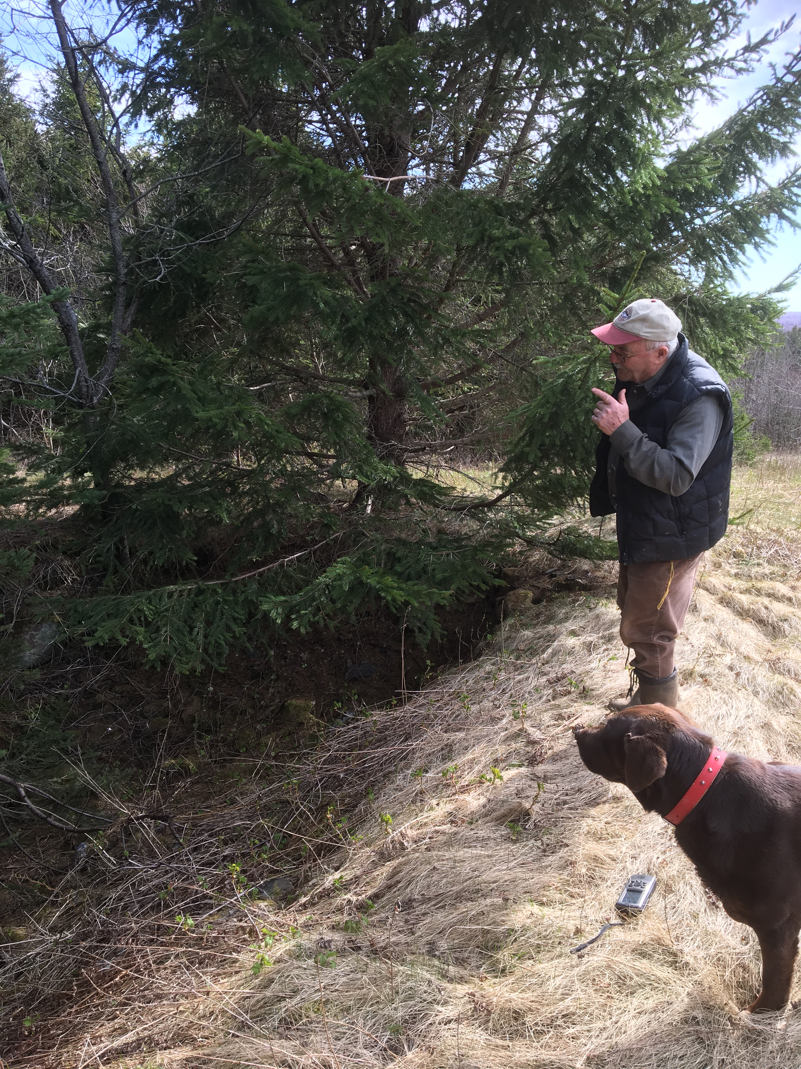
Figure 2 – Charlie and Brandy inspecting the cellar.

