Ronald MacGillivray (Bumps) (Eigg Mountain Settlement History)

There is a relatively small foundation at this site. Charlie was surprised as he remembers these as well-to-do people with extensive cleared fields.

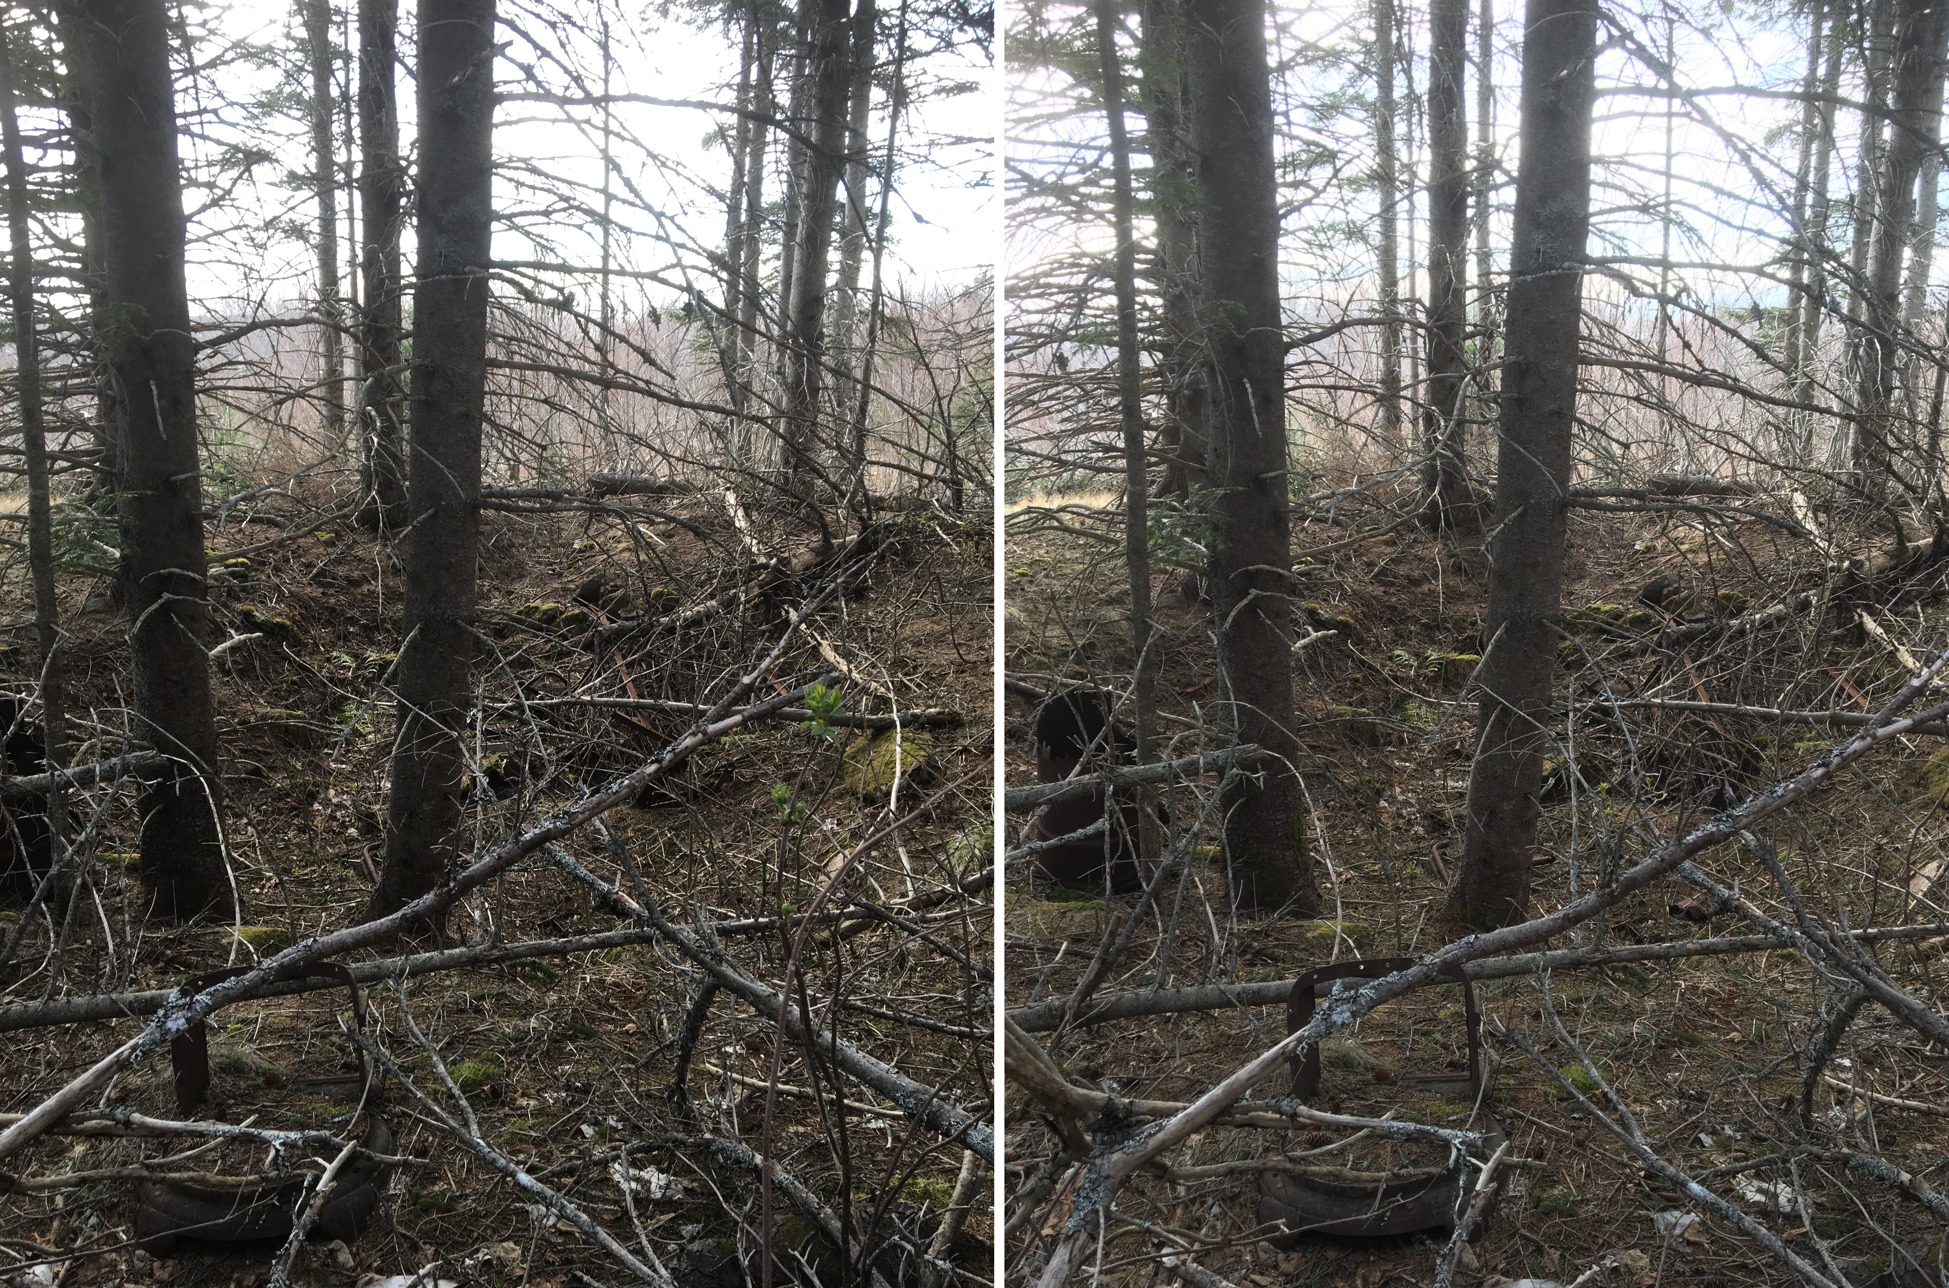
Figure 1 – The Cellar with parts of an old stove in the foreground.

