Bigley_Family(Joe) – (Eigg Mountain Settlement History)

Michael Bigley married Sarah “Sally” Walsh (d. 1859) “of the Mountain Road” SMAR
Edward “Ned” Bigley (b. 1827-d. February 25, 1909) married Ann “Nancy” MacEachern (b. 1827-d. February 15, 1895) d/o John and Isabella (MacGillivray) MacEachern married February 17, 1858 at Arisaig
1871 Census Arisaig District Division 2 # 107
1881 Census Arisaig District # 19
1891 Census Arisaig District # 31
1901 Census Antigonish District # 37
Ellen Bigley (b. 1857-d. 1933) married John MacGillivray Trenton, NS
Michael Bigley (b. 1858-d. 1904) US
Catherine Bigley (b. November 10, 1861) born at MacEachern’s Mountain SMAR married Angus MacEachern lived at Dunmaglass
John Bigley (b. April 24, 1863) US
Angus Bigley (b. July 7, 1864-d. 1914) moved to Antigonish and then to Glace Bay married Florence Chisholm (b. 1869) born at North Grant d/o Archie and Mary Chisholm married November 7, 1899 at Lakevale NSVS
1901 Census Antigonish District # 37
Isabella Bigley (b. December 23, 1865) married John MacIsaac Guysborough
Hugh Bigley (b. July 6, 1867) immigrated 1897 (1900 US Census) 1886 (1910 US Census) 1885 (1920 US Census) 1891 (1930 US Census) carpenter married (1) Ann MacEachern (b. 1868-d. February 15, 1895) born Antigonish married April 10, 1894 at Boston and (2) Christy Ann MacDonald (b. 1870) married June 1, 1897 at Boston
Patrick Bigley (b. 1832-d. March 28, 1908) married Mary Sallinger (b. 1836-d. January 28, 1929) married September 10, 1859 at Antigonish NSVS
1871 Census Arisaig District Division 2 # 108 Tenant Farmer
1881 Census Arisaig District # 20
1891 Census Arisaig District # 9
1901 Census Arisaig District # 95
1911 Census North Grant District # 45
1921 Census Maryvale Sub-District # 17 # 34 Mary living with daughter Mary
Michael Bigley (b. 1861) married Ann “Nancy” MacDonald (b. 1863) d/o Allan and Sarah MacDonald – MacIain Oig US

Margaret Bigley (b. October 1, 1862-d. February 23, 1891) born at Brown’s Mountain

Harriet A Bigley (b. September 10, 1864) married Hugh MacDonald Brierly Brook living with Nicholas and Ann Delaney in 1881.
1881 Census Antigonish District Division 2 # 192

John James Bigley (b. October 28, 1866-d. September 8, 1908) died at Antigonish Harbour probate file A-1355 page 212/1366 Antigonish Estate File 1908-1910

Ellen Bigley (b. 1869-d. 1968) married John D MacPherson North Grant buried with headstone at St. Mary’s cemetery Maryvale

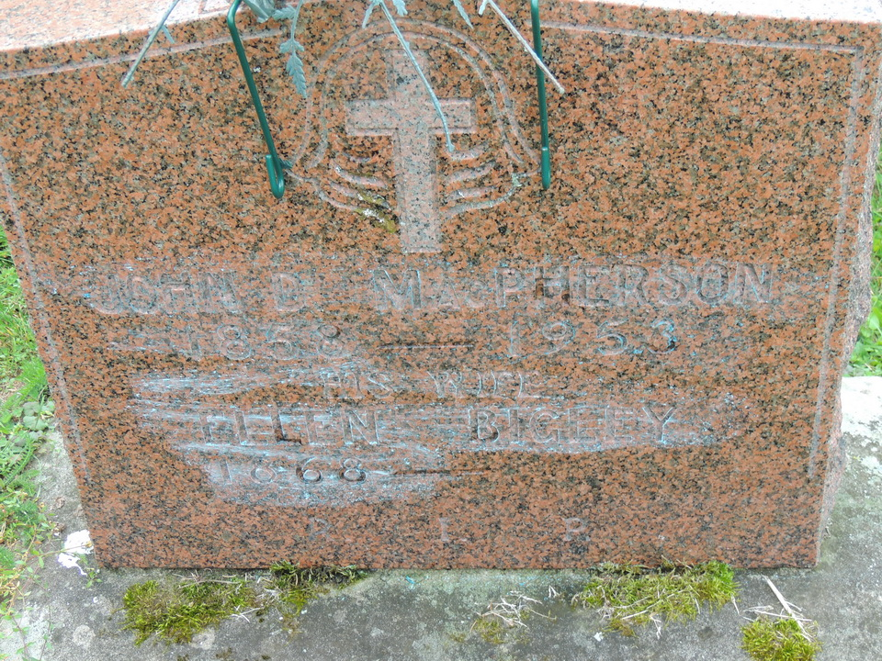

James Bigley (b. March 14, 1869) born at Brown’s Mountain

Sarah Bigley (b. December 18, 1870) born at Brown’s Mountain

James Bigley (b. November 18, 1873) born at Brown’s Mountain NSVS

Mary Bigley (b. April 15, 1873) married Alexander Duncan MacDonald (b. October 10, 1870-d. September 27, 1950) born Springfield s/o John and Catherine MacDonald NSVS Clydesdale married February 26, 1900 at Antigonish SNAR
1911 Census North Grant District # 45
1921 Census Maryvale Sub-District # 17 # 34
John Patrick MacDonald (b. January 15, 1901)
Patrick Joseph MacDonald (b. April 30, 1904)
Catherine MacDonald (b. 1908)
Patrick Moore (b. 1918) born England adopted son

Patrick Bigley (b. April 2, 1875) born at Brown’s Mountain NSVS

Catherine Teresa Bigley (b. January 26, 1878-d. May 21, 1920) immigrated 1905 (1910 US Census) 1909 (1920 US Census) housekeeper in private residence married Frederick James Moore B. 1870) born in England married February 18, 1912 in Newton, Massachusetts

James J Bigley (b. August 27, 1881) stable man in livery stable, iceman(teamster), labourer in woolen mill immigrated 1898 (1910 US Census) 1904 (1920 US Census) 1906 (1930 US Census) married Catherine Gillis (b. 1882) born Halifax immigrated 1893 (1910 US Census) 1895 (1920 US Census) married February 20, 1906 at Boston

James Bigley (b. 1834) born at Back Settlement Arisaig lived at Brown’s Mountain married Margaret Thomson (b. 1847-d. March 2, 1938) born Back Settlement Knoydart d/o Duncan Thomson and Margaret MacEachern married February 8, 1867 at Arisaig NSVS
1871 Census Arisaig District Division 2 # 111 Tenant Farmer
Mary Ellen Bigley (b. December 30, 1869-d. 1965) born at Brown’s Mountain NSVS married John G MacDonald New Glasgow

Hugh Bigley (b. November 8, 1871) born at Brown’s Mountain

Michael Bigley (b. December 7, 1873) born at Brown’s Mountain

Mitchell (Michael) Bigley (b. May 4, 1874) born at Brown’s Mountain NSVS

Duncan Bigley (b. October 18, 1875) born at Brown’s Mountain NSVS

Isabella Bigley (b. August 23, 1876) born at Brown’s Mountain NSVS

Hugh Bigley (b. September 8, 1876) born at Brown’s Mountain NSVS

Ann Bigley (b. August 15, 1880)

There are inconsistencies in the historical vital statistics for the Bigley families.

