Deed 502484287 - Book 26 page 409 Robert Power to John Power registered April 1878 (Eigg Mountain Settlement History)

…for the sum of $100

Bounded
…on the north by lands of Richard Dalton [Dalton is to the west]
... on the east by the Eigg Mountain Road [the road is to the north]
... on the south of the lands of Angus MacMillan and the heirs of the late Archibald McDonald [there is an Archie MacDonald to the south, but according to the rotated logic, Archie MacLellan would be to the south along with an Angus MacMillan]
... on the west by lands of Malcolm Fraser [Malcolm Fraser is to the south]
... containing 80 acres more or less

[Robert Power marked with X]

The land description makes partial sense if the lot is rotated over 90° clockwise to position the Daltons to the north. It cannot be any other than the one indicated in figure 1. The description must be from memory and its errors may simply indicate the failings of age.
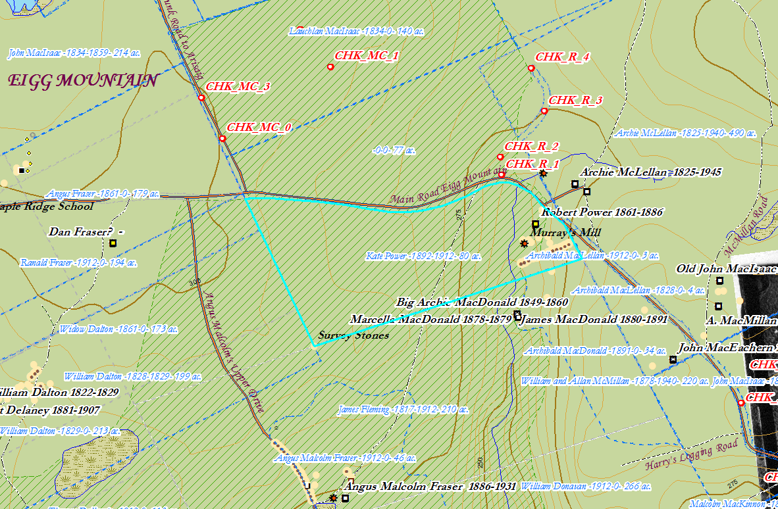
Figure 1 – The Power property.

