Fraser, Angus Donald (Eigg Mountain Settlement History)

Angus Fraser, son of Donald from the genealogy fits with Angus D. Fraser who willed land to a son Alex (see will).

This is probably also the A. Fraser on the Church map.

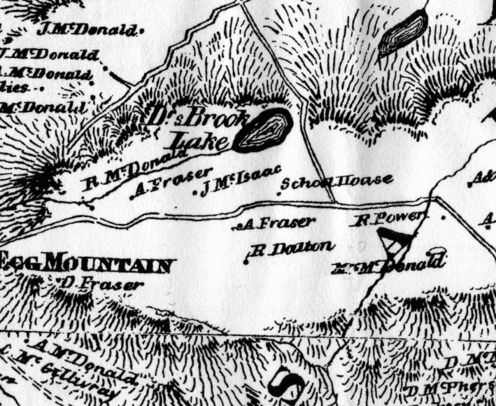
Figure 1 - Church Map (1879) showing A. Fraser.

Angus D. Fraser was born about 1842 to Donald and Mary (MacDonald) Fraser – he was their oldest child. He was living with his family in the 1871 and 1881 census and then in 1881 married Flora MacDonald born in 1859 from Ardness near Lismore. Their first child Alexander was born February 23, 1883 and baptized at Arisaig. By 1891 they had James (May 28, 1884), D John (1885), J John or George (May 15,1887), Margaret (1888) and Lewis (1890) and were living on a farm near New Glasgow in Pictou county. The family moved back to the mountain after Angus’s father Donald died in 1899 and in the 1901 census they were living with Angus’s widowed mother Mary and his sister Isabella and 5 more children – Angus (1892), Donald (December 4, 1893), Mary (September 18, 1895), Charles (July 22, 1897) and Agnes (1899). One more child Mary Ann was born May 20, 1903. Angus and Mary now had twelve children.

Angus died November 6, 1905 at the age of 63 years. By 1911 his widow Flora was living in Baileys Brook, Pictou county with the 5 youngest children – she was listed as a farmer.

Angus left a will and probate file A-1275. His eldest son Alexander received “all my real or landed estate consisting of fifty acres more or less. Also the whole of my personal property of whatever description together with my interest in fifty acres of land left by my father who has died interstate.” There was also some conditions: “that my said son Alex shall and will provide and support my beloved wife during her natural life…also that the home thus bequeated to my said son will be a home for all my family for either recreation or during sickness during a reasonable period.”

Of the dozen children of Angus and Mary MacDonald Fraser all left the mountain within a few years of their father’s death.

Alexander married Josephine McGinn and were living on the mountain in 1911 but moved to Knoydart– he died in 1961 in New Glasgow. The five youngest children moved with their mother to a farm in Pictou county. Margaret died in 1907. James married Margaret McInnis and lived in British Columbia where he worked in the mines. J John married and moved to Bailey’s Brook and died in 1951. Lewis and Angus enlisted in the Canadian Expeditionary Force fighting in the First World War and Lewis was killed in action in France in 1916. Angus died in Halifax in 1963. Charles was conscripted into the Canadian army late in the war but did not see any action – he became a carpenter in New Glasgow and died in 1923. Agnes immigrated to Boston in 1919 while sister Mary also moved to the US.

