Fraser, D. (Eigg Mountain Settlement History)

A “D. Fraser” is indicated on the Church map south of the Eigg Mountain Main Road to the west of the peak of Eigg Mountain. The Teasdales have no knowledge of a “D. Fraser” anywhere near here. They suspect that Church may be in error. The D. Fraser site is close to one they remember as a Mooney property. They place a Dan Fraser some distance to the east.

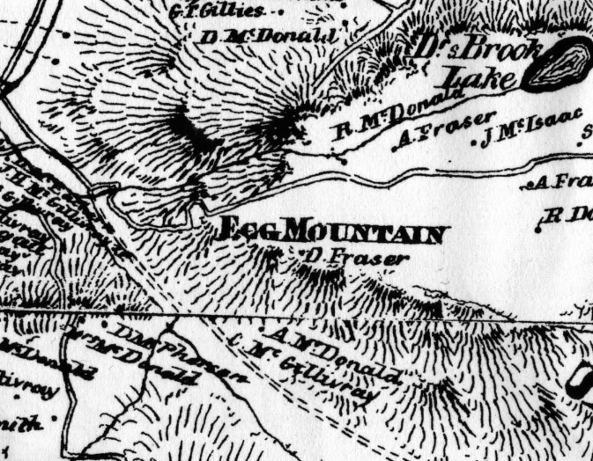
Figue 1 – Church Map (1879) indicating D. Fraser.

