Fraser, Dan (Eigg Mountain Settlement History)

The Teasdales remember three to five basements along the south side of the Main Road near Ron Fraser’s. One of these belonged to an Angus, one to a Dan Fraser. I have placed Angus Fraser to the west and Dan Fraser to the east of Ron Fraser’s near Pat Delaney’s eastern drive in a clearing visible on the 1945 aerial photos. These positions are pure guesswork.

Church places a D. Fraser some distance to the west.

If there was a farm here it would, at 300 metres, be the highest farm on Eigg Mountain, indeed the highest in Antigonish County. The next highest is near the “Squatter’s Basement.” You should check here to see if there were cultivated fields.

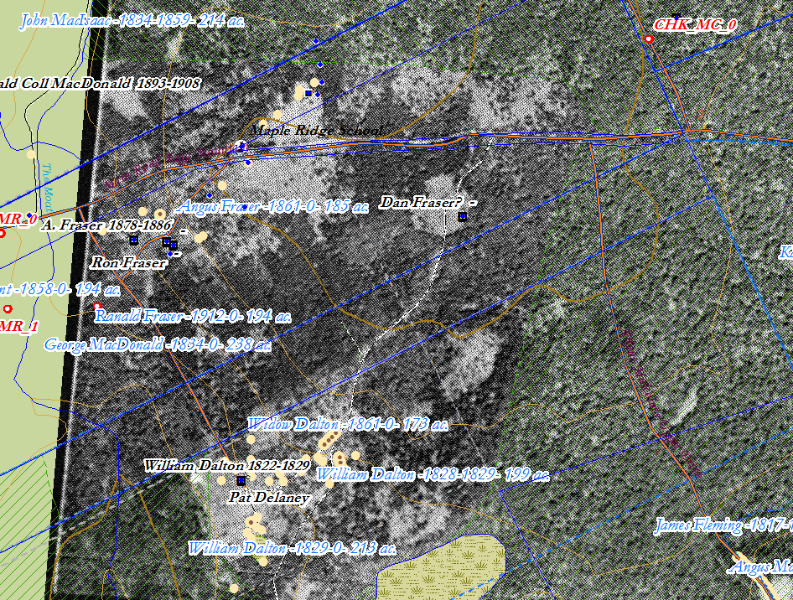
Figue 1 – ArcGIS map, 2018, with tenatative location of Dan Fraser.

Donald Fraser was born in Scotland about 1814 the son of Ronald and Mary (MacIsaac) Fraser pioneers and arrived on the mountain around 1823 with his family. He married Mary MacDonnell or MacDonald (MacLean et al vol.2 page 156 say MacDonnell from Pomquet while Rankin page 135 says MacDonald). The baptismal records for St. Margaret’s in Arisaig say Mary MacDonald. She was born around 1819. In the 1871 census they can be found on page 24 line 12 of division 2 – they owned a farm of 100 acres with 50 acres improved and 8 acres in pasture. They had 2 horses, 5 milk cows, 7 horned cattle, 11 sheep and 2 pigs. They also owned two oxen. They had 7 children ranging in age from 28 years to 12 years – Angus, Alexander, Margret, Archibald, Catherine, Isabella and Margret. In the 1881 census Donald and Mary have their oldest son Angus living with them as well as their widowed daughter Isabella now MacDonald and her one year old son Rory. Donald died at the age of 85 years in 1899 and his wife Mary died at the age of 87 years in 1906.

