Ranald Angus (The Plasterer) Fraser (1844-1926) (Eigg Mountain Settlement History)

Listed in McAlpine’s as Ranald A. I am assuming this is the person north of William Dalton in Plan B-11-1. He is probably Ranald, son of Angus (the A. in Ranald A.) son of Ranald the pioneer. If so, he had moved to Antigonish by 1929.

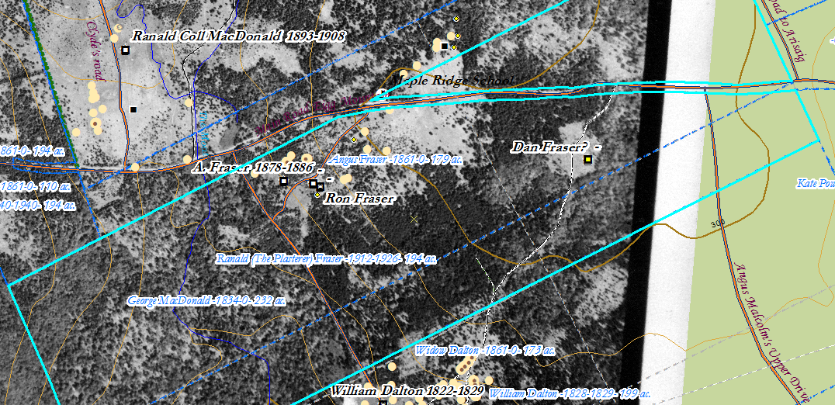
Figure 1 – Fraser Property

Ronald Fraser was born in 1844 – the sixth child of Angus and Rebecca (Effy) MacIsaac Fraser. He was known as Ronald “the plasterer” and was one of the last people to live on the mountain. Below is his story.

Angus Fraser son of Ronald and Mary (MacIsaac) Fraser pioneers was born about 1813 in Scotland and came to Nova Scotia around 1823 with his family. He married Rebecca (Effy or Effie) MacIsaac born around 1813 at Cape George to John MacIsaac – Ronald and Mary Fraser are found on page 29 line 5 of division 2 in the 1871 census. They had 8 children living with them – Angus, John, Mary, Catherine, Margret, Ronald (the plasterer), Sarah and Mary ranging in age from 29 years to 14 years. Angus died at the age of 58 years on December 23, 1871 of a “liver complaint”. In 1871 Angus owned a farm of 100 acres with 60 acres improved and 20 acres in pasture. He grew spring wheat, oats, buckwheat, potatoes, flax seed and flax. He had 3 horses, 2 milk cows, 3 horned cattle, 8 sheep and 3 pigs. He also harvested 40 cublic feet of birch maple along with 10 spruce logs that pervious year as well as 15 cords of firewood. He did not leave a will and neither did his father Ronald. His three brothers – Donald, Alexander (Sandy) and Malcolm lived nearby. Of the 4 brothers Alexander owned the largest farm – 200 acres with 100 acres improved and 30 acres in pasture. Donald and Malcolm owned 100 acres each. Donald Fraser owned 2 oxen – the others did not own any. The four brothers likely shared the oxen to till their land. Of the four brothers Malcolm had the most minimal farm with only 30 acres improved, 3 acres in pasture and only a milk cow. What was likely happening was the four brothers and their families were sharing farm produce and farm animals. In the 1881 census Effy Fraser a widow was living with her sons John and Angus and daughters Mary and Margaret. In 1891 Effy Fraser was living with her son Ronald and his wife Catherine and their two children along with her two sons – Angus and John. In the 1901 census Effy was 87 years old and still living with sons Ronald and his family and sons John and Angus. Effy Fraser – Mrs Angus Fraser – died at the age of 97 years on January 27, 1910 and was buried at Arisaig.

Ronald “the plasterer” Fraser was born in 1855 and married Catherine MacDonald (see MacLean et al. vol. 2 page 156) from Mabou, Cape Breton (see Rankin page 135). They lived on the farm of his father Angus until he moved to the town of Antigonish in 1924 (see obituary attached). In the 1921 census Ronald and Catherine are living with son George on the mountain. Ronald Fraser died May 7, 1926.

