Book G pg. 52, 1816 (Eigg Mountain Settlement History)

Grant to Joseph, John and Thomas Fennel as well as Michael Murphy

The survey description of this grant has the same inconsistency as G_50 (see also G_53), placing the Tobins further south in relation to the Fennels/Murphy than on the index sheet (and our Eigg Mountain map). The Fennel/Murphy grant position indicated on the Grants Index makes sense if the point of beginning is NW corner of Charles & Mary Wentworth. This survey also references the NE corner of Lt. Col. Pilkington which apparently would place the Fennel/Murphy grants higher up, consistent with the plans drawn up in G_50 and G_52. [This should at least be a warning of how wrong the original survey plans could be.]

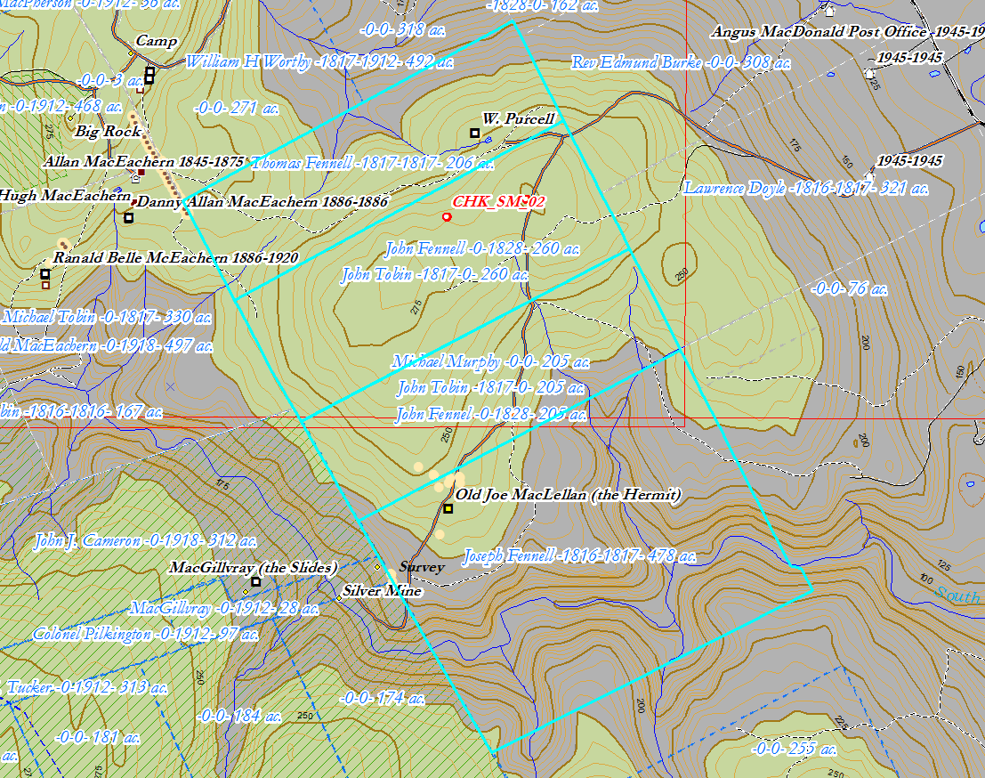
Figure 1 – Grants described in Book G pg. 52 but located according to the Land Grants Map. There they are numbered lots 1 to 4 from the bottom.

