Land Tenure – Lot 059 (Eigg Mountain Settlement History)

See also the combined version Lot 177

This lot may be the one that John Red Gillis bequeathed to his son Laughlan in 1868 (see A-383). Lauchlin left the mountain and in 1881 and in 1891 was living in or near the town of Antigonish with his wife Mary. He worked as a labourer and general servant.

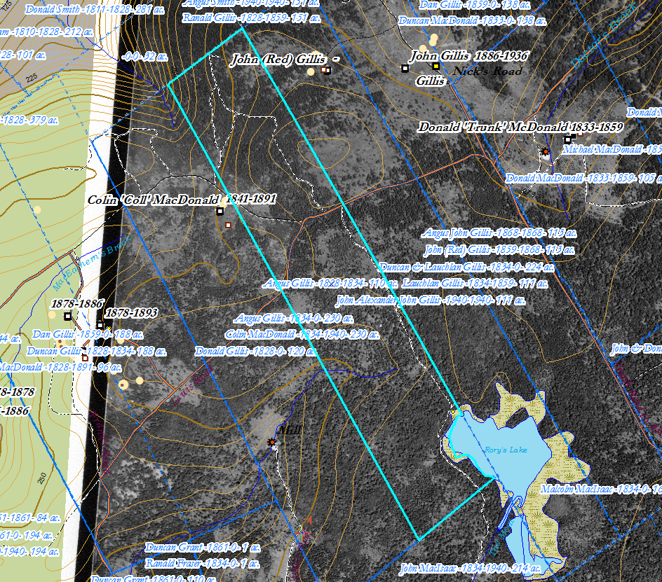

Email, 14 April, 2018, Joe D. MacDonald.

