Land Tenure – Lot 186 (Eigg Mountain Settlement History)

This land was originally granted to John Tobin in 1816 (see file for more). The MacEacherns farmed the northwest corner from the mid-19th century to the 1920s. Ronald MacEachern’s will of 1918 suggests that he had title. It was sold at auction to an unknown buyer.

Lame Angus is said to have inherited the farm on this lot from his uncle Hugh in 1920, but that is not consistent with other evidence so far.

Plan B-11-1 still shows the land as belonging to Michael Tobin in 1912 – Hugh, John and Ranald are listed as “occupants” implying that they were squatters (see Figure 2). In a land description of 1914 (Escheat 88), the lot is again described as 500 acres “granted to Michael Tobin.” Apparently there were conflicting ideas about ownership here.

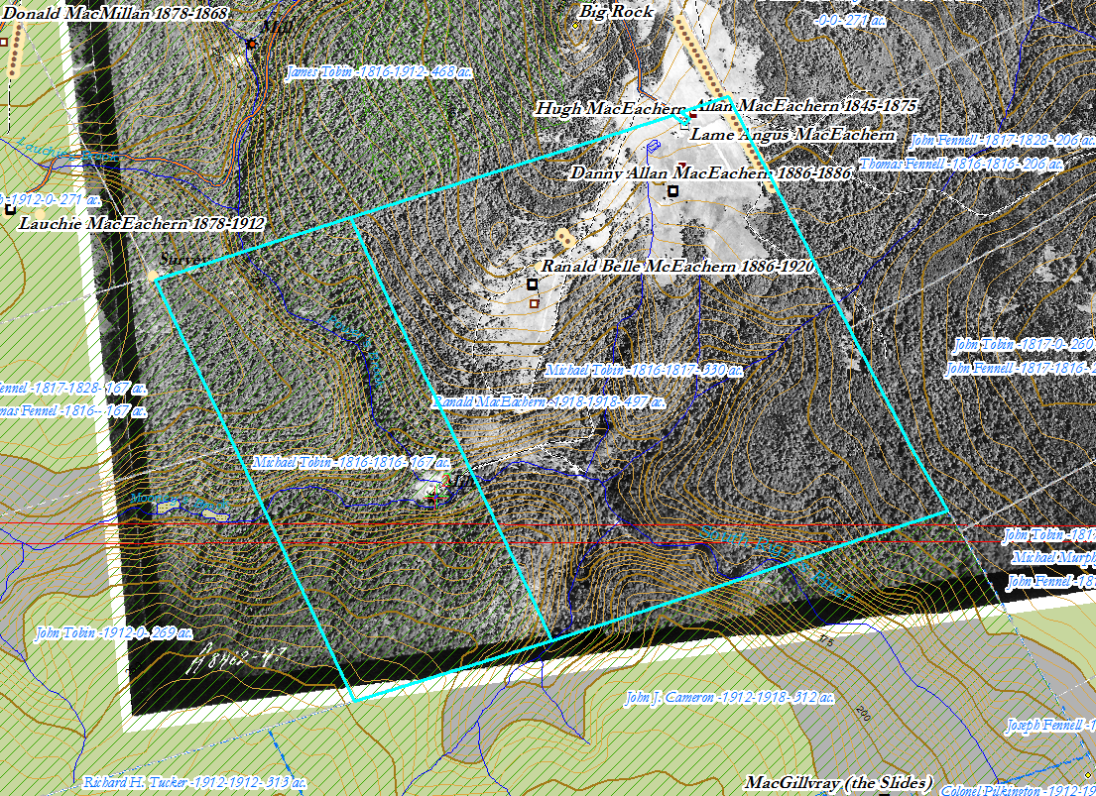
Figure 1 – Lot 186 in the ArcView map, 2018, with georeferenced 1945 aerial photo.

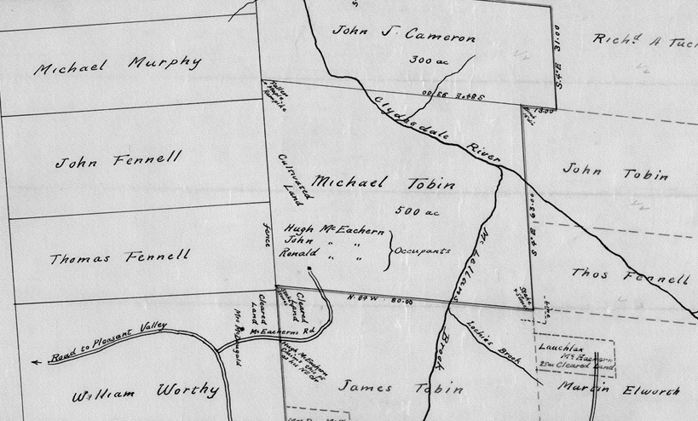
Figure 2 – Detail of Plan B-11-1 (1912) (with south at the top of the sheet – inverting normal orientation)

