Land Tenure (Eigg Mountain Settlement History)

This lot, according to the Land Grants Map, was granted to John Fennell. In 1817 Fennell sold it to John Tobin. The description does not quite fit:
…bounded beginning as follows at lands owned by John Tobin aforesaid,
…thence running north 8° West 100 rods,
…thence north 80° east 320 rods,
…thence south by 8° east by lands owned by Michael Tobin 100 rods,
…thence south 88° West to the place beginning containing in the whole 200 acres.
The lot described as “lands owned by John Tobin aforesaid” is the lot to the south. Everything else is consistent except that Michael Tobin would have to be where Edmund Burke and Lawrence Doyle are (Figure 1).

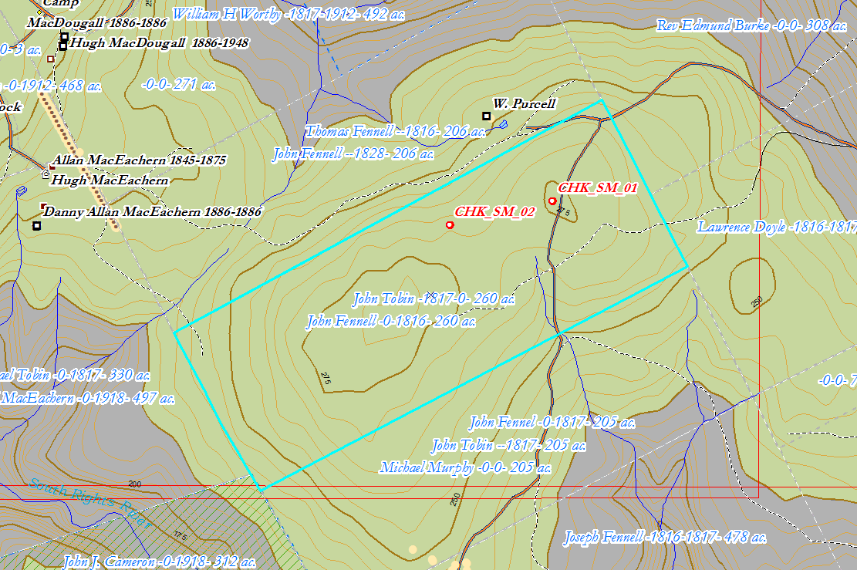
Figure 1 – John Fennell Grant.

