Land Tenure (Eigg Mountain Settlement History)

This lot, according to the Land Grants Map, was granted to Joseph Fennel. The 1816-17 date (see Figure 1) comes from Deed 50242052, but I am not sure that this lot is described in that deed.

It consists mostly of the gullies of the South Rights River, but the northwest corner was occupied and farmed by D. (Donald) MacLellan in 1878.
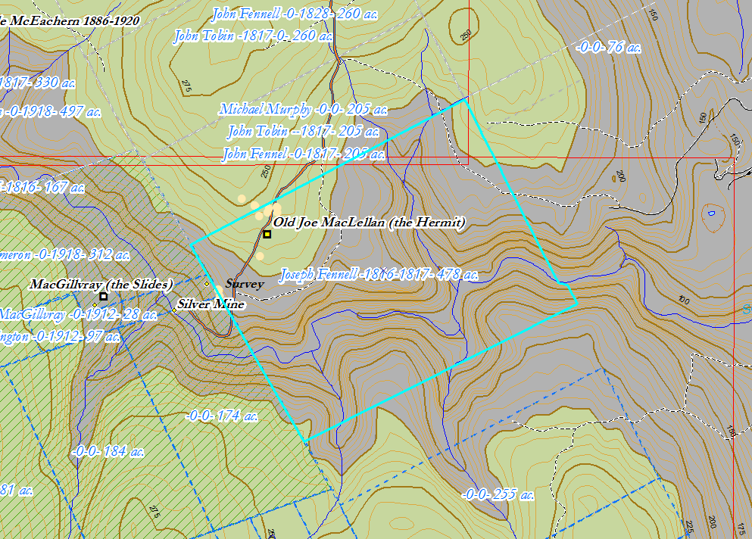
Figure 1 – Joseph Fennel Grant

