Land Tenure (Eigg Mountain Settlement History)

This land was granted to Duncan Grant in 1858 (see G4359). He died in 1864 and the land went to … (see probate file…). In an 1861 grant it is treated as two lots: Ranald Fraser in the North and Duncan Grant in the south. In Escheat 39-5 of 1940 it is attributed to Dan Fraser.

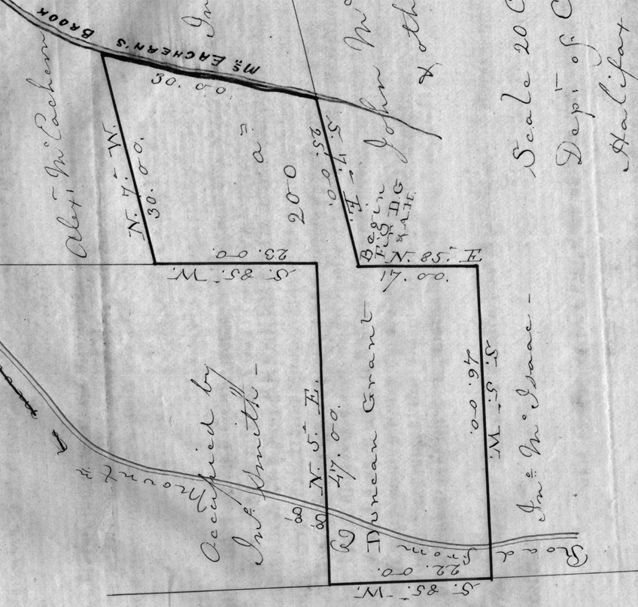
Figure 1 – The original grant map

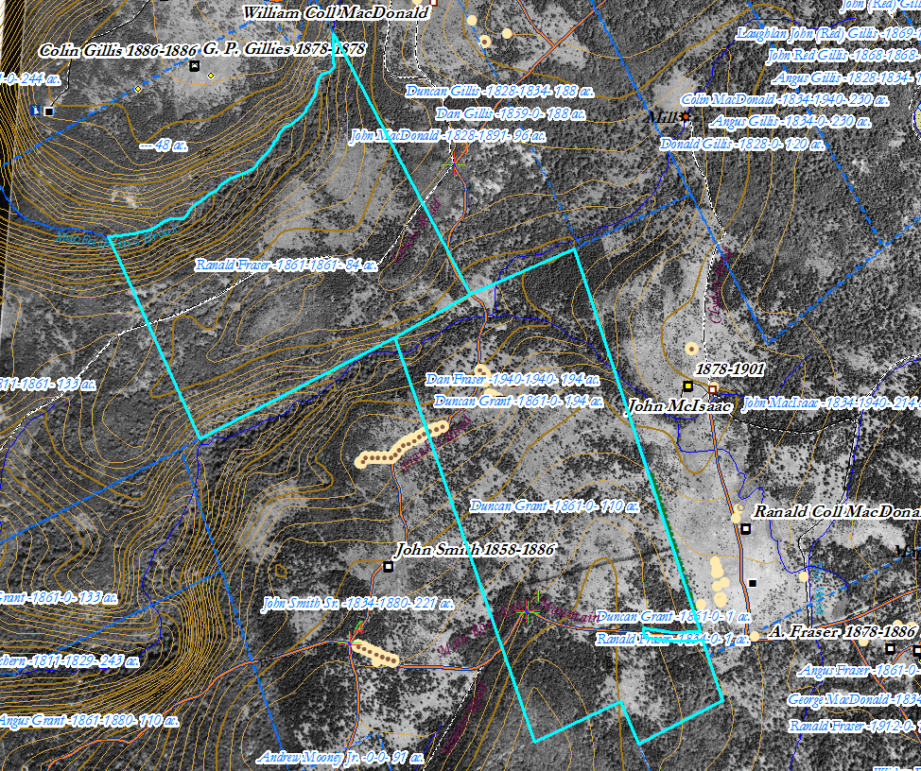
Figure 2 – The same plot of land as represented on the ArcGIS map, 2018.

