Land Tenure – Lot 570 (Eigg Mountain Settlement History)

This and the lot to the west appear to have been treated by the Gillis’s as a single farm (see the field pattern in Figure 1). Like the property to the west it was owned by Hughie (Ewan Mor) then by his son Peter Hughie. Peter appears to have bequeathed it to his daughter Mary and her husband Donald MacLellan. The MacLellan’s bequeathed the land to William Peter (Fettle) Hughie Gillis.

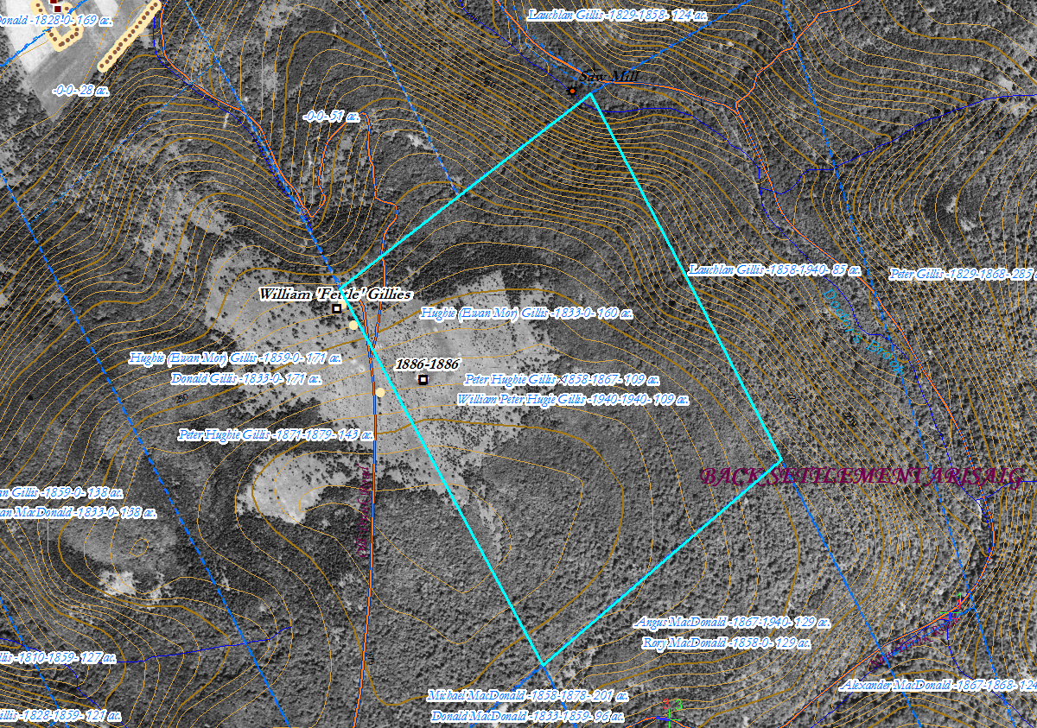
Figure 1 – Gillis’s Lot 570 with georeferenced 1945 aerial photo.

