Lot 272 John Red Gillis (Eigg Mountain Settlement History)

According to the Land Grants Map, this lot was granted to John (Red) Gillis and that is confirmed by a record of a grant to John in 1859 (plan 4612). This was likely not John Gillis, the pioneer who arrived in 1788 and settled on better land on the Arisaig shore. Local knowledge places the pioneer’s son, John Red Gillis here.

However, prior to that, Duncan Gillis is indicated as occupying the lot (in 1828, Plan M_64). This is confirmed by Plan Q_34, also 1838, which places Duncan and Lauchlan Gillis side by side on a lot which encompasses this lot and the one to the east (Duncan here, Lauchlan to the east). No-one is listed here on the Church map (1878).

Peter Gillis (pioneer) had sons Duncan and Lauchlan who are probably the ones named in 1838. Duncan moved to Inverness County. There is evidence of Lauchlan’s tenure as late as 1859 (Grant 4576 Figure 2). However, the Crown considered the land vacant and grantable in 1859 (i.e. to John Gillis).

John Red Gillis bequeathed the land to his son Alexander and daughter Flora in 1868 (see A-383). Alexander may have passed it on to his son John Alexander, since “John A. Gillis” is the name that appears on the Escheat file 39-14 in 1940. I have left John Alexander off the map since it is too confusing already.

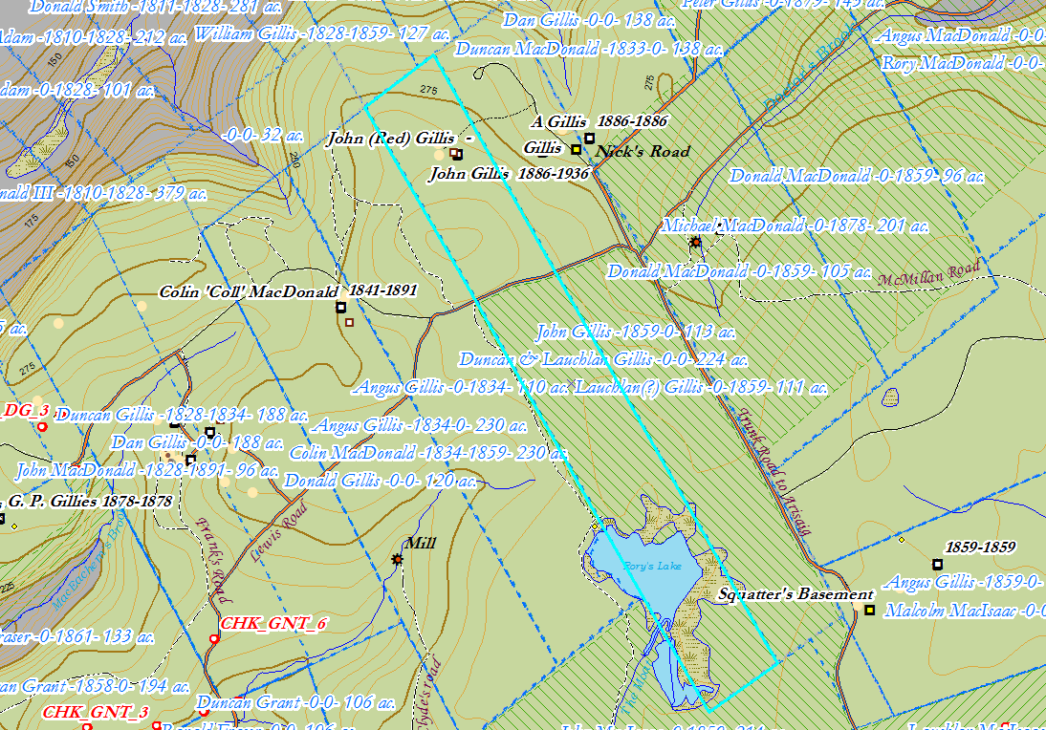
Figure 1 – Lot 272 on the ArcGIS map, 2018.

See also:
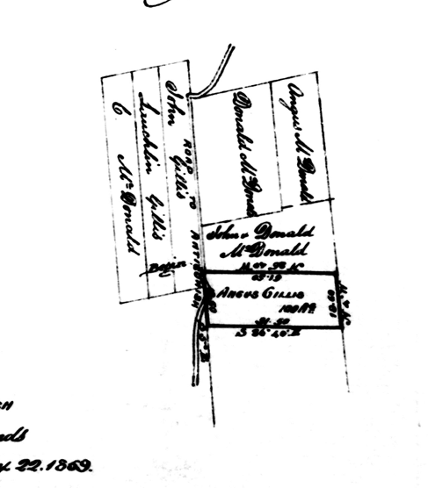
Figure 2 – Grant 4576, 1859

Neither John the pioneer nor John Red had a son named Duncan. John the pioneer had a son Lauchlan who is not likely the one named in 1828. John Red had a son Lauchlan to whom he bequeathed land, but that was in 1868, long after this other Laughlan was listed as owner.

