MacDonald_(Sandy Ban)– (Eigg Mountain Settlement History)

Angus Ban MacDonald was the pioneer – see Rankin page 243.
Donald MacDonald married Betsey MacDonald
Angus MacDonald married Catherine MacDonald
John MacDonald (b. 1794-d. 1872) probate file A-479 page 707/904 Antigonish Estate File 1870-1873 married Janet MacDonald (b. 1805) d/o Rory MacDonald, the Gusset Rankin
1871 Census Division 1 # 14
Alexander MacDonald (b. 1835) born at Moidart NSVS married Mary Smith (b. 1837) d/o Allan and Catherine MacAdam Smith married January 22, 1867 at Arisaig NSVS
1871 Census Arisaig District Division 1 # 13
1881 Census Arisaig District # 85
1891 Census Arisaig District # 57
1901 Census Arisaig District # 11
1911 Census Arisaig District # 13
1921 Census Arisaig District # 45
John MacDonald (b. 1867) lumberman married
1901 Census Arisaig District # 10
1911 Census Arisaig District # 12
Donald “Dan A” MacDonald (b. October 19, 1870) SMAR married Sarah MacDonald (b. 1883) lived at Doctor’s Brook
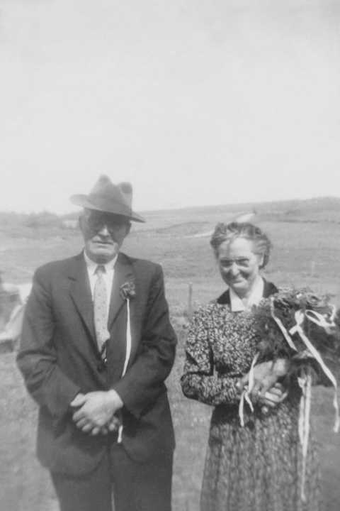

1911 Arisaig District # 11
1921 Census Arisaig District # 51
Alexander MacDonald (b. 1904)
Dougald MacDonald (b. 1906)
Duncan Joseph MacDonald (b. 1908)
Mary Catherine MacDonald (b. 1910)
John MacDonald (b. 1912)
Janet MacDonald (b. 1913)
Elizabeth MacDonald (b. 1914)
Anthony MacDonald (b. 1916)
John MacDonald (b. 1918)
William MacDonald (b. 1919)
Ann MacDonald (b. 1920)
Catherine MacDonald (b. 1872)
1901 Census Arisaig District # 11
1911 Census Arisaig District # 13
1921 Census Arisaig District # 45
John Allan MacDonald (b. 1874) Sydney Mines
1901 Census Arisaig District # 11
1911 Census Arisaig District # 13
Janet MacDonald (b. 1875) Sr. St. Joseph Agnes Halifax
Ronald MacDonald (b. 1877) married Flora Bell Gillis (b. 1887)
1901 Census Arisaig District # 11
1911 Census Arisaig District # 13
1921 Census Arisaig District # 45
Sarah MacDonald (b. 1917)
Alexander MacDonald (b. 1920)
Catherine MacDonald (b. 1837) house servant
1881 Census Arisaig District # 85
1891 Census Arisaig District # 71
1901 Census Arisaig District # 10
1911 Census Arisaig District # 12
Janet MacDonald (b. 1841) married Alex MacDonald (Donn), Pictou
1881 Census Arisaig District # 85
Angus MacDonald (b. 1842) joiner
1881 Census Arisaig District # 85
Roderick MacDonald (b. 1845-d. 1890) inherited half of the farm in his father’s will. Probate file A-1509 page 776/1281 Antigonish Estate File 1912-1913
1881 Census Arisaig District # 85
1891 Census Arisaig District # 71
Donald “Dan J” MacDonald (b. 1847-d. February 11, 1912) Obit/NSVS probate file A-1492 page 494/1281 Antigonish Estate File 1912-1913 died interstate (no will) but an inventory. Left half of farm when his brother Roderick died in 1890.
1881 Census Arisaig District # 85
1891 Census Arisaig District # 71
1901 Census Arisaig District # 10
1911 Census Arisaig District # 12
Sarah MacDonald (b. 1848) Pictou
1881 Census Arisaig District # 85
1891 Census Arisaig District # 71
Mary MacDonald (b. 1866)

