McEachern, John Archie (Eigg Mountain Settlement History)

John Archie McEachern was the last to live on the Dumaglass Road, also known as the Gusset Road. He left in the late winter of 1955. The snow was unusually deep that year, probably adding to his sense of loneliness and isolation as the last holdout of a vanished community. He abandoned everything including the livestock and went to Antigonish. The site appears on the 1893 Geological Survey map and on the Church Map marked as “H. McEachern.”

Charlie and Kenton Teasdale remember the farm as a particularly fine one. There were extensive fields with good soil. The house, barn and even some of the outbuildings were painted, which was rare. Charlie considered buying it himself, but thought at least that “this would have been a good one for the hippies to buy.”

The house faced 66 degrees (i.e. west) toward the road. The dimensions are roughly 28 ft. by 30 ft. with the long axis north-south. There was a small add-on north on the north west corner. Kenton speculates that this might have been for the cream separator which often spilled and left a foul smell, so was not welcome in the main house. There was a considerable amount of rotting wood left in 2005. The floor beams with notched ends were clearly visible. Charlie decided that the main building was an “L” shape, which is confirmed by the aerial photograph.

The farm is on the 1951 “geology camp” series of aerial photos. You can see what may be John Archie’s truck in the drive.

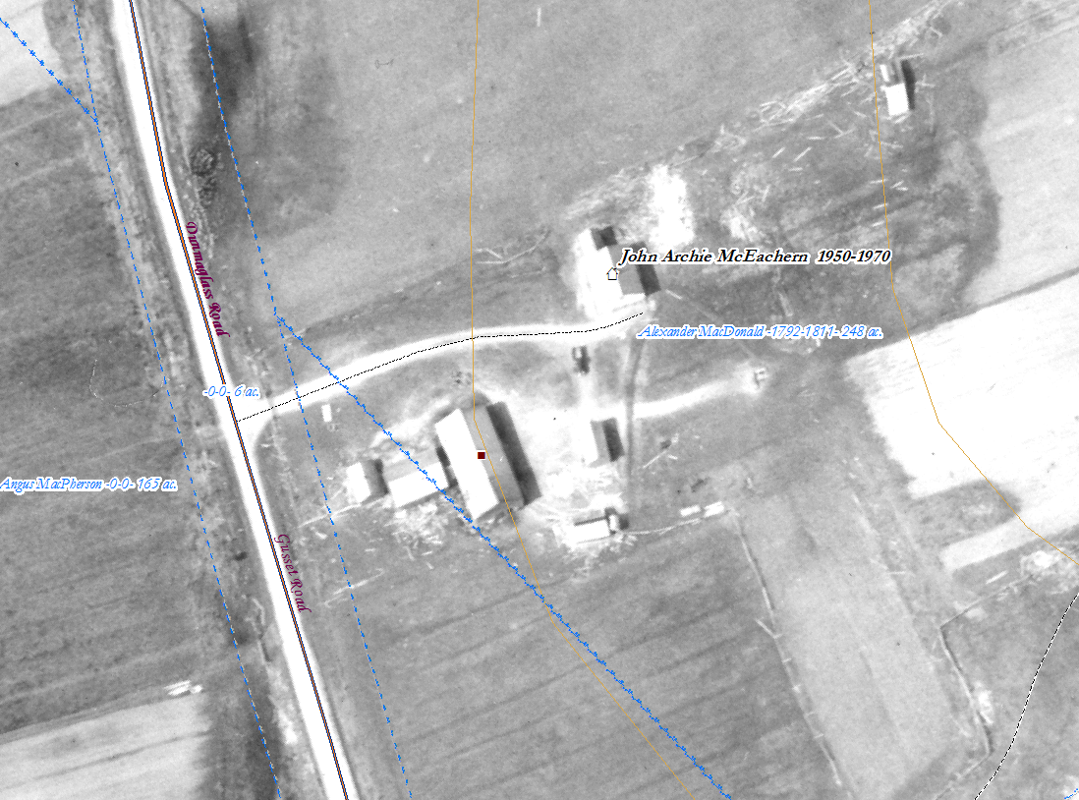
Figure 2 – John Archie MacEachern’s farm in 1951 just before he abandoned it.

Charlie and Kenton Teasdale, November 2, 2005.

He is referring here to the wave of back-to-the-landers, many of whom were American draft dodgers, who immigrated to rural Nova Scotia in the 1970s. Many farms like John Archie McEachern’s were being abandoned and they found land cheap to buy. Few of these newcomers are now still farming, but many stayed and brought cultural and entrepreneurial innovations to the communities that they became a part of.

