MacEachern, Danny Allan (Eigg Mountain Settlement History)

Danny Allan MacEachern, brother of Lame Angus lived at this site. He was a piper and was revered as a musical genius. The church received a new organ and they were trying to find someone to play it. They asked Danny if he would try. He sat down and studied the keys and pedals and promised to play it the following day. Sure enough, having never played one before, he followed through with his promise.

The Scottish Piper: After the Battle of Culloden, the Highland Scots were prohibited from playing the bag pipes. However, when these same Scots came to Canada they were free to play them.

…the one that fell off the sled and froze
…cousin to John Angus “Solomon” p. 186 of Blackwell-MacLean
…foundation is probably to the east of the one marked by GPS

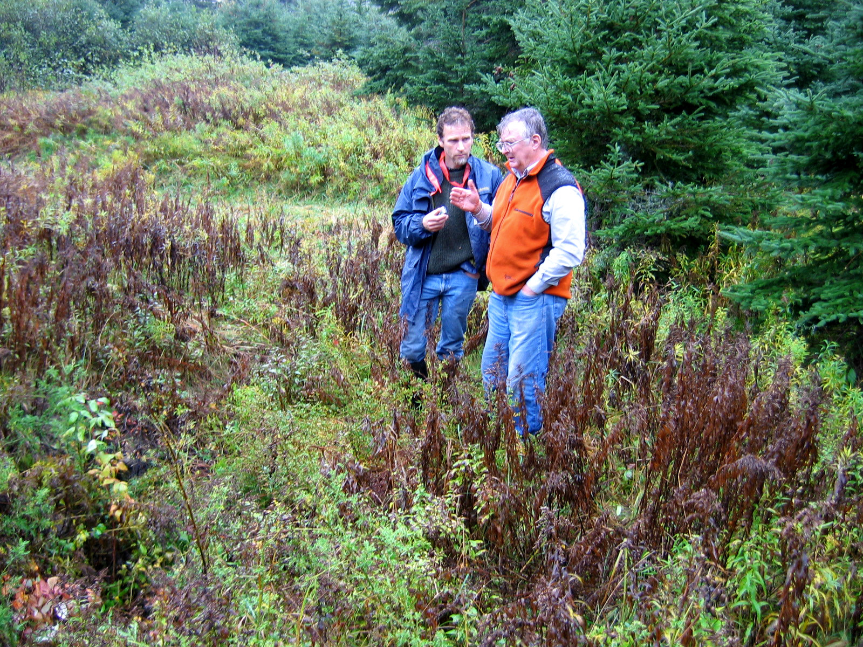
Figure 1 – Rod Bantjes interviewing Kenton Teasdale at the site of Danny Allan MacEachern’s house.

Source: Interview, Kenton and Charlie Teasdale, Eigg Mountain, October 16, 2004

Church, 1879, places a J. MacEachern here.

