Field of Archie the Widow MacIsaac (Eigg Mountain Settlement History)

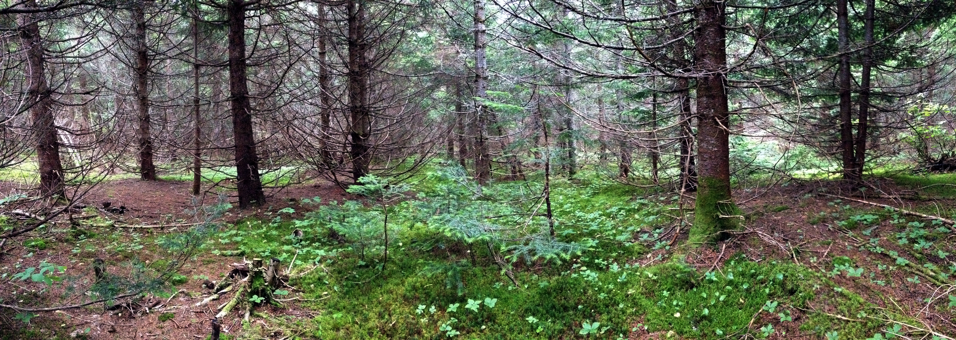
Figure 1 – Panorama of a former field overgrown with white spruce. August 9, 2015.

