MacIsaac, Archie the Widow (Eigg Mountain Settlement History)

This was an especially large well-defined basement when Lame Angus saw it as a youngster (19 teens/ 20s). The first occupant at this site was the son of Old John MacIsaac, Archie “the Widow.” The house was probably abandoned in the late 1800s. Kenton later indicated that Archie the widow was a first generation settler who left early, perhaps around 1840 to settle in Fairmont. This fits with the state of decay of the foundation and the difficulty in discerning fields from the aerial photographs. The land was originally granted to a Malcolm MacKinnon (from Grants Index, 1953).

We finally found the house site August 9, 2015. It was one of those cases where I walked straight to it. It is very overgrown with almost no rock showing in the cellar walls. It measures 24 X 25 feet and is oriented 41º. The cellar steps appear to be on the south side facing the stream. The extent of Archie’s fields is still unclear.

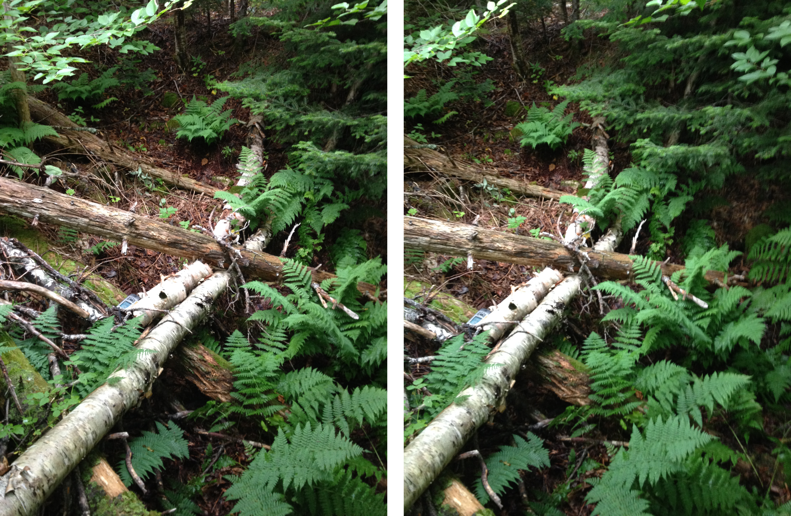
Figure 1 – Cellar Looking North. It is difficult to get the camera to show what the eyes can see when a cellar is overgrown like this. The depression becomes just a jumble of logs and foliage. So I have resorted to using stereo pairs, which if you can freeview, heighten the 3-D effect. This pair is designed for cross-viewing – that is the image for the left eye is on the right and vice versa.

Kenton Teasdale, Eigg Mountain, November 4, 2005.
Kenton Teasdale, 12 August 2015.

