Donald MacLellan (Eigg Mountain Settlement History)

Figure 1 – Panorama from within the cellar with centre looking east.

This site is on the north side of the mountain, close to William Fettle Gillis’s (see Lot 570). The house belonged to [was built by?] Donald MacLellan – the uncle of the Kenton and Charlie Teasdales’ grandfather. Donald was married to Mary. They had sons Archie and Ronald. Donald would have lived on the property in 1871. Mary died 1898 and Donald in 1908. In “Boundaries of School Sections for Antigonish County” Donald McLellan is indicated in 1873 as the within the boundary of the Eigg Mountain School.

William Fettle Gillis was Donald’s nephew. When Donald and Mary were old, William would go over and help with the cattle. The MacLellans left the property to William. While the house that came with it was larger and better appointed, William elected to remain on his own small house nearby. He was the last to live on the property.

Charlie and I returned to this site in June of 2018. We were both amazed at how much it had changed since 2004. It was largely open field when we were here with Ken. Now it is a spruce forest with trees of between 15 and 20 years of growth. It is strange that it had remained open since at least the MacLellans left it 100 years ago and then sprang into forest only in the last 15. Charlie had a hard time getting down to Fettle’s and a hard time getting back up here. So, it may be the last time he sees these places.

This was a very large house by Eigg Mountain standards. The foundation measures approximately 30 by 36 feet with the longer side oriented north-south. It has a two-chambered cellar with a large rock column in the centre which likely supported the hearth and chimney (see the remains in Figure 1). The house probably faced north looking down the slope of the land, with a view over the Northumberland Strait towards P.E.I.

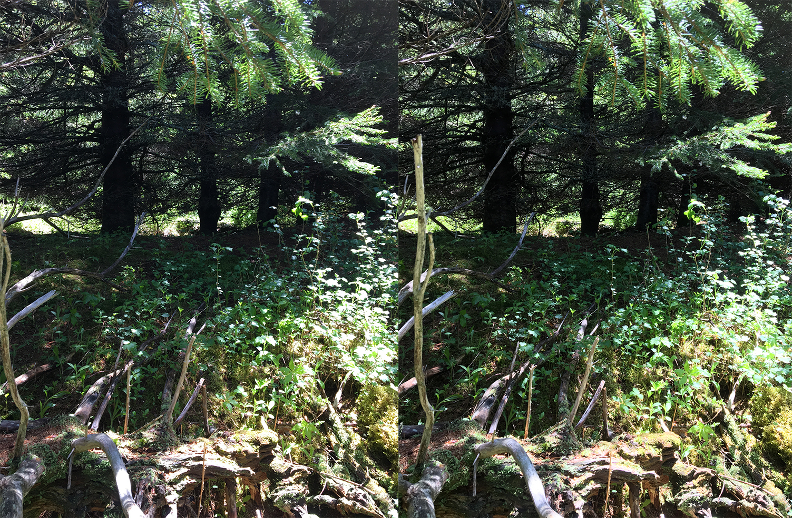
Figure 2 – Line of the cellar from the south, June 15, 2018. (See how to view in 3D)

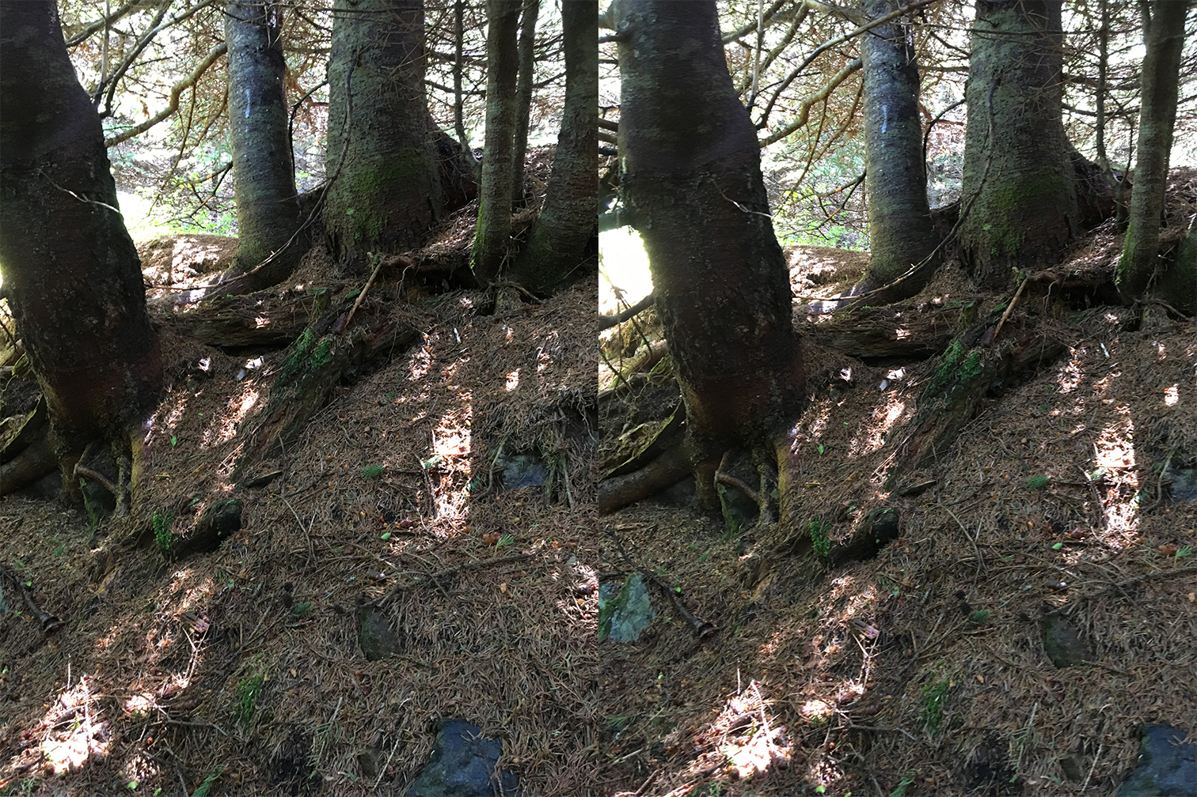
Figure 3 – West wall from inside the cellar. (See how to view in 3D)

Kenton and Charlie Teasdale, Eigg Mountain, October 16, 2004.
Kenton and Charlie Teasdale, Eigg Mountain, October 16, 2004.

