Maple Ridge School (Eigg Mountain Settlement History)

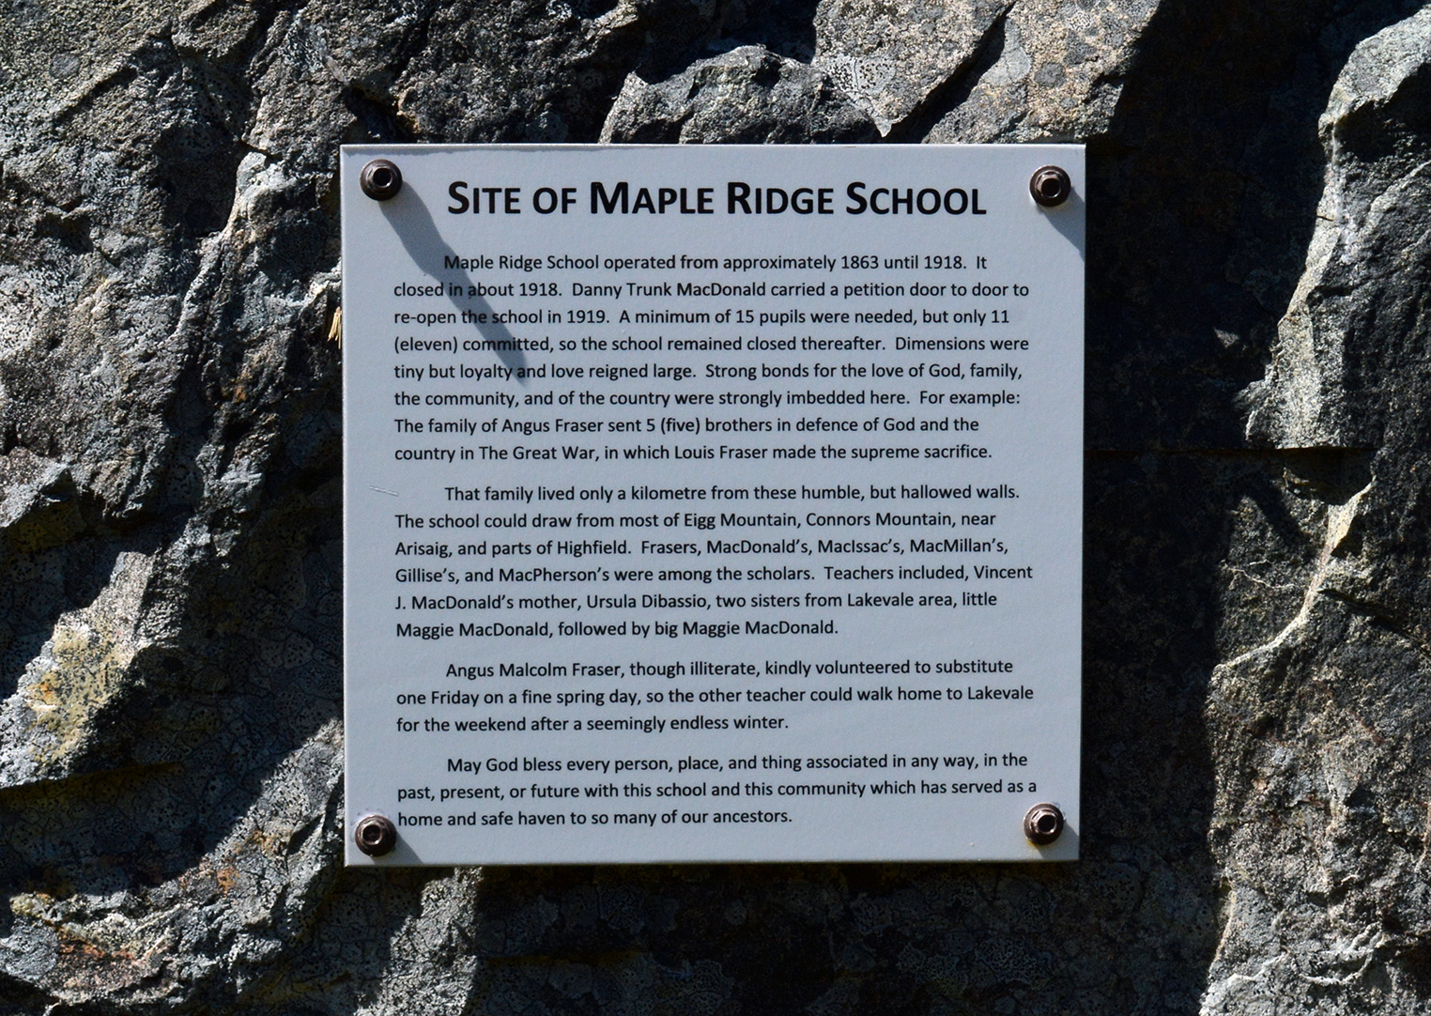
Figure 1 – Commemorative plaque erected at the Maple Ridge School site by Kenton, Charlie and Robert Teasdale.

This was the only local school serving the Eigg Mountain community. It appears on the Church Map so we know it existed in 1878. It closed permanently in 1914 – a telling sign of the decline of Eigg Mountain as a viable settlement. In 1919, (spring?) a petition was circulated to have the school reopened. However, the signatories only represented 12 children; not enough to persuade the authorities. Even as late as 1888, “the county school inspector reported that Eigg School had not operated for the year, for the region was ‘poor and very sparsely settled’.”

The school may not have been established until late in the 19th century, or at least not all children attended. For instance, Angus Malcolm Fraser, of school age in 1865, “never had a day of school in his life.” Literacy rates were high in Great Britain and especially Scotland in the late 18th century, but many of the settlers who came to Eigg Mountain were without it. This is evident in the way that they signed documents such as William and Mary Dalton’s land grant petition, with an “x,” the authenticity of which is witnessed by a clerk. They were not able to teach their children to read or write and may not have placed high value on literacy. Angus Donald Fraser is another example of a child born on the Mountain (in 1844) who was in 1905 unable to sign his name on his will.

The schoolhouse was a focus for community for the children, but also the adults who held dances there. The Teasdales’ grandfather took his wife-to-be home from one of these dances. His mother complained that he failed to take off his patent leather shoes for the walk home. Normally people would walk barefoot to save the expensive shoes.

Vince MacDonald’s mother taught school here as well as Ursula Debassio around 1890. Ursula Debassio, was a teacher, her father was a Portuguese language instructor (?) in Antigonish. She was Ronald Fraser’s great aunt.

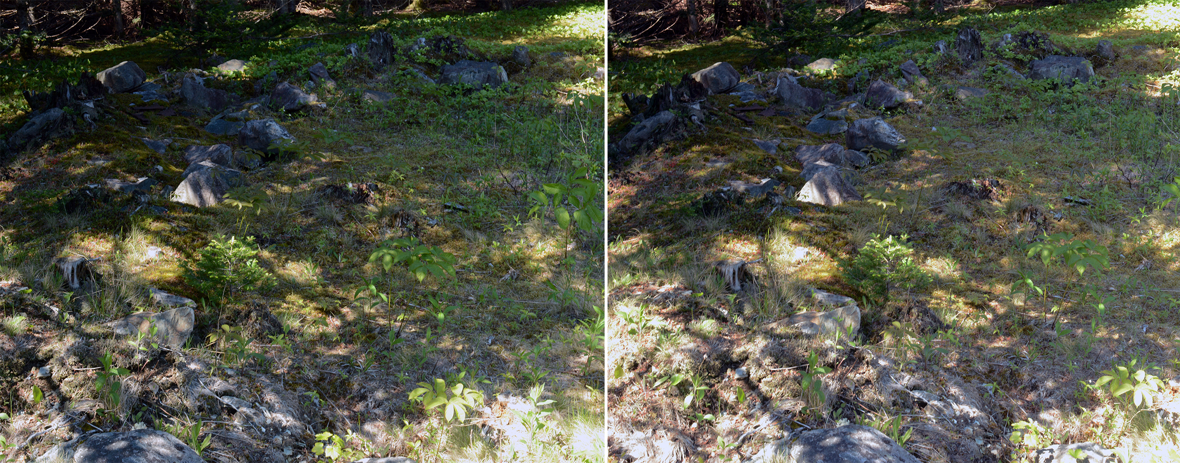
Figure 2 – Foundation of the school house looking toward the northeast corner, June 15, 2018.

The schoolhouse was a log building measuring approximately 21 by 18 feet.

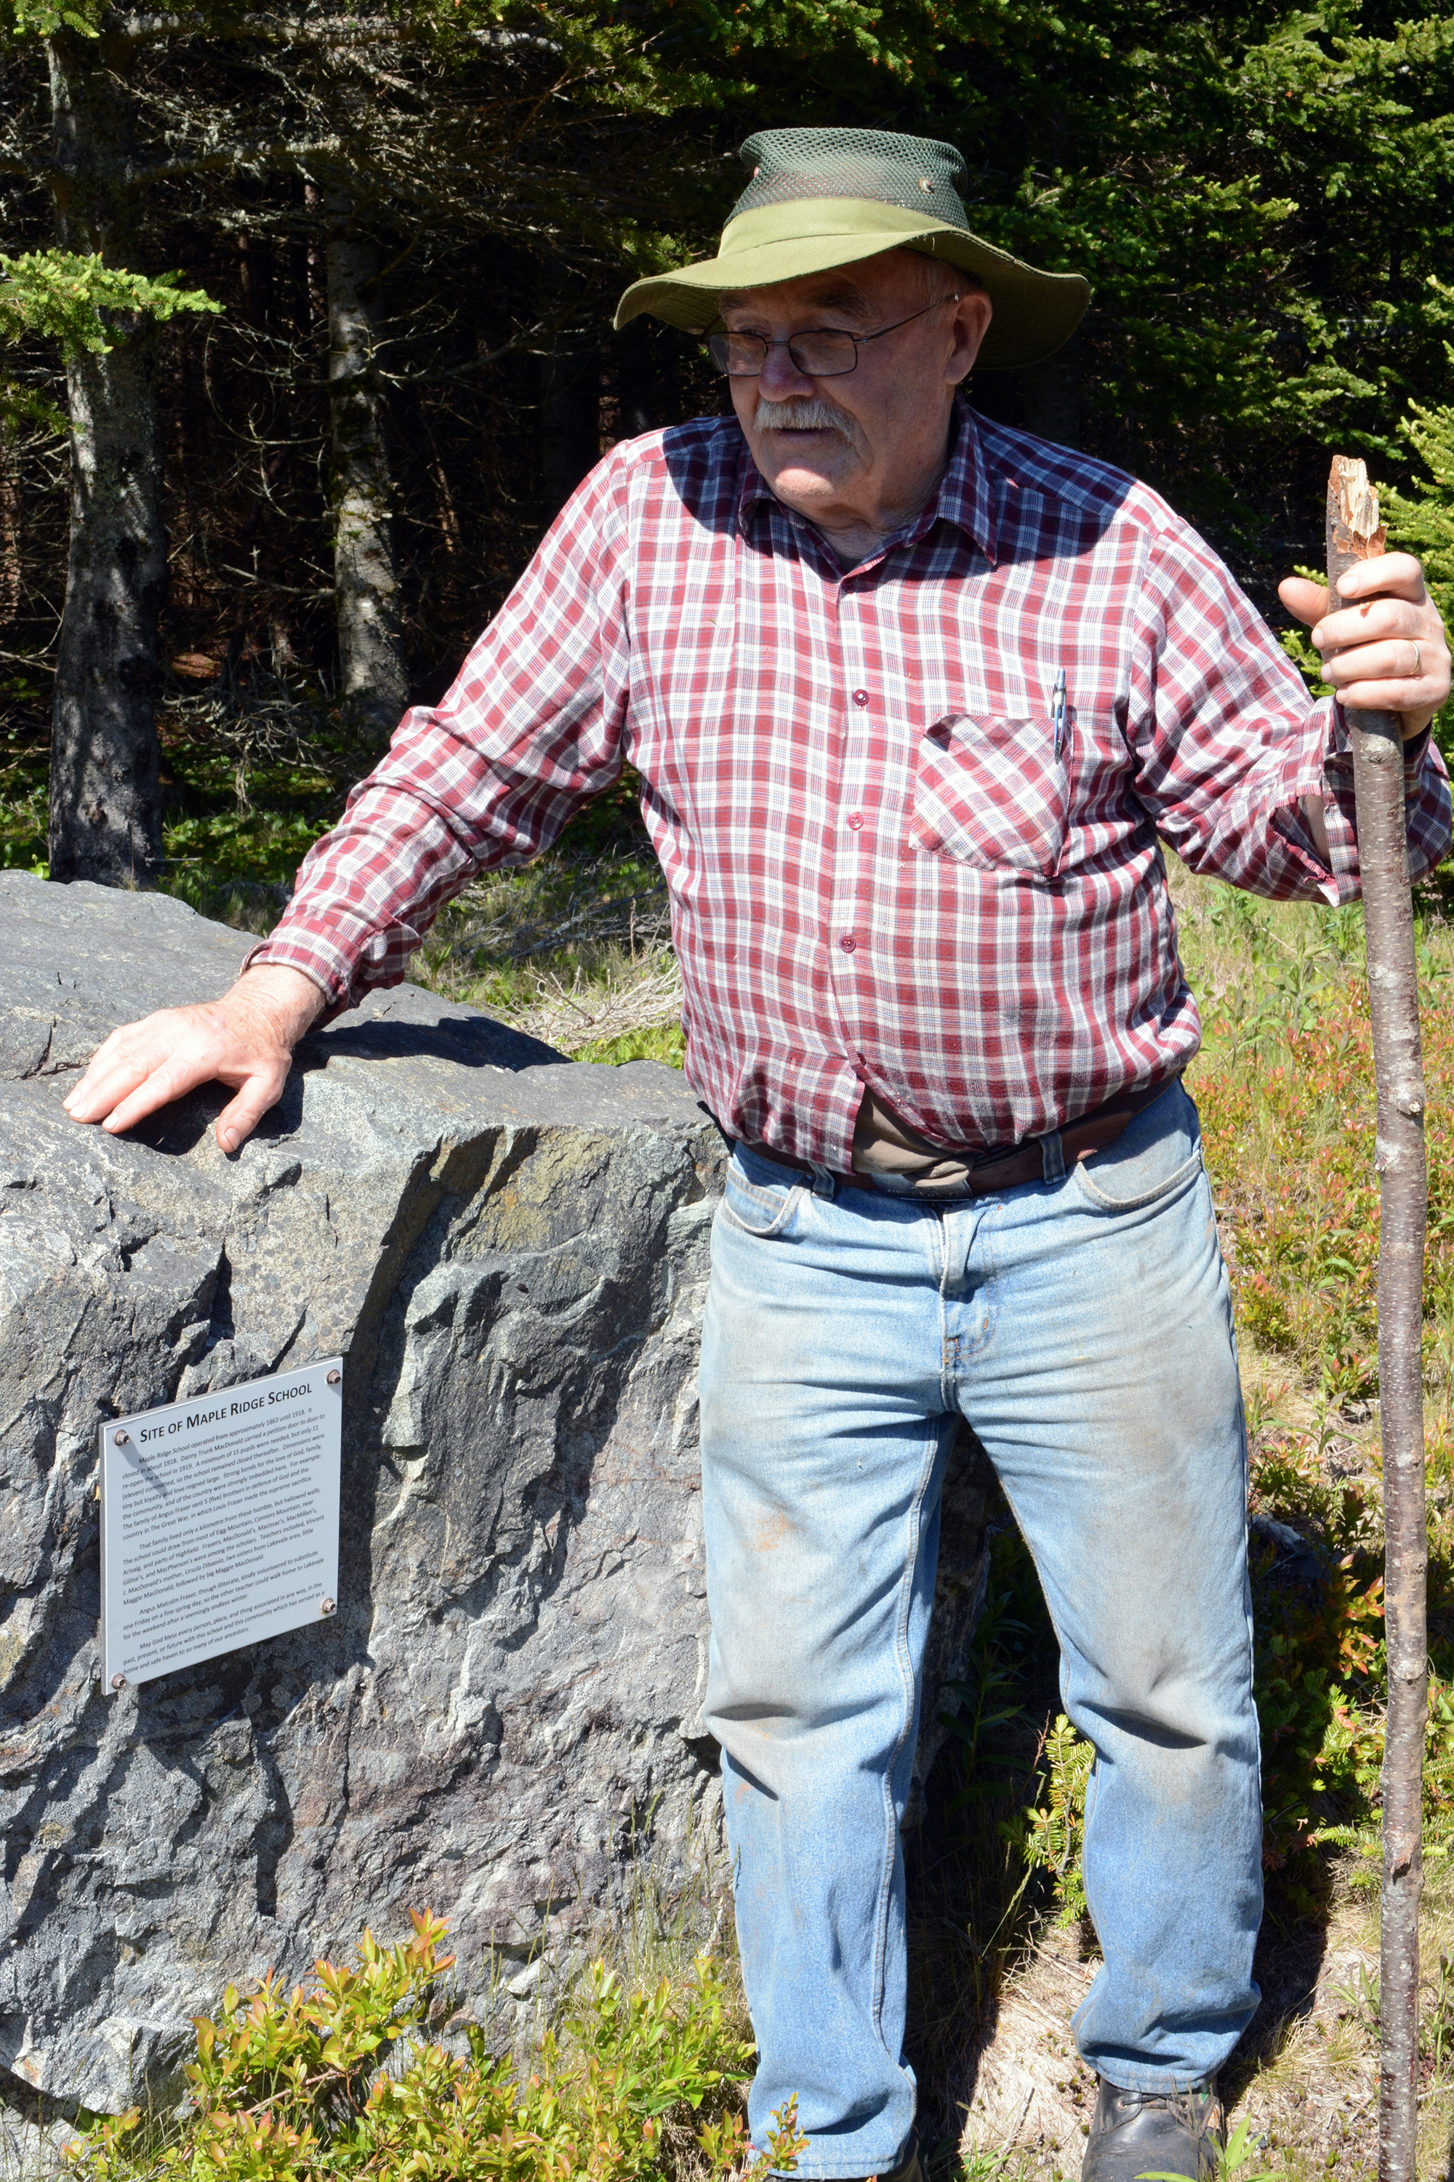
Figure 3 – Charlie Teasdale pondering life at the schoolhouse, June 15, 2018.

Laurie C. C. Stanley-Blackwell, and R. A. MacLean, Historic Antigonish: Town and County (Halifax, NS: Nimbus Pub., 2004), 9.
Kenton and Charlie Teasdale, Eigg Mountain, October 16, 2004.
Kenton and Charlie Teasdale, Antigonish, December 2, 2004.

