Obituary of Fraser, A. [Alexander, son of Ranald] (see Fraser, As] (Eigg Mountain Settlement History)

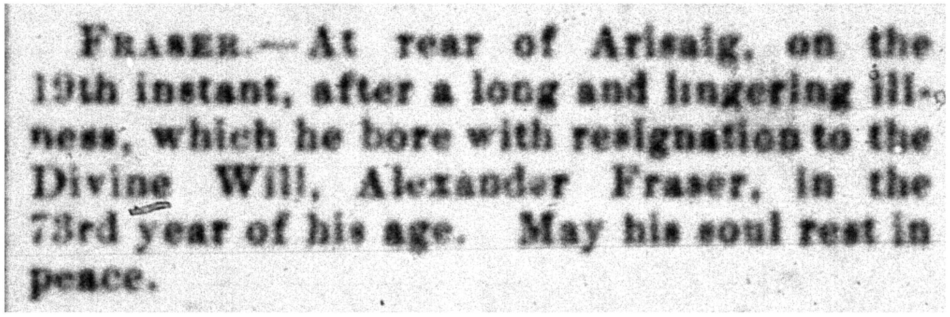
Source: The Casket, May 30, 1895.

