Obituary_MacEachern_Alexander – (Eigg Mountain Settlement History

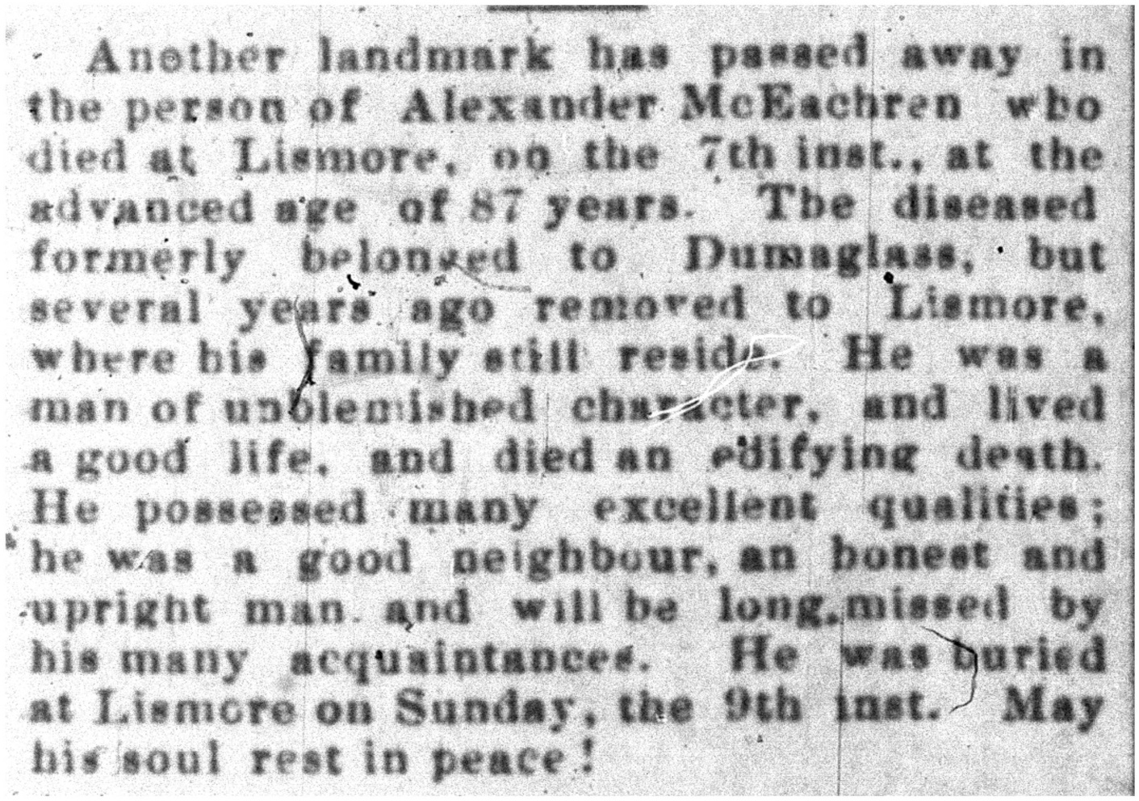
The Casket April 20,1899

