Scythe on Fraser/Mooney property (Eigg Mountain Settlement History)

This old scythe is located on one of the rock piles on the Mooney /Fraser property. This was a huge field (perhaps 150 acres). The oats or hay growing on it would all have been cut by hand with this simple tool and others like it.

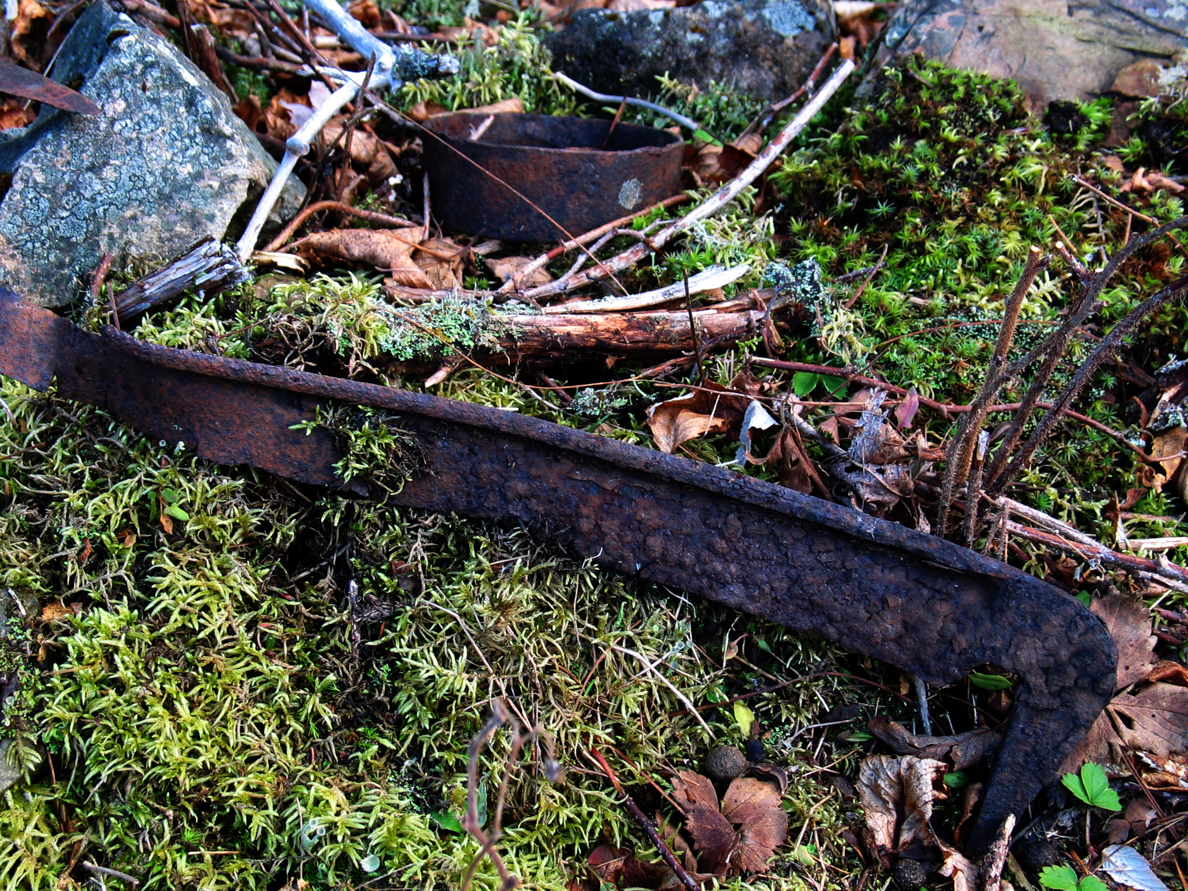

December 1, 2005

Please leave this and any other artefacts as you found them so that other visitors can enjoy them or researchers learn from them. Also note that “heritage objects,” or artefacts of historical value, are protected by Nova Scotia law.

