Probate record A-1098 (Eigg Mountain Settlement History)

Hugh MacGillivray, Summerville, died January 5, 1883 at 89 years old, recorded 1889-90

To his son John: two hundred acres in two parcels, one of 100 acres that Hugh owned and occupied at Summerville (see parcel LT_237) and one of 100 acres “of wood land at the rear of the heirs of Andrew MacGillivray.” (see parcel LT_87)

To his son Alexander: 130 acres on Brown's Mountain, Range 12, Lot 11 (see parcel LT_463)

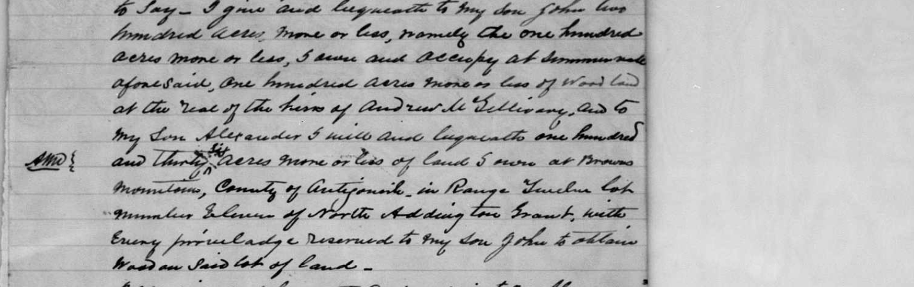

From Joe Macdonald (email, 11 January, 2018): “He [Hugh] was married to Catherine (MacDonald) and was the father of Rev. Andrew McGillivray who was at Lismore. Hugh's father was Andrew McGillivray - one of the three brothers who settled the area. The other two were Alexander and Angus. Hugh's brother was John - father of two priests Rev. Alexander and Rev. Ronald (Sagart Arisaig). I sent an email about his will to you last November 15. Angus's son John McGillivray was one of the executors of the will.

You can find Hugh and his family in the 1871 census page 11 line 8 of Arisaig district. Hugh was born about 1794 in Nova Scotia and died January 5, 1883 at 89 years old.”

For the McGillivrays in this area see also LT_664

