Probate record A-1772 (Eigg Mountain Settlement History)

Ronald MacEachern of Maple Ridge, 1918.

This is the first indication that this lot (Lot 186) was owned by a settler as opposed to an absentee owner. Ranald, in 1918, owned the lot that his cousins Danny-Allan and Hugh lived or once lived on. Given that the land description is for 500 acres I am assuming that Ronald owned the lot to the west as well as the one that he farmed. The entire lot was sold at public auction at Ronald’s death, with no record of who bought it (email, Joe MacDonald, 15 November, 2017). So it is uncertain how Lame Angus could have inherited the farm on this lot from his uncle Hugh in 1920.

Land description: “Bounded on the north by Crown land on the east by lands of John MacEachern deceased, south by the lands owned by or in possession of John Cameron MD and on the west by Crown lands. Land containing about 500 acres.”

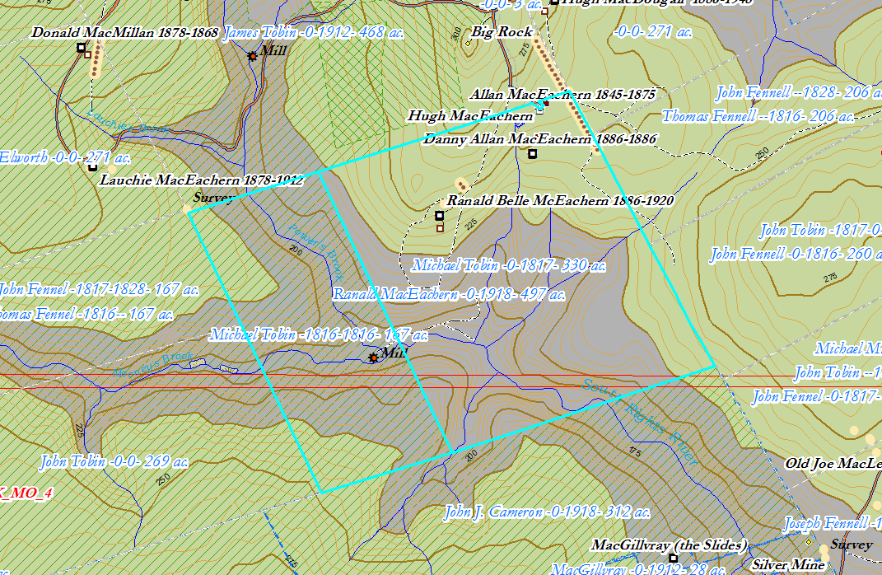
Figure 1 – Ranald MacRachern’s lot, ArcGIS map, 2018

Plan B-11-1 still shows the land as belonging to Michael Tobin in 1912. In a land description of 1914 (Escheat 88), it is again described as 500 acres “granted to Michael Tobin.” Apparently there were conflicting ideas about ownership here.
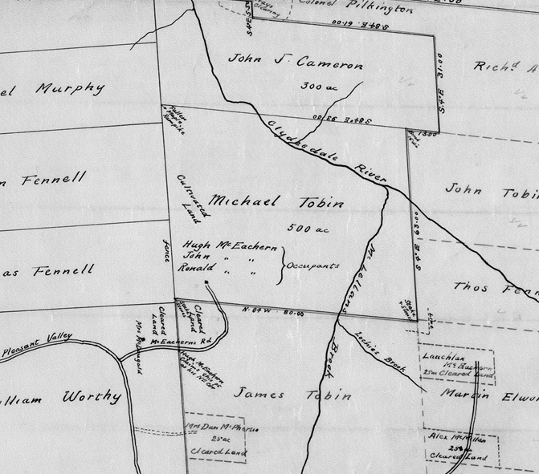
Figure 2 – Plan B-11-1 showing Michael Tobin as the owner in 1912 (South is up)

