Probate Record A-383 (Eigg Mountain Settlement History)

Probate file for John Gillis. This John (red) Gillis was a brother of Angus Gillis A- 407 and also son of John Ban Gillis, the pioneer. He died May 42, 1868 at the age of 86 years. He lived in the back settlement Arisaig according to the probate file. He owned 300 acres and an inventory of all his assets is in his probate file.

Land descriptions:
West: (Lot 059) "I give and bequeath to my son Lauchlin Gillis one hundred acres of land on the west side of my farm...

Middle (Lot 272): I give and bequeath to my son Alexander Gillis sixty-five acres of land out of the middle one hundred acres to be given on the west side of the same.
I give and bequeath to my daughter Flora Gillis thirty-five acres of land out of the east side of the middle one hundred acres to run the whole length of the middle lot of land (the compliment of which I above bequeath to my son Alexander Gillis.

East: (Lot 568) Also I give and bequeath to my son Angus Gillis the east one hundred acres of land on which I now reside..."

Two other sons of John Red Gillis - John and Donald received money but no land.

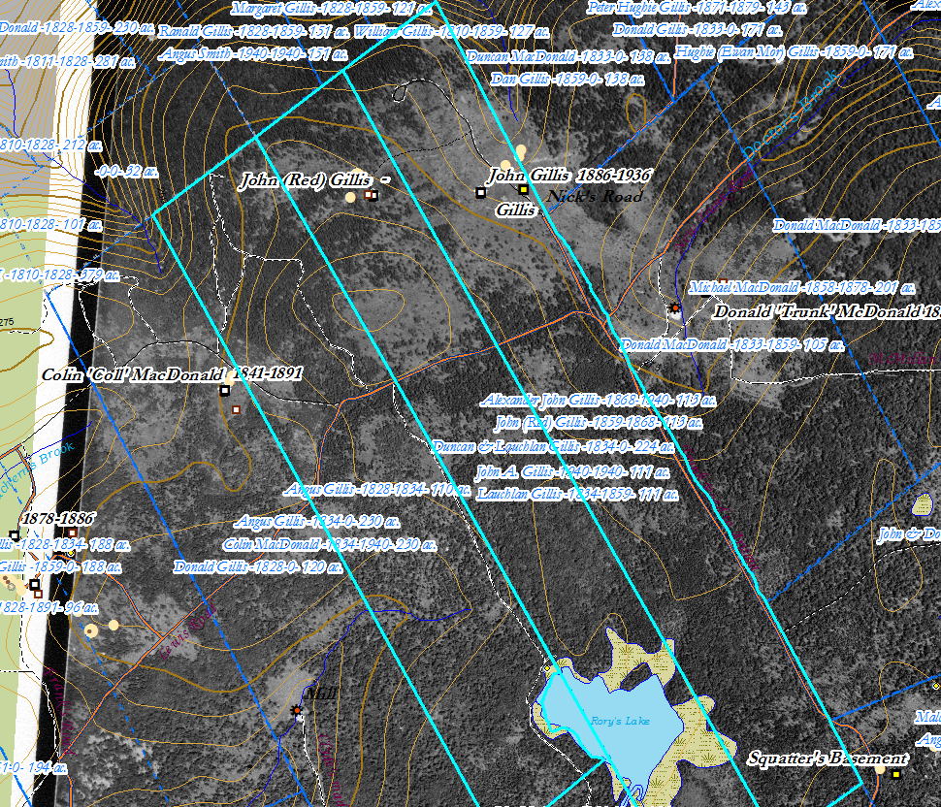
Figure 1 – John Red Gillis’s properties in 1868
I believe I may have the wrong three properties – I think the third might be the Dan Gillis property to the north east (see Figure 1).

Lauchlin, Alexander, Flora and Angus Gillis appear on pages 20 and 21 of the 1871 census - Flora is unmarried and living with her brother Alexander.

Rankin, 142.

